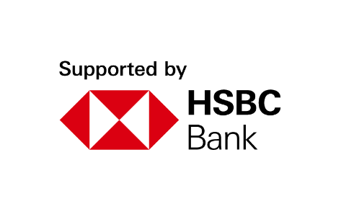
Youth Employment Services YES
www.yes.on.ca
CAREER ACCELERATOR: FINANCIAL LITERACY, CAPABILITY, AND INCLUSION
Facilitator’s Guide
Introduction to Financial Literacy, Capability, and Inclusion

Overview and Purpose

In this introductory module, youth will learn the definitions of financial literacy, capability, and inclusion. Participants will be presented with key concepts that will help develop/enhance their aptitude in all three areas. The key concepts covered are bank accounts: understanding how to navigate which financial institution and accounts meet your financial needs; pay statements: understanding deductions and how to read this essential financial document; budgeting: how to create a personal budget, measuring your expenses vs. your income, and saving: youth will be taught the concept of saving with an overview of various savings accounts.

Time

The workshop is between two to three hours long. All timings provided in the Facilitator’s Guide are approximate. Note that the timings for the slides don’t add up exactly to two or three hours, because some of the activities can be extended or shortened. You can lengthen, shorten or leave out activities based upon the needs of your participants and the amount of time you have for the workshop. You should have short breaks at least every 60 minutes.

Learning Outcomes

At the end of this workshop, participants will be able to:

- Define financial literacy, capability, and inclusion.
- Select a financial institution that meets their needs.
- Interpret their pay statement.
- Analyze their expenses compared to their income.
- Create a personal budget.
- Understand savings and saving account options.

Leading Questions

As participants complete this workshop, some of the questions they will think about include:

- How do you feel about talking about personal finances?
- Do you feel that the financial services you need are accessible to you?
- Who have you learned most about finances from? Do you feel you have the knowledge and skills to make responsible money management decisions?
- What new information do you think you need to confidently make financial management decisions that allow you to meet your personal financial goals?

Workshop Agenda

Introductions and Workshop Overview

1. Talking About Personal Finances
2. Financial Literacy, Capability, and Inclusion
3. Accessing Inclusive Financial Services
4. Financial Institutions in Canada
5. Interpreting Your Pay Statement
6. Cash Flow and Budgeting
7. Saving
8. Wrap-Up

Materials Needed

- Computer and internet connectivity
- Each participant should have a hardcopy of the workbook
- Each participant needs a device for connecting online (cell phone, tablet, computer)
- PPT Presentation Financial Literacy, Capability, and Inclusion
- Activity material –Sam Gupta’s Pay Statement

Formative Assessment

The ‘Evaluating YOUR Financial Capability’ exercise in the Participant Workbook constitutes the formative assessment for this module. This activity consists of asking participants to evaluate their own financial capability. The Personal Finance Portfolio (found on page 29 of the Participant Workbook) provides further opportunities to apply the concepts learned in this module.

Detailed Workshop Plan

Workshop Preparation
- Slide 24 – Investment Terms Match Up Activity
- Print and hand out, or email copies of the ‘Investment Terms Match Up Activity’ and Sam Gupta’s Pay Statement to all participants prior to commencing the workshop.
- In person delivery: Knowing Your Limits signs (Panic, Challenge and Comfort) printed prior to workshop.

Slide 1 | 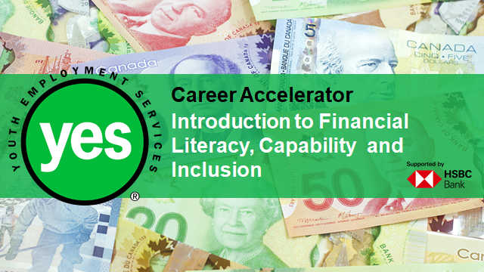 | Timing: 10 minutes prior to official class start time  Interaction Pattern: Whole class  Method: Music (optional)  Procedures and Notes:  Display the slide as the participants join the session. Begin the online call 10 minutes before the official class start time, in case participants sign on early. You may also choose to play some relaxing music to create an inviting online environment.  Welcome participants as they join and troubleshoot any technical difficulties they may have.
Slide 2 | 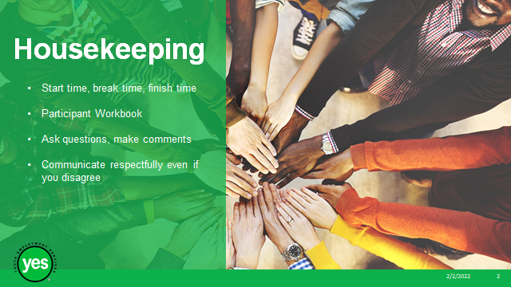 | Timing: 5 minutes  Interaction Pattern: Whole class  Method: Chat Box  Procedures and Notes:  Review all the housekeeping details indicated on the slide and any others you need to add. Encourage participants to post any questions using the Chat Box.  Class times – Review start time, break time, finish time, encourage participants to join the call early to be prepared, address any technical issues, project a professional image, address any questions about the class content, mention that questions about content can also be shared in a message between classes using Google Classroom and/or share contact information.  Participant Workbook – Direct participants to their Participant Workbooks. Indicate that this is their record of the key information in the workshop and ideas they generate during the workshop. It is also a resource they can come back to later as they prepare for real-life situations.  Virtual delivery - Participant workbooks should be left open in another tab so that participants can easily access them when they are asked to complete an activity.  Ask Questions/ Make Comments/ Communicate respectfully if you disagree - Review your expectations of the participants, such as active listening, sharing video, muting audio during presentations and mutual respect. Indicate that your role is to guide them through the material and facilitate discussion. You may ask the group to unmute or use the Chat box if they have anything to add to your list.
Slide 3 | 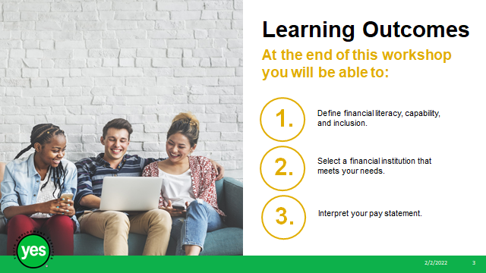 | Timing: 2 minutes  Interaction Pattern: Whole class  Materials Needed:  - Page 2 of the Participant Workbook  Method: Lecture  Procedures and Notes:  Review the learning outcomes of the workshop, stressing the practical knowledge and abilities that participants will walk away with.
Slide 4 | 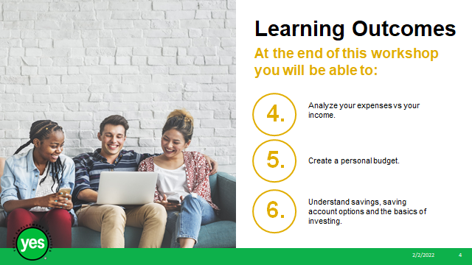 | Timing: 2 minutes  Interaction Pattern: Whole class  Materials Needed:  - Page 2 of the Participant Workbook  Method: Lecture  Procedures and Notes:  Continued.
Slide 5 | 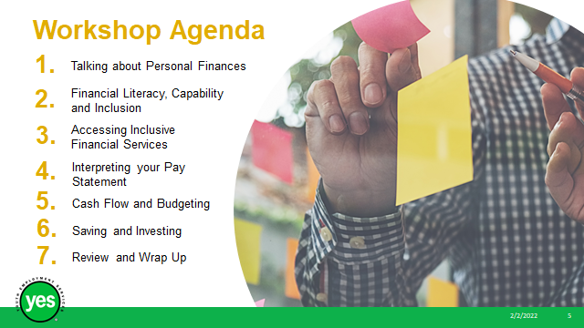 | Timing: 2 minutes  Interaction Pattern: Whole class  Materials Needed:  - Page 2 of the Participant Workbook  Method: Lecture  Procedures and Notes:  Review the agenda for the workshop.
Slide 6 |  | Timing: 10 minutes  Interaction Pattern: Whole class  Materials Needed:  - In person: 3 Printed Knowing Your Limits Activity signs: Panic, Challenge, Comfort  Method:  Virtual: Facilitated Discussion, Whole Group Activity, Unmute, Chat Box, Cameras on  In person: Facilitated Discussion, Whole Group Activity asking clients to stand in front of the sign that suits their comfort level  Procedures and Notes:  Share with the group:  For this Ice Breaker activity, I will be listing various everyday activities and asking that you gauge your feelings/level of comfort surrounding the activity. You will then be offered 3 choices and must choose only one:  1)Panic: Does this activity make you panic? Would you rather avoid it, or not do it at all?  2)Challenge: Do you find this activity challenging? It might be hard to motivate yourself to complete this activity, but you will still do it.  3) Comfort: This activity doesn’t cause you any additional stress. You would complete this activity, no problem.  For virtual delivery: Have clients turn on their cameras to participate in this activity. They will display their comfort level through their camera position. If their comfort level is Comfort: they will raise their hand with an open palm, for Challenge: they will raise their hand with a closed fist, and for Panic: they will raise both hands with open palms.  In person: You can print off and colour code signs with the words PANIC, Challenge! Comfort, on them, then place them in various corners of the room. Have the participants physically walk over to the sign that is applicable to the activity that you are on.  List the below activities, giving the participants a minute to determine their comfort level.  Activity 1: Going to the grocery store  Activity 2: Taking public transit  Activity 3: Visiting a crowded shopping centre  Activity 4: Visiting the dentist  Activity 5: Cleaning and doing chores  Activity 6: Writing an e-mail to someone important (potential employer, teacher, community leader)  Activity 7: Attending a new workout class  Activity 8: Talking about personal finances  Debrief the activity:  Ask participants to observe any trends they noticed specifically with activity 8. Chances are, many participants will be in the challenge or panic zone.  Share with participants:  It is totally normal for us to have different comfort levels with all of these everyday activities.  Our feelings towards the activities will be based on a variety of factors: our past experiences- whether they have been positive or negative, if we feel confident in our ability to complete the task, how important we feel that the activities are and sometimes just a matter of our own personal preference for performing the task at hand!
Slide  7 |  | Timing: 6 minutes  Interaction Pattern: Whole class  Materials Needed:  - Page 4 of the Participant Workbook  - 100 People Tell Us How Much Money They Make https://www.youtube.com/watch?v=a79PPZ_4abA&t=194s  (5:05 minutes)  Method: Video  Procedure and Notes:  Ask the group to describe which parts of the video stood out to them.  Share with the group:  Talking about finances is personal and can be a sensitive subject!  Everyone’s comfort level will be different, and everyone’s financial history and knowledge will be unique. The topics that we will cover today will help to prepare you for a healthy financial future.  If you have questions after this session, think of your network of support.  Have participants complete the individual activity listed on page 4 of the Participant Workbook.  Can you identify 2-3 trusted people in your life with whom you could discuss your finances? Do these people have the financial knowledge and tools to help guide you in the direction of the resources that you may need? It’s great to identify who those people are now, so that you can reach out to them when needed.  These trusted individuals can be family members, friends, community leaders, financial advisors, social workers, teachers, etc. These individuals may not all be experts, but they should be able to point you towards resources that can help you to enhance your financial knowledge.
Slide 8 | 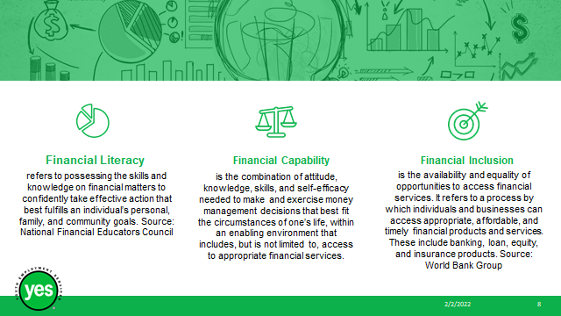 | Timing: 10 minutes  Interaction Pattern: Whole class/ Lecture  Materials Needed:  - Page 5 of the Participant Workbook  Method: Lecture, Unmute, Chat Box  Procedures and Notes:  Ask the group:  Does anyone know what financial literacy, financial capability, or financial inclusion mean? Let’s look at the definitions here:  Financial Literacy: refers to possessing the skills and knowledge on financial matters to confidently take effective action that best fulfills an individual’s personal, family, and community goals  Financial Capability: is the combination of attitude, knowledge, skills, and self-efficacy needed to make and exercise money management decisions that best fit the circumstances of one’s life, within an enabling environment that includes, but is not limited to, access to appropriate financial services.  Financial Inclusion: is the availability and equality of opportunities to access financial services. It refers to a process by which individuals and businesses can access appropriate, affordable, and timely financial products and services. These include banking, loan, equity, and insurance products.
Slide 9 | 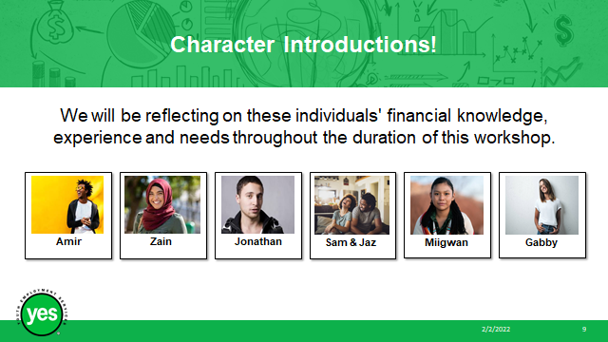 | Timing: 10 minutes  Interaction Pattern: Whole class  Materials Needed:  - Page 5/6 of the Participant Workbook  Method: Lecture, Unmute, Chat Box  Procedures and Notes:  Share with the group:  There are 6 characters that will be referenced throughout the duration of this workshop. I will be introducing them now.  These youth are demonstrating a need for support in enhancing their financial skills and accessing financial services.  Think about the type of support that these youth need. Do they need support with their financial literacy or capability? Could they benefit from accessing inclusive financial services?  Profile 1: Miigwan  Miigwan, a 19-year-old Indigenous youth, has enrolled for her first year of university and will begin her studies in September. Miigwan has worked a variety of cash jobs including babysitting her family and community member’s children and assisting small business owners at the local farmer’s market on the weekend during the summer months. Miigwan doesn’t hold an account at a financial institution yet and needs some help to find the best option for her unique circumstances. Miigwan has always been very responsible with her earnings, purchasing necessities and saving as much as she can. Miigwan would like to access a financial institution that can set her up with a chequing and savings account and potentially assist with a loan for her studies. Miigwan has received a partial scholarship for university but will still need a loan to cover the remainder of her tuition fees.  Profile 2: Gabby  Gabby is working a full-time job at Shoppers Drug Mart earning minimum wage. She lives with 3 roommates and struggles with her finances, often living paycheque to paycheque and struggling to pay her bills on time. Lately, she has started budgeting and realized that if she doesn’t order take out so regularly and packs her own lunch for work, she has about $200 left over at the end of the month. Although Gabby has made some progress through budgeting, she doesn’t feel confident about her financial knowledge and choices and avoids talking about finances with her network of support.  Profile 3: Sam and Jaz  Sam and Jaz are a couple that lives in a condo downtown. They feel very confident about their knowledge surrounding finances. They both earn livable wages and believe that they can find and secure appropriate financial services to meet their short-term and long-term goals.  Profile 4: Amir  Amir has recently completed his post-secondary education. He has secured a job in his field that is full-time. Amar has a chronic health condition and receives support from ODSP. Now that he has a full-time job, Amir would like to pay down his student debt and start saving or investing.  Profile 5: Zain  Zain is a newcomer that recently came to Canada 2 months ago. They currently receive income support from Ontario Works but are actively looking for full-time employment. Zain opened a bank account with the first bank that they found but now realizes that the account fees are very high.  Profile 6: Jonathan  Jonathan works a casual position as a General Labourer, typically working 16-30 hours a week but his shifts vary based on the employer’s needs. He had a full-time job with the city but was laid off during Covid-19. Jonathan has been falling behind on his bills. He’s using multiple credit cards to pay for his everyday expenses (groceries, gas, coffee). Jonathan is in overdraft at his current bank, so he has been using Pay Day Loan lenders regularly.
Slide 10 | 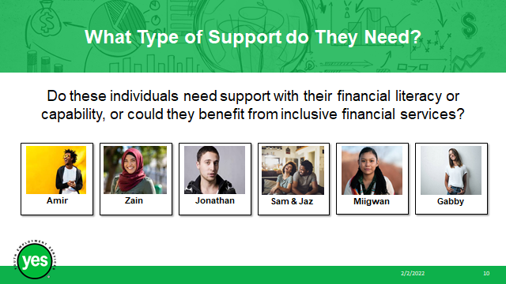 | Timing: 5 minutes  Interaction Pattern: Pairs/ Whole Class  Materials Needed:  - Page 5/6 of the Participant Workbook  Method: Breakout rooms, Unmute, Chat box  - Procedures and Notes:  - Assign the group partners and place them into breakout rooms.  Ask the pairs to identify if the individuals listed need support with their financial literacy or capability, or if they could benefit from accessing inclusive financial services.  Circle all that are appropriate using the chart on page 6 and take up the activity as a full class.
Slide11 | 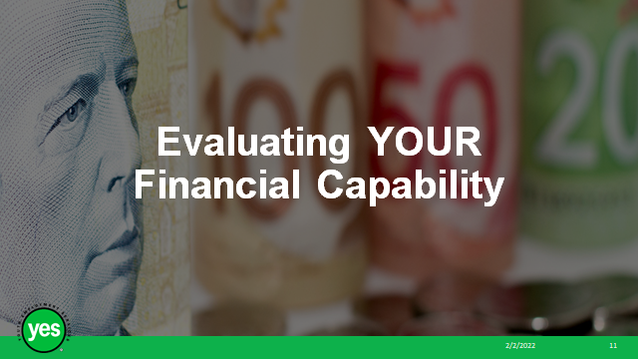 | Timing: 5 minutes  Interaction Pattern: Individual  Materials Needed:  - Page 7/8 of the Participant Workbook  Method: Personal Reflection  Procedures and Notes:  Share with the group:  Now that we have evaluated our characters: Miigwan, Jonathan, Sam & Jaz, Gabby, Amir and Zain and we are familiar with what it means to be financially capable, it’s time to reflect on our own financial decisions.  Ask participants to complete the independent reflection activity on page 7 and 8 of the participant workbook.  Encourage participants to be honest with their answers, and reassure them that this is an independent activity and the results will not be shared.  Debrief the activity: This activity was not to worry you, but rather to encourage you to reflect upon your own financial decision-making and to look for opportunities to expand your knowledge and abilities (like you are doing in this workshop!)
Slide 12 | 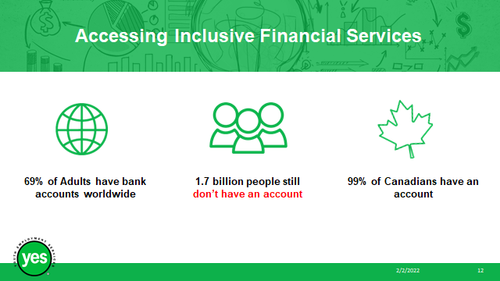 | Timing: 7 minutes  Interaction Pattern: Whole Class  Materials Needed:  - Page 8/9 of the Participant Workbook  Method: Lecture  Procedures and Notes:  Share with the group:  Since 2011, great strides have been made toward financial inclusion and 1.2 billion adults worldwide have obtained access to a bank account. Today, 69% of adults worldwide have an account.  Globally, close to one-third of adults – 1.7 billion – do not have a bank account, or financial institution according to the latest Findex data.  About half of individuals that do not have a bank account include groups such as women, households living below the poverty line, people in rural areas, and individuals that are out of the workforce.  Canada has one of the most accessible banking systems in the world - more than 99% of Canadian Citizens have an account with a financial institution.  Most Canadian financial institutions offer accounts and services specifically tailored to the needs of marginalized communities such as newcomers, individuals with disabilities and Indigenous peoples to contribute to and encourage their financial success.  3.1 How to Find and Access Inclusive Financial Opportunities  Do your research!  Most Canadian Financial Institutions offer various diversity initiatives and accounts and services that are unique to your needs.  Check out the Canadian Bankers Association Website: www.cba.ca  Here you can find information such as:  - Which banks provide banking, borrowing and investment services for BIPOC businesses, governments, and families.  - How specific financial institutions are supporting these communities: individuals with disabilities, newcomers, refugees, students, and young parents.
Slide 13 | 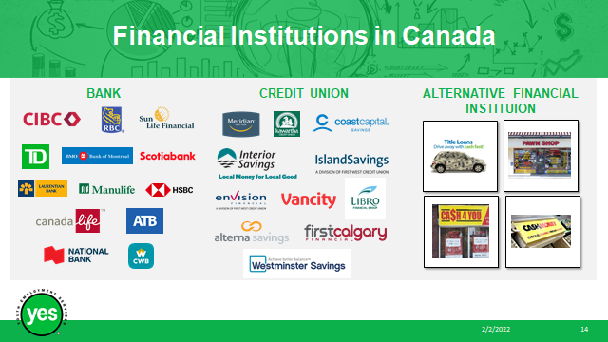 | Timing: 3 minutes  Interaction Pattern: Whole class  Materials Needed:  - Page 10 of the Participant Workbook  Method: Lecture/ Whole Group Discussion  Procedures and Notes:  Share with the group:  Did you know that there are 3 different types of financial institutions accessible to Canadians? In addition to traditional banking institutions (ex. the big six), we can also access financial services and products through credit unions and alternative financial services.  Let’s take a look at the difference:  Traditional banking institutions are financial institutions that are licensed to receive deposits and make loans. Banks are regulated by the federal government. They provide a safe place to store your money. Banks are profit-making financial institutions. (ie. CIBC, HSBC, RBC, TD Canada Trust, BMO, Scotiabank etc.)  A credit union is a type of financial institution that is like a bank, however, it is a member-owned financial cooperative, controlled by its members and operated on a not-for-profit basis. Their goal is to serve their members, not make a profit.  Alternative financial institutions provide consumers with financial products that are typically not offered within the traditional banking system. The services may be similar to those provided by banks but made accessible quicker and with higher fees. Services offered could be payday loans, rent-to-own agreements, pawnshops, car title loans and money orders.  Group Discussion:  How many people have a bank account or an account open with another financial institution?  When did you open it?  Are you satisfied with your experience so far?  Are you still with the same financial institution that you started out with? Why, or why not?
Slide 14 | 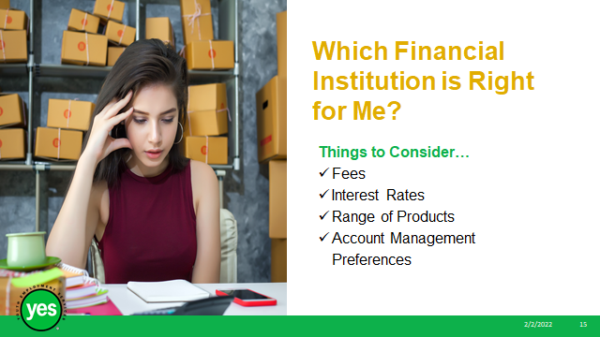 | Timing: 3 minutes  Interaction Pattern: Whole class  Materials Needed:  - Page 4 of the Participant Workbook  Method: Lecture, Unmute, Chat Box  Procedures and Notes:  Share with the group:  If you’re looking to open a bank account/ account with a financial institution, here are some things that you should keep in mind:  - Fees  - Interest Rates  - Range of Products  - Account Management Preferences  Fees:  - Monthly account fees and basic transaction fees can quietly eat away at your earnings  - When deciding on a bank product keep an eye out for policies that allow you to bypass the fees, like maintain a reasonable account balance or product bundles  - If the bank makes it virtually impossible to avoid the fees or if your financial circumstance won’t allow you to meet the requirements to waive them, consider other competitors, typically branchless banks can have fewer fees.  Interest Rates:  - The gap between the savings account interest rates offered by direct/virtual banks vs. traditional banks can be shocking.  - Virtual banks also have their drawbacks, but if your top priority is generating the maximum amount of interest on your savings, going virtual could be a great option.  Range of Products:  - The products, or accounts that you choose are going to vary depending on your own unique financial needs.  - Brick-and-mortar banks that have many branches available in person typically have a large suite of products and services, however, direct/virtual banks often have lower fees and better interest rates.  - Some individuals may find the best rates/deals and products by holding different accounts with various banks  - If you don’t mind having your savings account with one bank, your credit card with another, and opening your chequing account with another, this may be the right choice for you  Account Management Preferences:  - Things to consider: How often do you currently handle your banking needs in a branch vs. online? If face-to-face interactions and meetings with a banker are preferable for you, switching to a branchless bank might not be worth the savings you’ll get in reduced/eliminated fees and better interest rates  - If you can’t remember the last time that you were inside a physical bank branch, then you might as well benefit from the perks of direct banking.
Slide 15 | 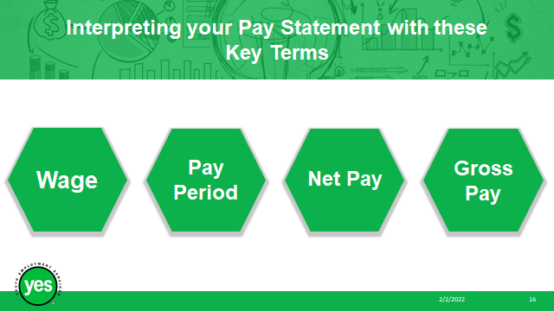 | Timing: 3 minutes  Interaction Pattern: Whole class  Materials Needed:  - Page 12 of the Participant Workbook  Method: Lecture, Group Discussion, Unmute, Chat Box  Procedures and Notes:  Share with the group:  Now that we have some foundational knowledge about personal finances, banking in Canada and our personal banking needs, it is important to understand key concepts associated with employment income.  Although some employers may still provide you with a physical copy of your pay statement, most are utilizing online platforms.  Employers are legally obligated to provide you with a pay statement whether it is digital, or a physical copy. The secure online platforms will manage your pay statements and your tax forms and make it easy to keep these documents safe and organized when you need to access them. Examples of online platforms are ADP, sage.com  Group Discussion: Pay Statement Key Terms  Does anyone know what these key terms mean?  Wage: money that is paid by the employer to an employee in exchange for work  Pay period: a recurring period during which an employee’s time is recorded and paid. The pay period could be weekly, bi-weekly, semimonthly or monthly.  Gross pay, or gross income: the amount of money earned before taxes, benefits and other payroll deductions are withheld from their wages.  Net pay: the amount of money remaining after deductions. This is sometimes referred to as your “take-home pay”.
Slide 16 | 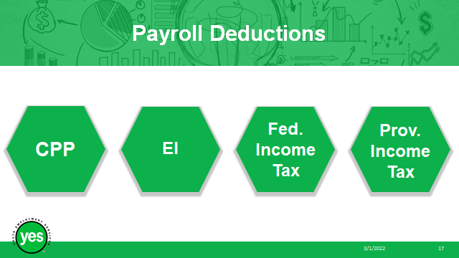 | Timing: 3 minutes  Interaction Pattern: Whole class  Materials Needed:  - Page 12 of the Participant Workbook  Method: Lecture  Procedures and Notes:  Share with the group:  As a working Canadian, you are subject to mandatory payroll deductions such as CPP, EI and income tax.  CPP (Canada Pension Plan):  CPP is a monthly taxable benefit that replaces part of our income when we retire.  CPP is deducted from your paycheque at a rate of 5.70% (2022) up to a maximum contribution of $3,499.80 (2022) per year.  EI (Employment Insurance):  The Employment Insurance (EI) program provides temporary income support to unemployed workers while they look for employment or to upgrade their skills.  EI is deducted from your paycheque at a rate of 1.58% (2022) up to a maximum of $952.74 (2022) per year.  Once you have reached the maximum contributions, your employer should stop deducting CPP and EI. If you over-pay, the money will be returned to you when you do your taxes.  Income tax:  You will pay taxes on your income at both the federal level and the provincial/territorial level.  In Canada, the tax system is progressive or graduated, meaning the more money you make, the more income taxes you pay.  Your employer will deduct income tax all year round based on what they think your income for the year will be. This amount will be assessed by Canada Revenue Agency when you file your taxes and you may get money back or need to make an additional payment.
Slide 17 | 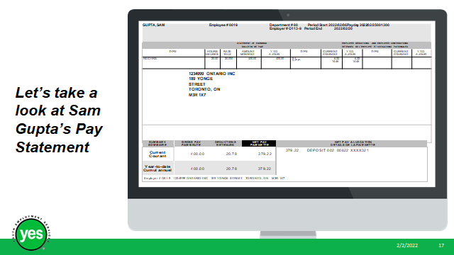 | Timing: 2 minutes  Interaction Pattern: Whole Group/ Facilitated Discussion  Materials Needed:  - Page 12 of the Participant Workbook  - Sam Gupta’s Pay Statement  Method: Lecture, Chat, Unmute  Procedures and Notes:  Ask the group:  What should your pay statement include?  - the pay period for which the wages are being paid;  - the wage rate, if there is one;  - the gross amount of wages and – unless the employee is given the information in some other manner (such as in an employment contract) – how the gross wages were calculated;  - the amount and purpose of each deduction, such as CPP and EI.  - any amounts that were paid in respect of room or board;  - the net amount of wages
Slide 18 | 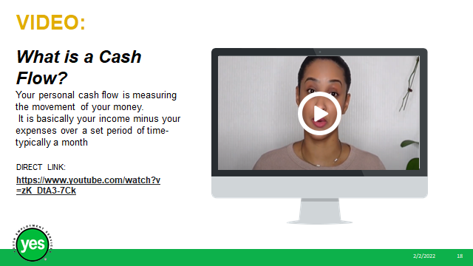 | Timing: 18 minutes  Interaction Pattern: Whole class, Individual  Materials Needed:  - Page 14 & 28 of the Participant Workbook  Method: Video, Chat, Unmute, Discussion, Personal Reflection  Procedures and Notes:  Screen the video: https://www.youtube.com/watch?v=zK_DtA3-7Ck (6:43 minutes)  Ask the group:  What is a personal cash flow statement? And why do you need one?  What from the video stood out to you?  Personal Reflection Activity:  Direct the participants to the Cash Flow Activity in the Personal Finance Portfolio on page 21-22 of the participant workbook. Provide them with 10 minutes to complete this activity.
Slide 19 | 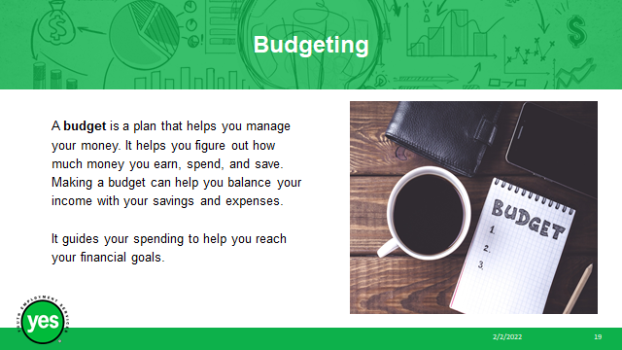 | Timing: 5 minutes  Interaction Pattern: Whole class  Materials Needed:  - Page 14/23 of the Participant Workbook  - Virtual Delivery: Whiteboard  - In person delivery: Smartboard/Whiteboard/Easel Pad of paper & marker  Method: Whole Group, Whiteboard, Unmute, Chat box  Procedures and Notes:  Share with the group:  Next, we will be taking a closer look at budgeting. There are many helpful tools that can assist with budgeting, apps, spreadsheets, apps from your own banking institutions that can help you to manage your money and cash flow. Some examples of other free apps include Mint, Wally, KOHO.  Instruct the participants that you would like to hear from them now, encourage them to brainstorm together about the importance of budgeting and how it can help us.  WHITEBOARD ACTIVITY: Why is budgeting important? How can it help you?  A budget is especially important if you:  - feel overwhelmed by the state of your finances  - feel like you’re not in control of your money, or aren’t sure where it is going  - don't save regularly  - have problems paying off your debts  - want to make the most of your money  - are planning for a major purchase or a life event  Making a budget can help you:  - reduce stress  - set spending limits  - find ways to pay down your debts  - reduce costs and save more  - live within your means  - have more money for things that are important to you  - feel more confident and in control of your money  Budgeting will help you to track and manage your money and take note of what you spend.  If you track everything that you spend for a few months, it will become clear where you can save money.  A key example of this would be, if you spend $3.00 on coffee every day, that alone will cost you almost $1100.00/ year, or more than $90.00/ month.  Ask participants to complete personal finance portfolio budgeting self-reflection activity 1 on page 23 of their participant workbook.
Slide 20 | 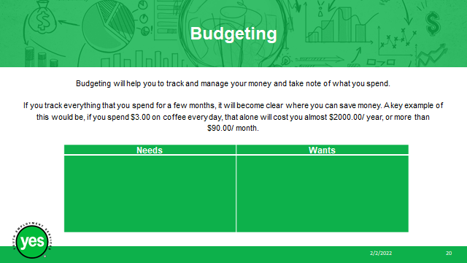 | Timing: 10 minutes  Interaction Pattern: Whole class, small groups, individual  Materials Needed:  - Page 14/15 of the Participant Workbook  - Page 23-24 of the Participant Workbook  Method: Lecture, Breakout Rooms  Procedures and Notes:  Review the definition with the group.  Small Group Activity:  NEEDS VS. WANTS  During this activity, your group will be provided with a list of expenses and asked to place them into the appropriate category.  There are two options. If an item is a “need” it is an essential necessity, if it is a want, it is “nice to have” but classifies as an optional expense, or a luxury item.  Divide the group into small groups and place in breakout rooms. Provide them with 7 minutes to complete the activity.  Debrief the activity: Did your group agree on how to divide the items? Were there any items that could be classified as both a need and want?  Individual Activity: If you have the time, ask the group to complete the Budgeting Self Reflection Activity 2 found in Part 2 of their Personal Finance Portfolio (page 23-24).  Alternatively, share that this activity is useful for them to complete at a later time.
Slide 21 |  | Timing: 6 minutes  Interaction Pattern: Whole class  Materials Needed:  - Page 15 of the Participant Workbook  - 100 People Reveal How Much Money They Have Saved https://www.youtube.com/watch?v=Fqyxp-4TMZA&t=27s  (4:21 minutes)  Method: Video, Unmute, Chat Box, Facilitated Discussion  Procedures and Notes:  Screen the video: 100 people reveal how much money they have saved.  Ask the group to share what parts of the video stood out to them.
Slide 22 | 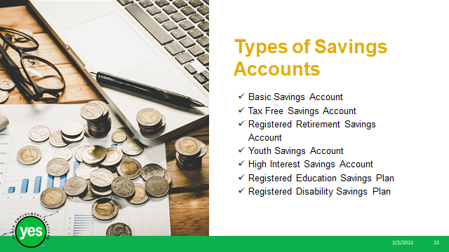 | Timing: 10 minutes  Interaction Pattern: Whole Class  Materials Needed:  - Page 16 of the Participant Workbook  - Glossary of Terms  Method: Lecture, Unmute, Chat  Procedures and Notes:  Share with the group:  Saving is an important part of investing in your financial future and is going to look a bit different for everyone. Whether you have short- or long-term savings goals (or both), the ‘pay yourself first’ method is the single best way to start saving money.  The ‘pay yourself first’ method refers to putting an amount of money aside from each paycheque right away. You could consider this amount to be a fixed expense and budget for the rest of your expenses out of the remaining amount.  Whether you are using the pay yourself first method or another method of saving, it is best to have this money out of sight and out of mind so that you are less tempted to spend it.  You could consider opening one of eight types of savings accounts in Canada to keep your money safe, and possibly start earning some interest.  Types of Savings Accounts in Canada  Basic Savings Account  - A basic, entry-level savings account is very similar to a chequing account but designed as a place to store your money long-term and accumulate a small amount of interest.  Tax-Free Savings Account (TFSA)  - A Tax-Free Savings Account (TFSA) is a registered savings account that can be used for any savings goal and allows for tax-free gains  - Any amount contributed and any income earned in the account (i.e. investment income) is typically tax-free, even when it is withdrawn.  - Unlike an RRSP, you can withdraw from a TFSA at any time without penalty.  Youth Savings Account  - Youth savings accounts are accounts that are offered to Canadian residents under the age of 18 and usually have very few – if any – monthly fees or limitations on transactions.  - A youth savings account will usually provide a high or unlimited number of transactions and require no minimum balance. A youth savings account is an excellent tool to teach children the importance of saving.  High-Interest Savings Account (HISA)  - High-interest savings accounts in Canada typically have no minimum deposit requirement.  - These accounts are very similar to regular savings accounts, but with higher interest rates and more restrictions around withdrawals and minimum balance. They must also be registered with the Canada Revenue Agency.  Registered Retirement Savings Plan (RRSP)  - A Registered Retirement Savings Plan (RRSP) is a savings plan created by the Federal government to help Canadians save for retirement  - The main benefit of RRSPs is that tax on contributions is put off until retirement when income is generally lower.  - RRSPs are tax-deferred, which means that any money you contribute now will be exempt from this year’s taxes and instead will be taxed when you withdraw it.  - Contributing to your RRSPs is a great way to lower your current tax bill and save for retirement  - Under the Homebuyers Plan and Lifelong Learning Plan, you can withdraw money up to a certain limit to finance your home purchase and to finance training or education.  Registered Education Savings Plan (RESP)  - A Registered Education Savings Plan (RESP) is a special savings plan introduced to help people save for children or grandchildren’s post-secondary education  - The Canadian government also has the Canada Education Savings Grant, a program that matches 20% of any RESP contributions to a maximum of $500 per child per year.  - Unlike RRSPs, a deposit into an RESP will not provide you with an immediate tax break. If the funds are in the account, however, capital gains within the account are not subject to taxes.  - When the funds are withdrawn to be used for an approved education expense, which includes tuition, housing, books, or even living expenses, the withdrawals are taxed in the hands of the student, the beneficiary.  Registered Disability Savings Plan (RDSP)  - Registered Disability Savings Plans (RDSPs) let you put money into a registered account to support a person with a disability  - When this person needs funds, they can withdraw the savings and any earnings they have produced  - Like RESPs, an RDSP is also eligible for grants from the Government of Canada and contributions are not tax-free  - You can withdraw funds from an RDSP tax-free, but you will have to pay taxes on any income the RDSP earns and return any government grants.  Share that these definitions can seem overwhelming as it is a lot to remember. Remind participants that they can refer back to these definitions and the Glossary of Terms at a later time to determine which method of saving is the best fit for them.
Slide 23 |  | Timing: 3 minutes  Interaction Pattern: Whole class  Materials Needed:  - When it’s Time to Stop Saving and Start Investing https://www.youtube.com/watch?v=AL9zx1aU1SI (2:08 minutes)  Method: Video  Procedures and Notes:  Screen the video: When it’s Time to Stop Saving and Start Investing.  Share with the group:  It can be difficult to know when is a good time to stop saving and start investing.  Saving is the safer route because the dollar amount in your bank account won’t typically decrease unless you withdraw funds.  Unfortunately, the value of your investments won’t always go up. In some cases, investments can become completely worthless.  Investing in things such as Bitcoin and other Cryptocurrencies may be trending, however it is best to stick with the safer route until you have minimal debt and have created an emergency savings fund with some additional leisure money. Investment gains are not a reliable source of income.
Slide 24 |  | Timing: 5 minutes  Interaction Pattern: Whole class, Individual  Materials Needed:  - Page 31/32 of the Participant Workbook  Method: Personal Reflection  Procedures and Notes:  Share with the group:  A financial roadmap is a simple visual guide to help you remember your financial priorities and long-term goals. It's designed to help you maximize your money by prioritizing short-term goals with longer-term goals in mind.  Using the SMART method of goal setting can help you stay on track. SMART goals are:  S – specific  M - measurable  A – achievable  R – realistic  T – time framed  Can anyone give me an example of a financial goal that meets the SMART criteria?  For this next activity, please go to page 30 and 31 of the participant workbook and write out your short-term and long-term goals utilizing the SMART GOAL method. You can then write them out using sentences, or draw them out using pictures.  Encourage participants to share their personal financial SMART goals with the group if they feel comfortable doing so.
Slide 25 |  | Timing: 2 minutes  Interaction Pattern: Whole class, Individual  Materials Needed:  - Page 20 of the Participant Workbook  Method: Personal Reflection  Procedures and Notes:  Share with the group:  Based on what you have learned today, think about whether you are currently making the most of your money in the financial institution that you currently have an account with.  Could you open a better account with fewer fees? Should you open a savings account?  Take some time to research your options and determine if you could benefit from making some changes to your accounts, or your financial institution of choice.  Ask participants to complete the final self-reflection on page 9 of the participant workbook.
Slide 26 |  | Timing: 2 minutes  Interaction Pattern: Whole class  Materials Needed:  - None  Method: Group Discussion  Procedures and Notes:  Encourage participants to ask any final questions or share any final thoughts related to today’s workshop or financial literacy, inclusion and capability.

