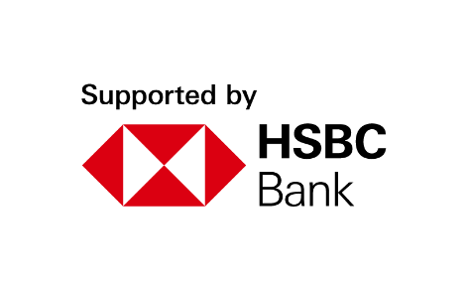
Youth Employment Services YES
www.yes.on.ca
CAREER ACCELERATOR: FINANCIAL MANAGEMENT FOR YOUNG ADULTS
Facilitator’s Guide
Financial Management for Young Adults

Overview and Purpose

This workshop provides critical information that will assist participants in understanding how to complete sometimes mundane but necessary tasks for becoming a financially responsible young adult. The concepts included are using, building, and interpreting credit; debt, debt repayment, consolidation, and bankruptcy; personal income taxes and lastly, online security and preventative measures that participants can take to avoid fraud with their finances. It is recommended that participants complete ‘An Introduction to Financial Literacy, Capability and Inclusion’ to build foundational knowledge related to the key concepts discussed in this module.

Time

The workshop is between two to three hours long. All timings provided in the Facilitator’s Guide are approximate. Note that the timings for the slides don’t add up exactly to two or three hours, because some of the activities can be extended or shortened. You can lengthen, shorten or leave out activities based upon the needs of your participants and the amount of time you have for the workshop. You should have short breaks at least every 60 minutes.

Learning Outcomes

At the end of this workshop, you will have the tips and resources to be able to:

- Comprehend credit: different types, how to apply for credit and to understand your credit score.
- Understand debt: know your options, including repayment, consolidation, and bankruptcy.
- Track personal documents needed to file your income taxes.
- File your income taxes.
- Optimize your online security and prevent fraud.

Leading Questions

As participants complete this workshop, some of the questions they will think about include:

- How can using credit contribute to long- and short-term financial goals?
- What are the benefits of having good credit? How can having bad credit hold you back?
- Is all debt bad? What is the difference between good and bad debt?
- What are some ways the government helps low-income people during tax season?
- What are some common online fraud schemes? How can you avoid them?

Workshop Agenda

- Introduction to Module
- What is Credit?
- Understanding Debt
- Filing Income Taxes
- Online Security and Fraud Prevention
- Final Questions

Materials Needed

- Computer and internet connectivity
- Each participant should have a hardcopy of the Participant Workbook
- Each participant needs a device for connecting online (cell phone, tablet, computer)
- PPT Presentation Financial Management for Young Adults
- Activity material – In person Delivery- Red, Yellow, Green signs for “Interpreting Credit Scores” Activity.

Formative Assessment

The ‘What do you Need to Prepare for Tax Season?’ Self-Reflection exercise in the Participant Workbook constitutes the formative assessment for this module. This activity consists of asking participants to evaluate their readiness for filing their personal taxes, and to prepare for tax season.

Detailed Workshop Plan

Workshop Preparation –
- In person delivery: Interpreting Credit Scores RED, YELLOW, GREEN signs printed prior to workshop
- Virtual/ In person: Internet browser open to CRA website for virtual tour: https://www.canada.ca/en/services/taxes/income-tax/personal-income-tax/get-ready-taxes.htm

- Virtual delivery: Prepare poll: Who is more likely to experience online scams? Older people, or young adults?

Slide 1 | 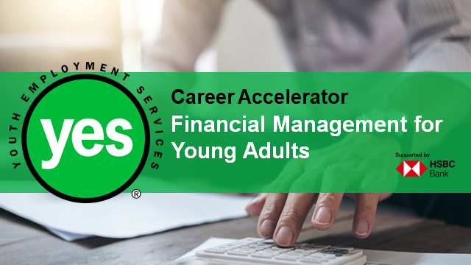 | Timing: 10 minutes prior to official class start time  Interaction Pattern: Whole class  Method: Music (optional)  Procedures and Notes:  Display the slide as the participants join the session. Begin the online call 10 minutes before the official class start time, in case participants sign on early. You may also choose to play some relaxing music to create an inviting online environment.  Welcome people as they join and troubleshoot any technical difficulties they may have.
Slide 2 | 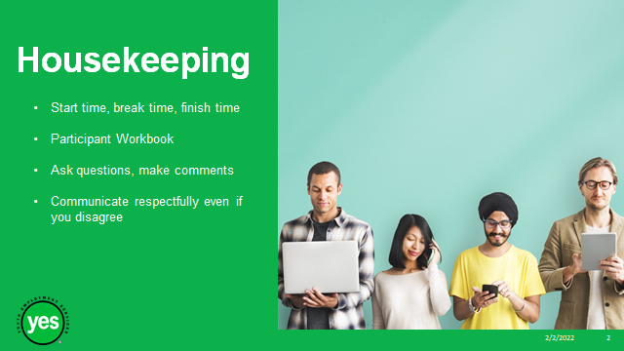 | Timing: 5 minutes  Interaction Pattern: Whole class  Method: Chat Box  Procedures and Notes:  Review all the housekeeping details indicated on the slide and any others you need to add. Encourage participants to post any questions using Chat Box.  Class times – Review start time, break time, finish time, encourage participants to join the call early to be prepared, address any technical issues, project a professional image, address any questions about the class content, mention that questions about content can also be shared in a message between classes using Google Classroom and/or share contact information.  Participant Workbook – Direct participants to their Participant Workbooks. Indicate that this is their record of the key information in the workshop and ideas they generate during the workshop. It is also a resource they can come back to later as they prepare for real-life situations.  If facilitating virtually, Participant Workbooks should be left open in another tab so that participants can easily access them when they are asked to complete an activity.  Ask Questions/ Make Comments/ Communicate respectfully if you disagree- Review your expectations for the participants, such as active listening, sharing video, muting audio during presentations and mutual respect. Indicate that your role is to guide them through the material and facilitate discussion. You may ask the group to unmute or use the chat box if they have anything to add to your list.
Slide 3 | 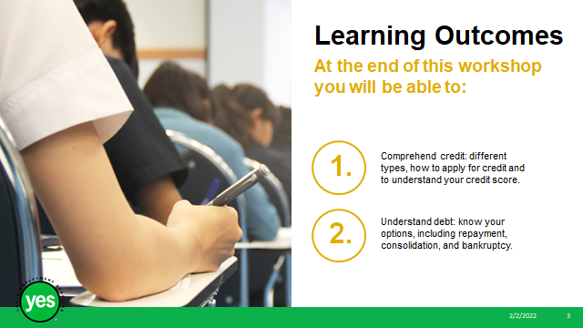 | Timing: 2 minutes  Interaction Pattern: Whole class  Materials Needed:  - Page 1 of the Participant Workbook  Method: Lecture  Procedures and Notes:  Review the learning outcomes of the workshop, stressing the practical knowledge and abilities that participants will walk away with.  Continued on next slide.
Slide 4 | 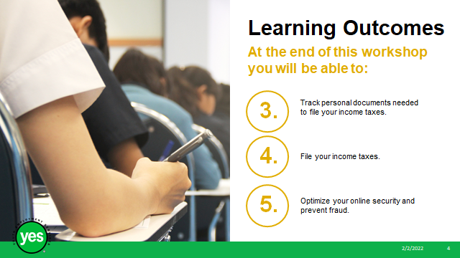 | Timing: 2 minutes  Interaction Pattern: Whole class  Materials Needed:  - Page 1 of the Participant Workbook  Method: Lecture  Procedures and Notes:  Continued from pervious slide.
Slide 5 | 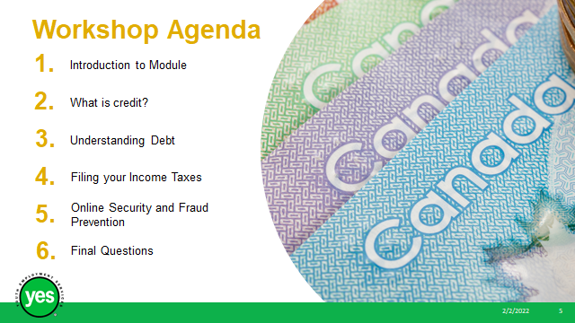 | Timing: 1 minute  Interaction Pattern: Whole class  Materials Needed:  - Page 2 of the Participant Workbook  Method: Lecture  Procedures and Notes:  Review the agenda for the workshop.
Slide 6 |  | Timing: 5 minutes  Interaction Pattern: Whole class  Materials Needed:  - Page 4 of the Participant Workbook  Method: Facilitated Discussion, Unmute, Chat Box  Procedures and Notes:  Ask the group:  Who knows what “adulting” means or can define it?  Read the adulting definition.  Today, we will cover tasks such as applying for credit and maintaining a good credit score, dealing with debt, collecting tax documents, and filing personal taxes, as well as ensuring your financial data is secure to protect yourself against fraud.  While these tasks may sound dull, tedious, and maybe even unexciting, they are an essential part of adulting and feeling confident in this extremely important area of your life.  Can you think of any other tasks that are essential in order to be a responsible young adult?
Slide  7 | 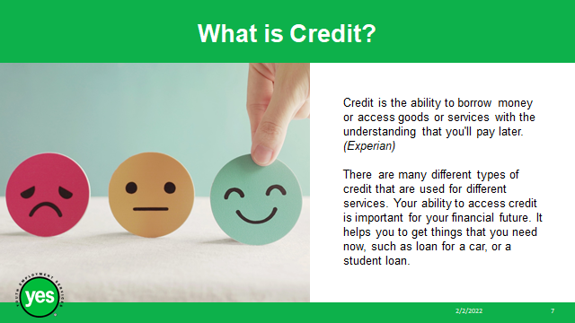 | Timing: 5 minutes  Interaction Pattern: Whole class  Materials Needed:  - Page 3 of the Participant Workbook  Method: Facilitated Discussion, Unmute, Chat Box  Procedures and Notes:  Read the definition.  Ask the group: What does credit mean to you?  Have you accessed credit before? Why?  What are some different forms of credit?
Slide 8 | 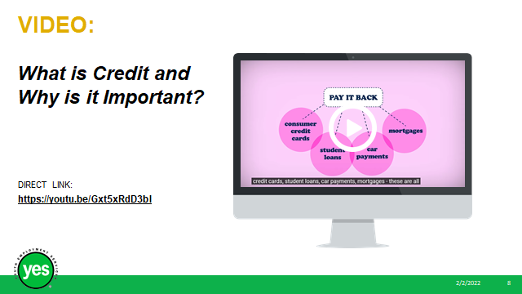 | Timing: 4 Minutes  Method: Video, Chat box, Unmute, Discussion  Materials Needed:  - Page 4 of the Participant Workbook  Procedure and Notes:  Screen the video: What is credit and why is it important? https://youtu.be/Gxt5xRdD3bI (2:48 minutes)  Ask the group to share what parts of the video stood out to them.
Slide 9 | 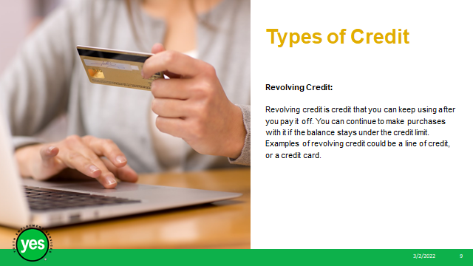 | Timing: 10 minutes  Interaction Pattern: Whole class  Materials Needed:  - Page 5-6 of the Participant Workbook  Method: Lecture, Facilitated Discussion, Unmute, Chat Box  Procedures and Notes:  There are many different credit products available to young people. The two most common types of credit are revolving credit and installment loans.  Revolving credit is credit that you can keep using after you pay it off. You can continue to make purchases with it if the balance stays under the credit limit. Examples of revolving credit could be a line of credit, or a credit card.  Example:  Sam uses their credit card to pay for concert tickets online. They use their online banking app to pay the charge to the credit card right away, so they don’t get charged any interest.  Later that day they visit the campus bookstore and pick up a set of textbooks for their accounting course. Sam uses their credit card again to pay for the books and some groceries that they ordered for curbside pick-up. When they receive their pay cheque they pay off the entire balance on their card using their secured online banking app.
Slide 10 | 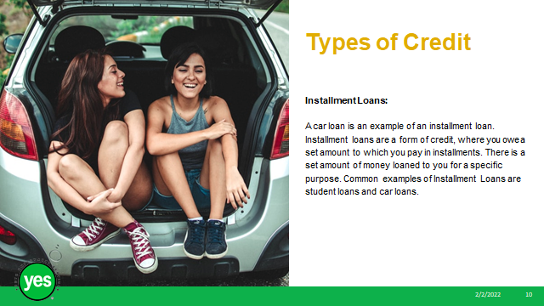 | Continued from previous slide  Installment loans are a form of credit, where you owe a set amount to which you pay in installments. There is a set amount of money loaned to you for a specific purpose. Common examples of Installment Loans are student loans and car loans.  Example:  Sam is financing a car. They are given a timeframe to pay for the car, 48 months, then asked to pay a certain amount per month for those 48 months until the car is paid off.
Slide 11 | 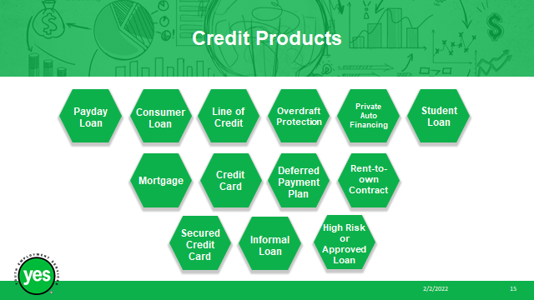 | Timing: 20 minutes  Interaction Pattern: Whole Class, Small Groups  Materials Needed:  - Pages 5-9 of the Participant Workbook  Method: Lecture, Breakout Rooms, Chat box, Unmute  Procedures and Notes:  Briefly explain the Forms of Credit, what they are and how they work.  Consumer Loan:  A lump-sum payment from a financial institution directly to you or a business where you are making a purchase.  Suitable for medium- and longer-term needs (ex. buying a car or education).  Line of Credit:  A type of pre-approved loan that allows you to borrow money when you need it, up to a maximum amount – like a credit card.  Overdraft Protection:  A service that financial institutions offer on chequing accounts, which allows you to access additional funds after the account reaches a $0 balance.  Private Auto Financing:  A loan for the purchase of a vehicle arranged through the car dealer's financing company.  Student Loan:  A loan provided by the government for education costs with a special rate and special repayment terms for students.  Sometimes guaranteed if you meet specific eligibility criteria.  Mortgage:  A type of loan used to buy a home or other property. Your home or property is the security or guarantee for the loan.  To be eligible for a mortgage, you must provide a significant down payment and meet other strict criteria.  Credit Card:  When you make a purchase, you borrow money from the credit card company (ex. Visa) to pay the vendor, and you must pay back the money you've borrowed by a due date.  If you do not pay the balance in full each month by the payment due date, you incur interest charges.  Deferred Payment Plan:  A purchase plan in which you can delay paying for a purchase for a specified time, usually by paying the amount in installments, with interest  Often offered by appliance and furniture stores.  Rent-to-own- Contract:  A type of loan in which you rent an item (usually furniture or appliances) for a defined period.  You have the option of purchasing the item by continuing to pay the rental fee over time or by paying a lump sum.  You do not own the item until the last installment of the loan is paid.  Payday Loan:  A short-term loan that you promise to pay back from your next paycheque.  Offered by payday loan companies and by most cheque-cashing outlets.  Secured Credit Card:  A card that requires you to provide the card issuer a security deposit before the card is issued  Your credit limit is normally set as a percentage of your deposit (usually 100% or more).  Informal Loan:  Money that you borrow from a family member, friend or other individual.  High Risk or Approved Loan:  A type of unsecured loan that you may apply for if you are turned down for a personal or other loan by a financial institution  Often used by people with poor credit for short-term emergency loans.  Request that the participants turn to PG 5-9 in the Participant Workbook.  Small Group Activity:  Each group will be assigned 4 Types of Credit from the chart found on pages 5-8. They will need to weigh the advantages and disadvantages, then choose one type of credit that makes sense for the assigned reason the group is seeking credit. I will provide each group with an assigned reason for seeking credit and the types of credit available to your group.  Group 1: Assigned Types of Credit 1-4: This person wants to purchase a car.  Group 2: Assigned Types of Credit 5-9: This person wants to purchase new furniture for their apartment.  Group 3: Assigned Types of Credit 10-13: This person wants a form of credit to use if they travel or for online purchases. They are good at saving but have never had a credit card before.  Once your group has chosen a form of credit, please research real examples of this form of credit and select one credit product and designate a note taker and a presenter.  After 10 minutes, I will ask your group to report back on the type of credit you chose and why and the fees associated with the form of credit they will be moving forward with (interest, APR, etc.)  Debrief the Activity: Have each group present their findings and rationale, sharing the reason their group was seeking credit, as well as the form of credit they chose.  Was it easy to agree and select a form of credit for their assigned reason? Why, or why not?
Slide 12 | 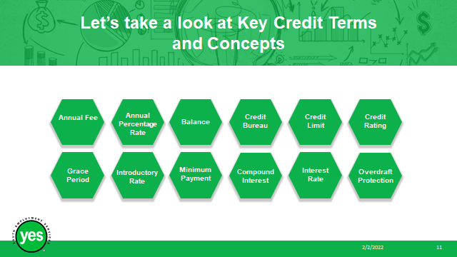 | Timing: 10 minutes  Interaction Pattern: Whole Group, Individual  Materials Needed:  - Page 10 of the Participant Workbook  Method: Lecture, Whole class, Individual Activity, Unmute, Chat box  - Procedures and Notes:  - Ask the group to complete the credit terms matching activity on page 10 of the participant workbook.  - Take up the activity with the group while providing the below expanded definitions and discussion.  - Grace Period: The period after a payment deadline when the borrower can pay back the borrowed money without adding interest or a late fee. Typically, the grace period is 21 days, although this will vary.  - Compound Interest: Compound interest occurs when interest gets added to the principal amount invested or borrowed, and then the interest rate applies to the new (larger) principal/balance owed on your card. It's essentially interest on interest, which over time leads to exponential growth. Some credit cards compound interest daily.  - Credit Bureau: A reporting agency that collects information on consumer credit usage. There are currently two main credit bureaus in Canada: Equifax, and TransUnion.  - Interest Rate: money paid regularly at a particular rate for the use of money lent, or for delaying the repayment of a debt. Example: If you take out a $300,000 mortgage from the bank and the loan agreement stipulates that the interest rate on the loan is 4%, this means that you will have to pay the bank the original loan amount of $300,000 + (4% x $300,000) = $300,000 + $12,000 = $312,000. All credit will come with an interest rate, these can range from 4% to 20 %. It is important to have a clear understanding of what that means.  - Minimum Payment: The minimum amount of money that you are required to pay on your credit card statement each month to keep the account in good standing. Sometimes the minimum payment will only be the interest on the balance that you owe, meaning that you if you’re only paying the minimum payment, you are not paying off any of the debt that you owe.  - Credit Limit: Is the absolute maximum amount of money that your lender will let you borrow while using your credit card or line of credit.  - Introductory Rate: An interest rate offered by credit card issuers in the initial stages of a loan. These rates are often set much lower than standard rates to attract new cardholders. Make sure you know how long the introductory rate will last and what the standard interest rate will be once the introductory period ends.  - Overdraft Protection: is a loan service provided by a bank that protects against nonsufficient funds, or NSF fees. If you spend more than what is in your account, overdraft protection covers that purchase. You would be charged a fee for this service.  - Annual Percentage Rate (APR): The yearly interest rate charged on outstanding credit card balances.  Additional terms not included in activity:  - Annual Fee: The cost of owning a credit card, this is a fee that you are charged once per year. Some credit card providers offer cards with no annual fees.  - Balance: An amount of money. In personal banking, balance refers to the amount of money in a savings or checking account. In credit, balance refers to the amount of money owed.  - Credit Rating: A financial institution's evaluation of an individual's ability to manage debt. It’s critical to have a good credit rating if you want to borrow money or apply for a credit card or loan.
Slide13 | 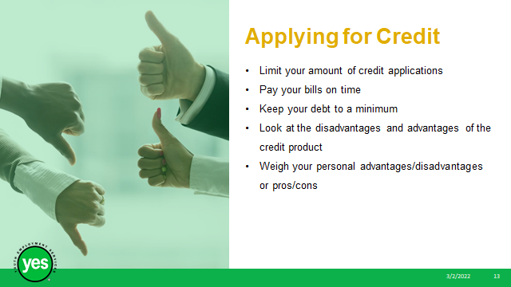 | Timing: 7 minutes  Interaction Pattern: Whole Class  Materials Needed:  - Page 11 of the Participant Workbook  - In person delivery: Smartboard/whiteboard Easel Pad of paper & marker  - Virtual delivery: Whiteboard  Method: Whole class, Whiteboard, Unmute, Chat  Procedures and Notes:  Share with the group:  As you can see, there are many different forms of credit products and each form of credit comes with its own unique advantages and disadvantages.  The Government of Canada advises to limit your number of credit applications or credit checks. Each time you apply for a credit card, the lender will perform a credit check.  If you have too many credit checks in your report, lenders may think that you are urgently seeking out credit, or that you are trying to live beyond your means.  Your ability to access credit will be dependent on your credit history, whether you have paid your bills on time, if you have a lot of debt already and if you have utilized credit in the past, among other factors.  It’s also important to weigh the personal pros and cons, or the advantages and disadvantages of the type of credit you are considering applying for.  What are some common advantages and disadvantages to consider?  Whiteboard Activity: Have the group brainstorm advantages & disadvantages of credit. Document their responses on the whiteboard, classifying whether it is an advantage, or a disadvantage.  Debrief the activity: Was it was easier to come up with advantages, or disadvantages?
Slide 14 | 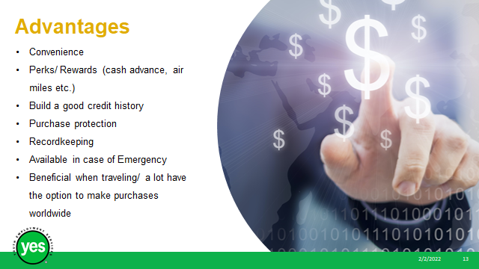 | Timing: 2 minutes  Interaction Pattern: Whole Class  Materials Needed:  - Page 11 of the Participant Workbook  Method: Lecture  Procedures and Notes:  Read the advantages of credit as shown on the slide.
Slide 15 | 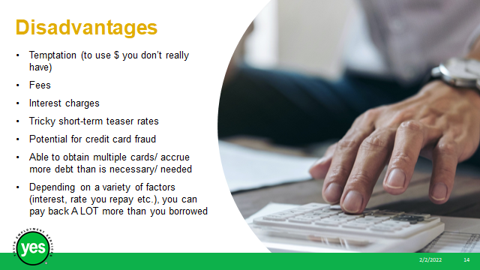 | Timing: 2 minutes  Interaction Pattern: Whole Class  Materials Needed:  - Page 11 of the Participant Workbook  Method: Lecture  Procedures and Notes:  Read the disadvantages of credit as shown on the slide.
Slide 16 | 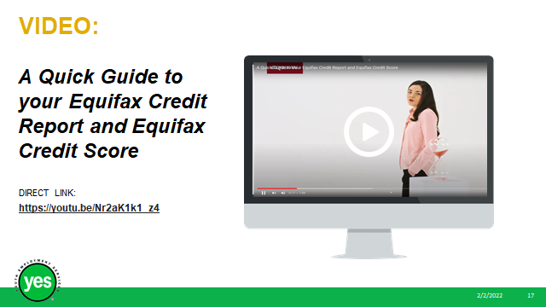 | Timing: 3 minutes  Interaction Pattern: Whole class  Materials Needed:  - Page 12 of the Participant Workbook  Method: Video, Unmute, Chat  Procedures and Notes:  Share with the group:  We are now going to watch a quick video to introduce us to the concept of credit reports and scores.  Screen the video: A Quick Guide to your Equifax Credit Report and Equifax Credit Score (1:58) https://youtu.be/Nr2aK1k1_z4
Slide 17 | 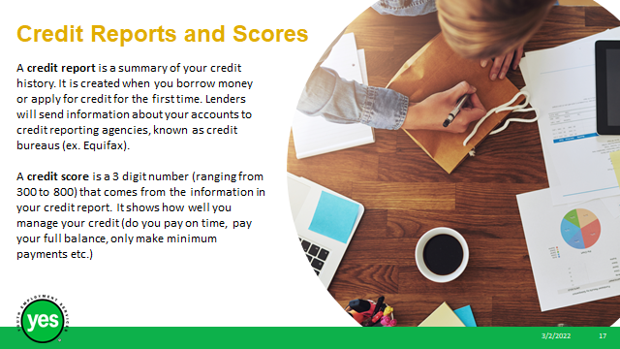 | Timing: 10 minutes  Interaction Pattern: Whole class  Materials Needed:  - Page 12 of the Participant Workbook  Method: Lecture  Procedures and Notes:  Share with the group:  A credit report is a summary of your credit history. It is created when you borrow money or apply for credit for the first time. Lenders will send information about your accounts to credit reporting agencies, known as credit bureaus (ex. Equifax).  A credit score is a 3 digit number (ranging from 300 to 800) that comes from the information in your credit report. It shows how well you manage your credit (do you pay on time, pay your full balance, only make minimum payments etc.) Your credit score will be calculated based off a formula used after looking at your credit report. You will gain points on your credit score if you are using credit responsibly. You will lose points if you have trouble managing your credit.  The two main credit bureaus in Canada are Equifax and TransUnion. You can order your credit report by mail, fax, phone, in person or online for free through either of these bureaus.
Slide 18 | 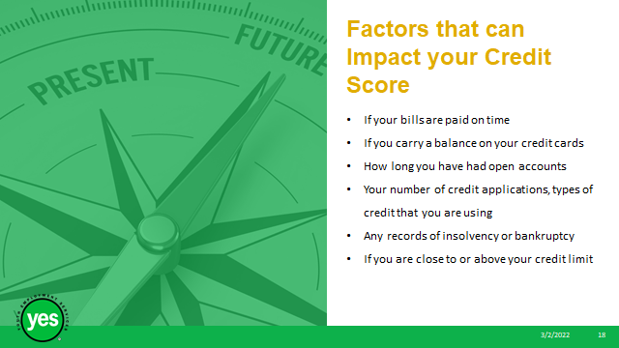 | Timing: 10 minutes  Interaction Pattern: Whole class  Materials Needed:  - Page 13 of the Participant Workbook  Method: Whole Group, Discussion, Unmute, Chat box  Procedures and Notes:  Share with the group:  Your credit report and can impact whether you are approved to rent an apartment/house, whether you can get a loan, some employers may even perform a credit check when they are looking to hire someone, so it can also affect your employability.  Ask the group:  If you are new to the world of credit, or if you haven’t had the best credit history, what are some ways that you can improve our credit?  How can you build your credit?  What bills can impact your credit score?  If we already have a loan, credit card or line of credit, what are some ways that you can prove yourself to be a responsible borrower?  Share with the group:  The bills that can impact your credit score are phone, internet, and utilities like water and electricity.  Other factors that can impact your credit score:  - If you carry a balance on your credit cards  - How long you have had your credit  - Your number of credit applications, types of credit that you are using  - Any records of insolvency or bankruptcy  - If you are close to or above your credit limit
Slide 19 | 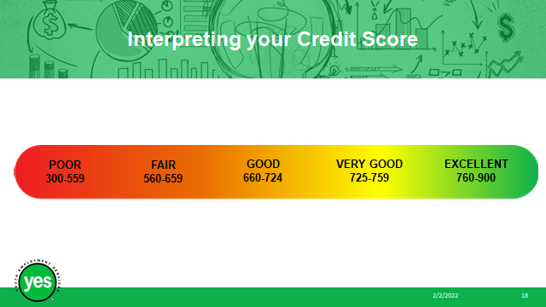 | Timing: 10 minutes  Interaction Pattern: Whole class/ Small Groups  Materials Needed:  - Page 13 of the Participant Workbook  Method: Lecture, Small Group Activity, Breakout Rooms, Unmute, Chat Box  Procedures and Notes:  Review the credit scores on the slide and what they mean.
Slide 20 | 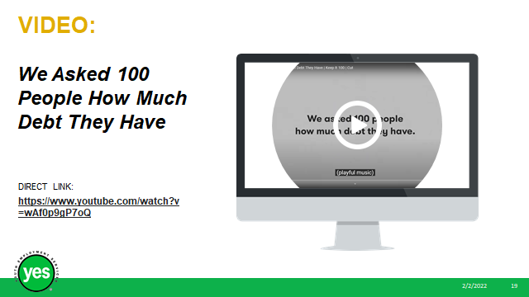 | Timing: 6 minutes  Interaction Pattern: Whole Group/ Facilitated Discussion  Materials Needed:  - Pages 13/14 of the Participant Workbook  Method: Lecture, Video, Chat, Unmute  Procedures and Notes:  Screen the video: 100 People Tell us How Much Debt They Have (5:01 minutes)  https://www.youtube.com/watch?v=wAf0p9gP7oQ  Ask the group to share what parts of the video stood out to them.  Share with the group: Often, people feel badly about the debt that they have, even feeling shame because of it.  It’s important to note that not all debt is bad. It is common to acquire debt to ultimately land us into a better financial situation for our future. I.e. paying for post-secondary education to obtain a higher earning career.  This is an investment in our future and should not be seen as negative. It is completely normal to have debt!  - A 2018 Statistics Canada study showed that only 23% of Canadians had received financial support from their families towards their post-secondary education.  - In 2020, 69.8% of Canadians had debt and the average Canadians debt was $73,500. The debts were most commonly student loans, credit cards, mortgages, and car loans.
Slide 21 | 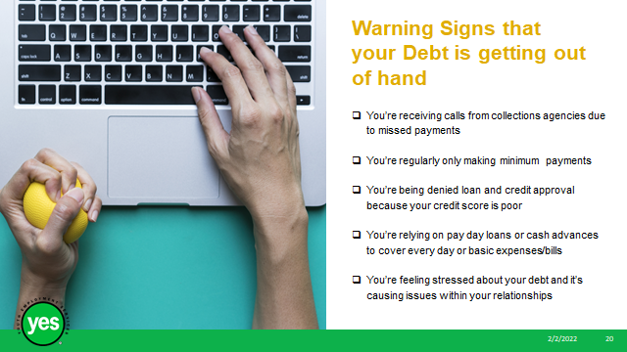 | Timing: 2 minutes  Interaction Pattern: Whole class  Materials Needed:  - Page 14 of the Participant Workbook  Method: Whole Group, Facilitated Discussion, Unmute, Chat  Procedures and Notes:  Encourage the group to brainstorm:  Can you think of some examples of warning signs that your debt might be getting out of hand?  Review the slide.
Slide 22 | 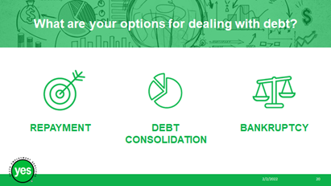 | Timing: 10 minutes  Interaction Pattern: Whole class, Individual  Materials Needed:  - Pages 14-16 of the Participant Workbook  Method: Lecture, Chat, Unmute, Discussion, Individual Activity  Procedures and Notes:  Ask: What are your options for dealing with debt?  Share with the group:  Repayment  The best option for your credit score would be to repay the debt. It’s a great idea to come up with a debt repayment plan. See how much total debt that you have, then plan a timeline for repaying that debt.  Tips for Debt Repayment:  - Think through your purchase/aim to spend less than you may want to spend (it’s easy to pile up debt due to our lifestyle choices) Ex. Purchasing a quality used car, rather than a new car could save you thousands of dollars.  - Pay more than the minimum payment.  - Set up an automatic payment so that you don’t have to worry about missing or late payments.  - Pay off your biggest/ most expensive debt first (If one of your cards has a very high interest rate, concentrate on paying down the balance of that card first, while still contributing at least the minimum payments on any other debts owed).  - Communicate with creditors. If you are unable to pay, or must pay late this month, notify your creditor.  Debt Consolidation  Debt consolidation is a form of debt refinancing. This could mean taking out one larger loan to pay off many other loans.  Pros:  - One simple monthly bill to pay  - Smaller payments overall  - A lower interest rate that means that more of your payment will go toward the principal (balance owed)  - Can improve credit score (although may hurt it to start, after you’re able to repay your debts it could improve your score)  Cons:  - Could come with added costs: additional fees (balance transfer, cancellation, annual fees)  - You may not be able to get the loan with a lower interest rate depending on your credit score, meaning that you could be paying the same, or more interest on the debt even though it is now combined  - Doesn’t solve underlying financial issues. This helps to make a lot of payments into just one payment, but doesn’t prevent you from spending and doesn’t automatically mean that your habits will change  Bankruptcy  Bankruptcy is not having enough money or assets to pay all debts. Bankruptcy is a legal proceeding involving a person or a business that is unable to pay their outstanding debts.  Filing for bankruptcy would impact: your credit score, your property (house, or, car), your spouse, someone that co-signed a loan, your student loans.  Individual Activity: Next, we will be completing an independent activity about repayment. Please turn to PG. 15 in your Participant Workbook.  Take a look at the chart. Let’s say that you have a debt of $1,000.00 and you would like to pay this debt off, with automatic monthly payments taken from your account.  Choose the automatic monthly payment amount and then calculate how long it will take you to pay off the debt.  You can use the Debt Calculator: https://www.creditcanada.com/debt-calculator  Total Debt Owed: $1,000.00  Interest Rate: 20%  Monthly Payment:  How long it will take to pay off the debt:  Debrief the activity: Having a debt repayment plan is wise. It’s a good idea to revisit and adjust the amount you can afford to pay every few months.
Slide 23 | 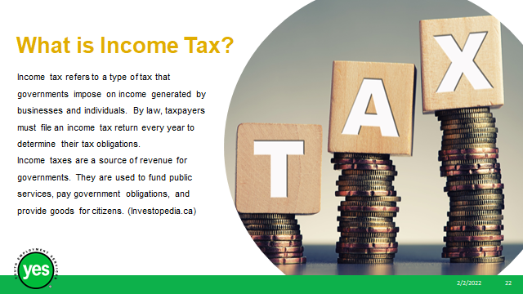 | Timing: 5 minutes  Interaction Pattern: Whole class  Materials Needed:  - Pages 16-17 of the Participant Workbook  Method: Lecture, Facilitated Discussion  Procedures and Notes:  Ask the group:  What is income tax?  Income tax refers to a type of tax that governments impose on income generated by businesses and individuals. By law, taxpayers must file an income tax return every year to determine their tax obligations.  Why do we file our taxes? What do our taxes pay for?  Income taxes are a source of revenue for governments. They are used to fund public services, pay government obligations, and provide goods for citizens.
Slide 24 | 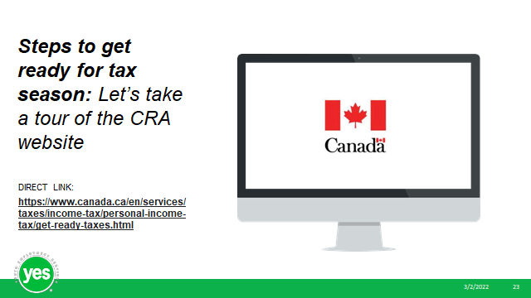 | Timing: 5 minutes  Interaction Pattern: Whole class  Materials Needed:  - Page 17 of the Participant Workbook  - Website: https://www.canada.ca/en/services/taxes/income-tax/personal-income-tax/get-ready-taxes.html  Method: Lecture, Website Tour, Unmute, Chat Box, Facilitated Discussion  Procedures and Notes:  Provide the group with a tour of the CRA website to look through the steps needed to prepare for tax season.  Virtual Delivery: Share your screen and open your browser to: https://www.canada.ca/en/services/taxes/income-tax/personal-income-tax/get-ready-taxes.html  In Person Delivery: Provide the participants with the website link and have them browse the website on their own device. Or, if you have a Smartboard, provide the group with a tour of the website.
Slide 25 | 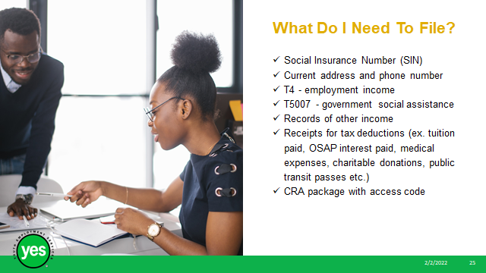 | Timing: 5 minutes  Interaction Pattern: Whole class  Materials Needed:  - Page 18 of the Participant Workbook  Method: Lecture  Procedures and Notes:  Share with the group:  It is important to have everything you need to file your taxes prepared before you file or have someone file for you. Regardless of who is submitting your tax return, it is important to keep these documents in a secure file in case you are audited. If you are audited and do not have these items handy, you could be asked to pay money back to the government.  Documents needed for filing your personal income tax:  - Your social insurance number and other personal information, current address, phone number  - Income T-slips (T4s etc.) These will be provided by your employer (most likely in February) and may be accessible on the secure online platform that holds your pay statements.  - T5007 statement of benefits provided by the Ministry of Community and Social Services if you received social assistance.  - Records of any other income, such as an income statement from a side hustle/ self-employment/ cash job (ie. If you nanny for a family on the weekends and they pay you in cash, document your earnings)  - Receipts for tax deductions, including medical expenses, childcare expenses, transit passes, charitable donations, student loan interest paid  - Information from past tax years, such as your RRSP Contribution limit.  - The tax package sent to you by the Canada Revenue Agency, including your access code to file online or by telephone. If you didn’t receive this it can be found online on cra.ca or physical forms can be found at all post offices.  Make sure you hold onto this list so that you can refer back to it at tax time.
Slide 26 | 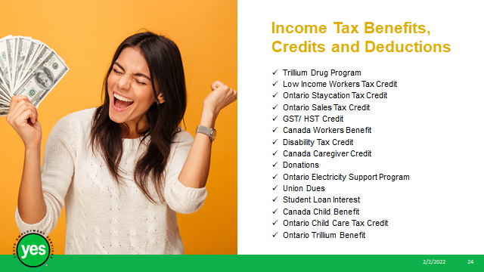 | Timing: 7 minutes  Interaction Pattern: Whole Class  Materials Needed:  - Page 18-19 of the Participant Workbook  Method: Lecture, Unmute, Chat box  Procedures and Notes:  Share with the group:  In Ontario, there are many different income tax benefits/credits that are worth looking into.  To receive these credits, you must be an Ontario resident and file a personal income tax return, even if you didn’t earn a taxable income. Even if you didn’t earn any employment income, it’s possible that you could receive money from the government.  The amount of money that you can receive from these benefits is based off your income, age, where you live and the size of your family.  Most tax return software (ex. Turbo Tax) will automatically prompt you with questions to apply for tax credits and benefits. You can also apply by filing a paper tax return and accompanying forms.  Share the website tour of where to look for the Benefits and Credits with the group by providing a website tour, or link to the website for participants to view at a different time (link is also listed at the back of the Participant Workbook):  https://www.canada.ca/en/revenue-agency/services/tax/individuals/topics/about-your-tax-return/tax-return/completing-a-tax-return/deductions-credits-expenses/deductions-credits-expenses.html  These are the Ontario Income Tax Benefits/Credits that you may be able to claim:  - Donations (if you donate more than $50 to a charitable organization you can claim it on your taxes)  - Student Loan Interest (you will receive a form from the government with the amount paid)  - Union Dues (If you pay union dues- not your employer)  - Canada Child Benefit (Must be the primary person responsible for a child under the age of 18 to qualify)  - Ontario Child Care Tax Credit (If a child’s household earns less than $150,000/yr the eligible child’s parent can claim up to $8,000 for a child under 7 and up to $5,000 for each child aged 7-17)  - Ontario Trillium Benefit (a combination of 3 tax credits help Ontario residents with low-moderate income pay for sales and property taxes and energy costs. You must qualify for one of the following three credits: Ontario Sales Tax Credit, Ontario Energy and Property Tax Credit, or Northern Ontario Tax Credit)  - Ontario Electricity Support Program (this benefit lowers the electricity bills for lower income households. How much you can receive is dependent on how many people reside in the residence and their combined incomes)  - Trillium Drug Program (anyone who does not have private health insurance can apply regardless of their income)  - Low Income Workers Tax Credit (can apply if your individual net income is less than $38,500/yr)  - Ontario Staycation Tax Credit (temporary credit for 2022-can claim up to $1,000 of your accommodation expenses if you travelled within Ontario)  - Ontario Sales Tax Credit (designed to provide relief for low-moderate income residents for the sales tax they pay. The amount will depend on the individual’s income)  - GST/ HST Credit (must be over 19 years old and earn a combined income of less than $60,000 to qualify)  - Canada Workers Benefit (amount can be received by individuals earning less than $24,573, or families earning less than $37,173)  - Disability Tax Credit (for individuals with prolonged impairments lasting more than 12 months can apply, the individuals support people may also qualify)  - Canada Caregiver Credit (you may qualify if you reside with/ care for someone over the age of 18 with a physical or mental impairment)
Slide 27 | 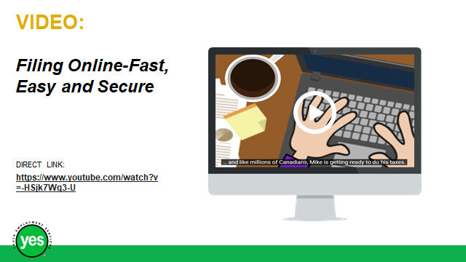 | Timing: 7 minutes  Interaction Pattern: Whole class, Individual Activity  Materials Needed:  - Page 20 of the Participant Workbook  Method: Lecture, Facilitated Discussion  Procedures and Notes:  Ask the group to brainstorm:  What are your options for filing your taxes?  You can file your taxes online or mail in a paper copy. You can also find other options to have someone else, such as an accountant, complete them for you.  Here are some common options:  - Certified tax software (electronic filing – ex. Turbo Tax). You can download the software directly from the website - This should be FREE to use, however you will need to pay to use versions of the program that provide more guidance.  - Authorize a representative – this could be a family member or an accountant  - Community volunteer tax clinics – these are often found at community centers or libraries and are accessible to low-income individuals  - Discounter – this is a tax preparer (ex. H&R Block) that calculates your refund and immediately pays you a part of your refund. It’s best to avoid using businesses like this as you could end up paying them more than you get back. Most people receive returns from the government fairly quickly so it is best to wait if you can.  - Paper tax return  - Automated phone line (File my Return)  - Tax filing assistance from a CRA agent
Slide 28 | 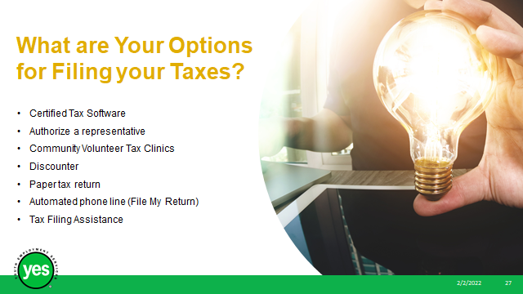 | Timing: 5 minutes  Interaction Pattern: Whole class  Materials Needed:  - Page 20 of the Participant Workbook  Method: Video, Facilitated Discussion  Procedures and Notes:  Share with the group:  We are now diving into our final concept of the day: Online Security and Fraud Prevention.  Screen the video: How to bank safely online:  https://youtu.be/DGo-OhDWIKQ (2:00)  Ask the group what stood out to them from the video.
Slide 29 | 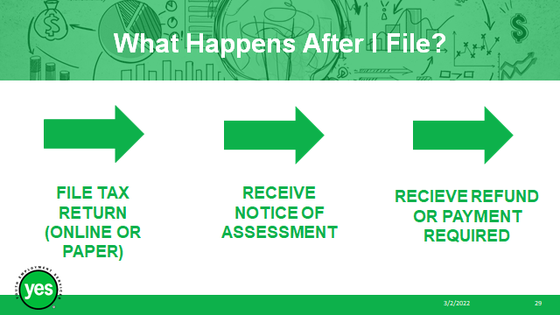 | Timing: 2 minutes  Interaction Pattern: Whole class  Materials Needed:  - Page 21 of the Participant Workbook  Method: Lecture  Procedures and Notes:  Share with the group:  After you file your tax return, Canada Revenue Agency will assess the information you provided for accuracy.  Once they have determined that the information that you provided is correct, they will issue you a notice of assessment.  Your notice of assessment can be found on your online CRA account or will be mailed to you typically within 2 weeks of submitting your tax return.  Your notice of assessment will verify if you will receive a refund and how much, or if you will be required to pay.  Most refunds are issued via direct deposit, however there is an option to receive a physical cheque if that is your preference.  Ask the group to complete the Self Reflection Activity: What do you need to be ready for tax season? Found on Page 21 of the Participant Workbook.  Debrief the Activity: Do you feel more prepared for filing your taxes? Which method do you think you will use for filing this year?
Slide 30 | 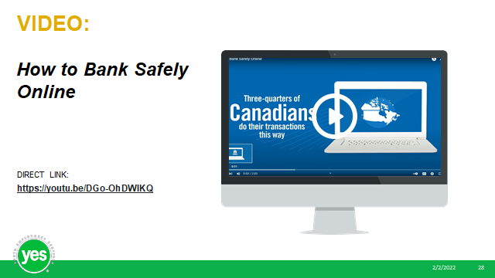 | Timing: 5 minutes  Interaction Pattern: Whole Class  Materials Needed:  - Page 22 of the Participant Workbook  - Virtual Delivery: Poll  Method: Lecture, Poll, Unmute, Chat  Procedures and Notes:  Share with the group:  While the concept of scams and fraud is nothing new, the digital age has created new opportunities for cyber criminals to steal your money, identity, or both.  Cyber criminals execute scams in a variety of different ways including via social media, phishing e-mails, SMS messages on your mobile phone, fake tech support phone calls and more.  Typically, the scammer will request things like passwords and banking information.  Can you think of any online scams?  Have you, or anyone you know, ever fallen victim to an online scam? What was it? How did it happen?  Virtual Delivery: Launch Poll (Who falls victim to online scams more often? 1. Older People 2. Young Adults): Do you think older people or young adults fall victim to scams more often?  In Person Delivery: Ask participants to raise their hands if they believe that older adults fall victim to scams more often than young adults.  Share with the group:  A June 2021 article from the New York Times shared that survey research from the Better Business Bureau has shown that younger adults lose money more often than the older people that you may think of as the stereotypical victims.  The reports show that 44% of people ages 20-29 lose money to fraud, more than double the 20 % of people aged 60-79.  Young people most commonly fall victim to online retail scams (sharing their banking/address/birthday information with “businesses” that influencers are promoting, for example) or employment scams (often these will request your SIN and DOB as a part of the employment application).
Slide 31 | 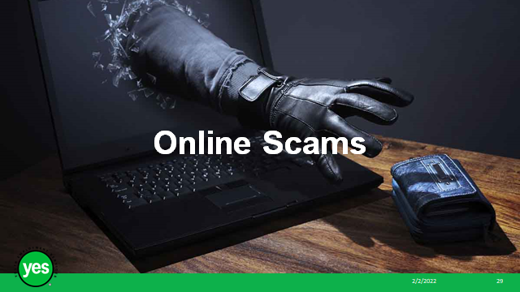 | Timing: 5 minutes  Interaction Pattern: Whole class  Materials Needed:  - Page 22-23 of the Participant Workbook  Method: Lecture, Facilitated Discussion  Procedures and Notes:  Share with the group:  Simple steps that you can take to protect you and your finances online, on computers and mobile devices:  - Choose secure passwords. When choosing your password, make sure it would be difficult for a criminal to guess. Try not to use the same passwords across many websites. If there is a security breach on website and your banking password is the same, that will put you at risk.  Some tips for coming up with a strong password: you can create your own personal formula using a combination of numbers, letters and symbols, a word you will remember and the first few letters of the site that you are accessing. For example, a combination of your word (sushi), your favourite number 52 and the three letters of the site you are accessing (Twitch) would look like this: TWIsushi52! You could also use a song title or lyric, combined with a number as a secure password.  - Protect your tablet, phone, and computer. Install an anti-virus, anti-spyware, and internet firewall tools on all of your devices. Check regularly to make sure that these programs are active and updated to keep your information protected.  You can also protect against malicious software by being careful about using free public WiFi to conduct financial transactions and by ensuring that you only download apps directly from your bank or a reputable app store that your financial institution directs you to.  - If something is not right, contact your bank or creditor immediately. The Government of Canada recommends checking your bank statements and reviewing your transactions regularly. If there are any transactions listed that you didn’t make or are unsure about contact your financial institution or lender immediately and notify them.  - Never disclose your personal information. Although your bank may contact you by phone, text, and email they will never ask you for personal information like your full credit card number, PIN, or online banking password. They would already have that information. If you are unsure about the communication that you receive, contact your financial institution using a phone number or email address that is legitimate.  The Canadian Bankers Association often posts about fraud prevention tips. You can follow their Twitter posts to be in the know. @CdnBankers
Slide 32 | 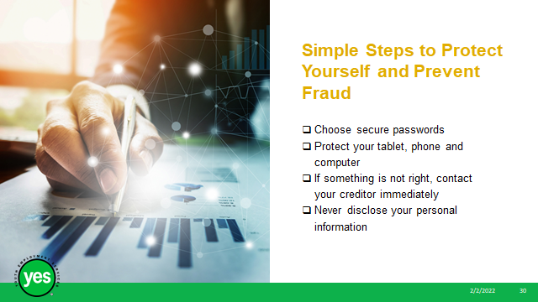 | Timing: 5 minutes  Interaction Pattern: Individual Activity  Materials Needed:  - Page 23 of the Participant Workbook  Method: Self Reflection, Unmute, Chat  Procedures and Notes:  Direct participants to use Simple Steps listed on PG 23 of the Participant Workbook and ask them to complete the final Self Reflection Activity- How Secure is My Online Presence on PG. 24.
Slide 33 | 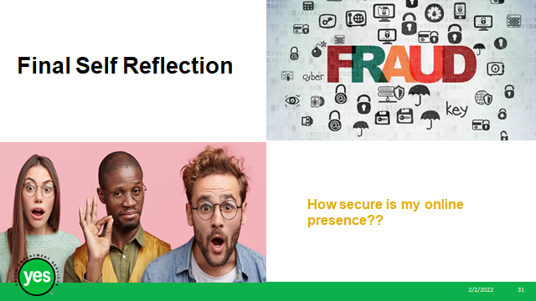 | Timing: 5 minutes – more as needed  Interaction Pattern: Whole class  Materials Needed: None  Method: Unmute, Chat Box, Facilitated Discussion  Procedures and Notes:  Share with the group:  Upon completion of this module, you have been equipped with the skills and knowledge needed to be in better control of your finances and complete tasks essential to *adulting*.  Be sure to keep this workbook on hand as a resource to help you navigate credit, debt, taxes and online security in the future.  Remember that family, friends, career counsellors, and other community organization staff can also be great resources who can point you in the right direction if you need a little bit of extra support with anything that we talked about today.
Slide 34 |  | Timing: 5 minutes – more as needed  Interaction Pattern: Whole class  Materials Needed: None  Method: Unmute, Chat Box, Facilitated Discussion  Procedures and Notes:  Ask the group to ask any outstanding questions about the workshop content.  Facilitate a discussion to respond to the questions.

