Youth Employment Services - YES
www.yes.on.ca
Future Skills:
Strategies for building resiliency and self efficacy
Facilitator’s Guide
Strategies for Building Resiliency & Self Efficacy: Workshop at a Glance

Overview and Purpose

This workshop explores the concept of self-care and the skills we need to persevere and thrive, including coping skills, the domains of self-care, developing a self-care action plan, self-regulation, resilience and self-efficacy. Participants develop a self-care plan that includes actions that you do regularly (maintenance self-care) and also considers what actions you can take when things are stressful (emergency self-care). Participants learn strategies for recognizing strategies, abilities and beliefs related to self-care.

Time

The workshop is between three and six hours long. All timings provided in the Facilitator’s Guide are approximate. Note that the timings for the slides don’t add up exactly to three or six hours, because some of the activities can be extended or shortened. You can lengthen, shorten or leave out activities based upon the needs of your participants and the amount of time you have for the workshop. You should have short breaks at least every 90 minutes.

Learning Outcomes

At the end of this workshop participants will be able to:

- Understand the concept of self-care.
- Identify the ways they currently deal with challenging situations.
- Recognize the six domains of self-care and positive actions they can take related to each domain.
- Develop their own self-care action plan.
- Recognize actions that are related to maintaining self-care and responding to emergency self-care.
- Understand ways that they can improve the success of implementing their self-care plan.
- Identify strategies for self-regulation, the ability to be resilient, and develop the belief that they can successfully navigate in the world (self-efficacy).

Leading Questions

As participants complete this workshop, they will think about and answer the following questions:

- How do you cope with challenging situations now?
- What do you do for self-care now? Are you more active in some areas of self-care but ignore others?
- What experiences in the past have provided caring relationships, expressed high expectations for you, or provided opportunities to participate and contribute?
- What new information from the workshop do you plan to use in your self-care actions going forward?

Workshop Agenda

Introductions and Workshop Overview

- Self-Care
- How Do You Cope with Challenging Situations Now?
- Domains of Self-Care
- Self-Care Action Plan
- Maintenance Self-Care
- Emergency Self-Care
- Tips for Self-Care
- What We Need to Thrive
- Review and Wrap-Up
- Additional Resources

Materials Needed

- White board/Screen/Internet connectivity
- Each participant should have a workbook and a device
- PPT Presentation Self-Care
- Activity material - Cue cards
- Activity material - Bubbles

Formative Assessment

Participants will be assessed based on their completion of their Self-Care Plan. An evaluative mark will not be assigned but the focus will be on the successful participants being equipped with a completed personalized plan as a result of their participation in this workshop.
Detailed Workshop Plan

Slide 1 | Welcome  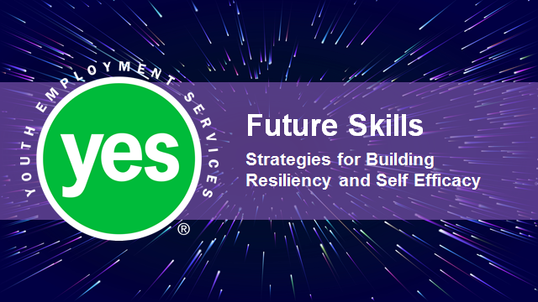 | Timing: Display as the participants come in.  Interaction Pattern: Whole class.  Materials Needed: None.  Procedures and Notes: None.
Slide 2 | 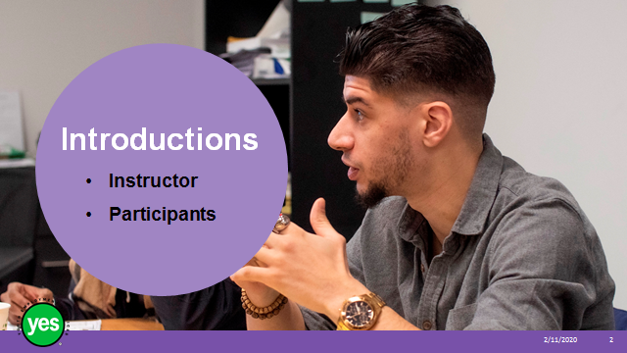 | Timing: 2 minutes.  Interaction Pattern: Whole class.  Materials Needed: None.  Procedures and Notes: Introduce yourself as the instructor. Have each participant briefly state their name. Have each participant put a name card in front of them for your reference.
Slide 3 | 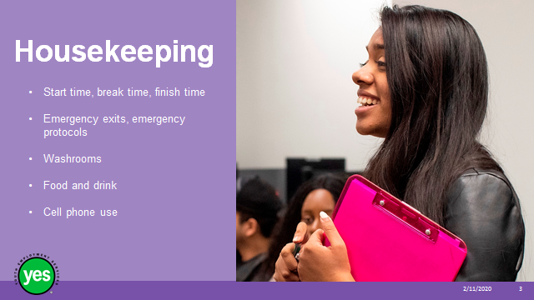 | Timing: 2 minutes.  Interaction Pattern: Whole class.  Materials Needed: None.  Procedures and Notes: Review all of the housekeeping details indicated on the slide. For cell phone use, indicate that if they are expecting an urgent call, their phone should be on vibrate. Otherwise indicate it should be on silent. They should not respond to texts or emails during the workshop.
Slide 4 | 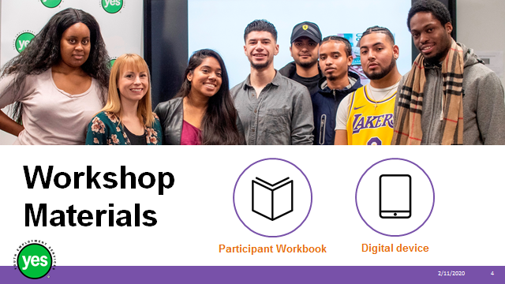 | Timing: 2 minutes.  Interaction Pattern: Whole class.  Materials Needed: One Participant Workbook per participant.  Procedures and Notes: Direct participants to their Participant Workbooks. Have them put their names on them. Indicate that this is their record of the key information in the workshop and ideas they generate during the workshop. Indicate that there are several activities in which they may choose to use their cell phone/device.
Slide 5 | 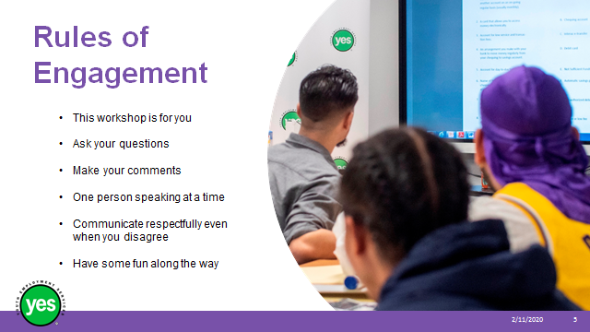 | Timing: 2 minutes.  Interaction Pattern: Whole class.  Materials Needed: None.  Procedures and Notes: Review your expectations for the participants. Indicate that your role is to guide them through the material and facilitate discussion.
Slide 6 | 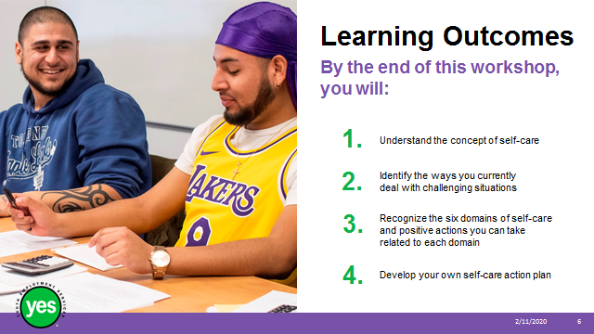 | Timing: 2 minutes.  Interaction Pattern: Whole class.  Materials Needed: Page 2.  Procedures and Notes: Review the learning outcomes of the workshop, stressing the practical knowledge and abilities that participants will walk away with.
Slide 7 | 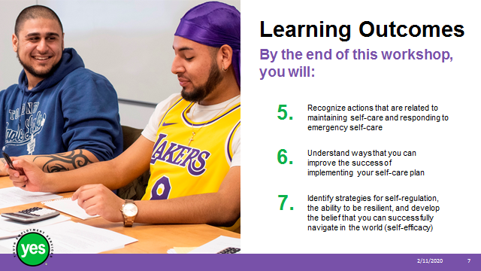 | Continued from previous slide.
Slide 8 | 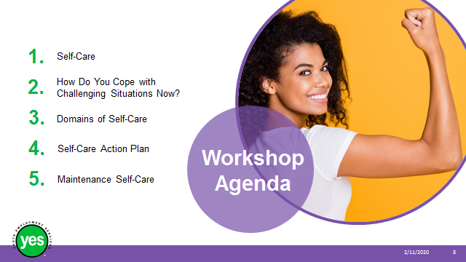 | Timing: 2 minutes.  Interaction Pattern: Whole class.  Materials Needed: Page 3.  Procedures and Notes: Review the agenda for the course.
Slide 9 | 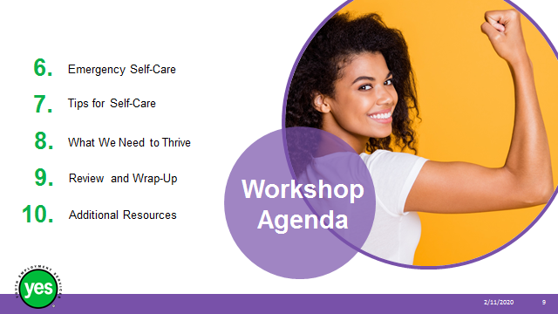 | Continued from previous slide.
Slide 10 |  | Timing: 5 minutes.  Interaction Pattern: Whole class.  Materials Needed: Page 4 Activity.  Procedures and Notes: Explain that self-care is a personal matter. Everyone’s approach will be different. It relates to what you do at work and outside of work to look after your whole body well-being. Self-care is necessary for your effectiveness and success in honoring your professional and personal commitments.
Slide 11 |  | Timing: 2 minutes.  Interaction Pattern: Whole class.  Materials Needed: None.  Procedures and Notes: Explain that it is easiest to think of your self-care plan as a roadmap – you have your trip planned but you also need to think of planned vehicle maintenance, travel activities and rest stops along the way.
Slide 12 | 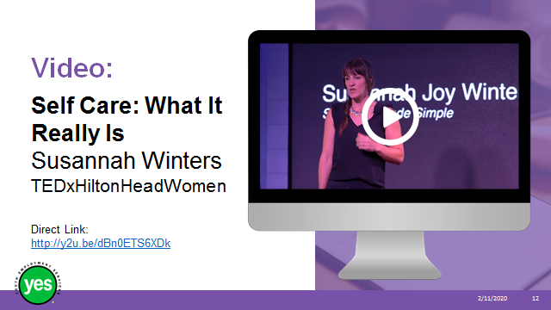 | Timing: 20 minutes.  Interaction Pattern: Whole class and pairs.  Materials Needed: YouTube video.  Procedures and Notes: Share that this video provides an overview of the idea of self-care. Ask the participants to listen for main ideas and any examples that really stand out to them.
Slide 13 | 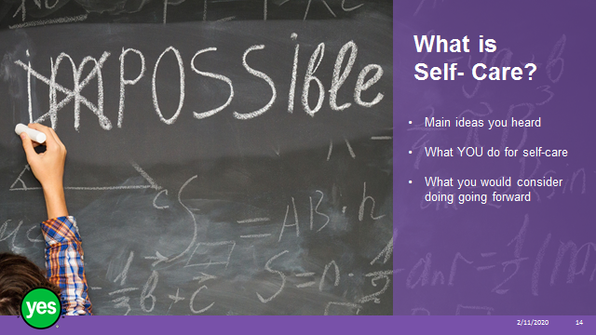 | Timing: 10 minutes.  Interaction Pattern: Whole class and pairs.  Materials Needed: Page 6.  Procedures and Notes: Ask pairs to share with each other:  - Main ideas they heard  - What they do  - What they would consider doing going forward
Slide 14 |  | Timing: 10 minutes.  Interaction Pattern: Individual.  Materials Needed: Page 5 Activity.  Procedures and Notes: Have participants complete the checklist independently.  Give the participants have 5 minutes to work.  After 5 minutes, share that decreasing or eliminating at least one “negative” coping strategy can be one of the goals of your maintenance self-care; employing more "positive" strategies can be another.
Slide 15 | 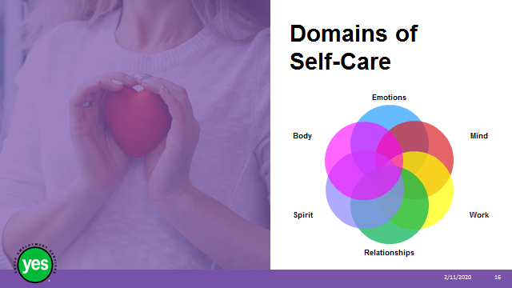 | Timing: 5 minutes.  Interaction Pattern: Whole class.  Materials Needed: Page 6.  Procedures and Notes: List the different aspects of self-care. There is no “one-size-fits-all” self-care plan, but there is a common thread to all self-care plans - making a commitment to attend to all the domains of your life, including your physical and psychological health, emotional and spiritual needs, and relationships.
Slide 16 | 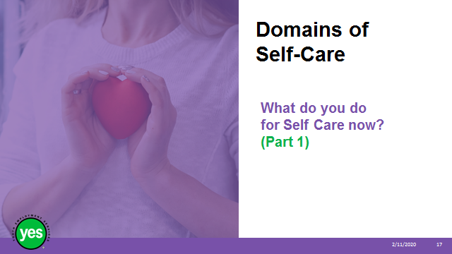 | Timing: 10 minutes.  Interaction Pattern: Individual.  Materials Needed: Pages 7 to 9 Activity.  Procedures and Notes: Have participants complete the checklist independently.
Slide 17 | 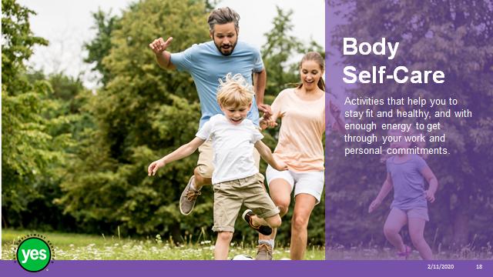 | Timing: 2 minutes.  Interaction Pattern: Whole class.  Materials Needed: Page 6.  Procedures and Notes: Review definition.
Slide 18 | 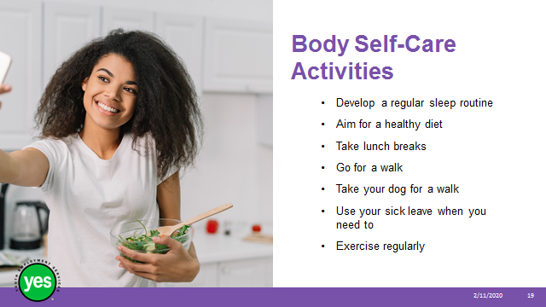 | Timing: 5 minutes.  Interaction Pattern: Whole class.  Materials Needed: None.  Procedures and Notes: Review list. Highlight 1 or 2 of the examples.
Slide 19 | 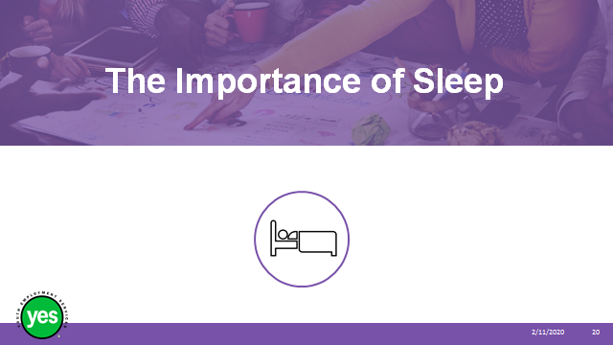 | Timing: 2 minutes.  Interaction Pattern: Whole class.  Materials Needed: None.  Procedures and Notes: Share that in a study from Harvard Medical School they found that most people are sleeping less than six hours a night and chronic sleep loss can contribute to health problems including difficulties with –  - Learning and memory  - Metabolism and weight  - Safety  - Mood  - Cardiovascular health  - Disease
Slide 20 |  | Timing: 2 minutes.  Interaction Pattern: Whole class.  Materials Needed: Page 6.  Procedures and Notes: Review definition
Slide 21 | 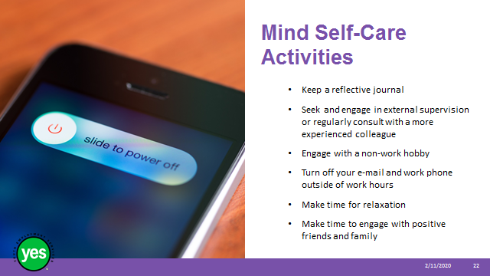 | Timing: 5 minutes.  Interaction Pattern: Whole class.  Materials Needed: None.  Procedures and Notes: Review list.  Highlight 1 or 2 of the examples.
Slide 22 |  | Timing: 5 minutes.  Interaction Pattern: Whole class.  Materials Needed: None.  Procedures and Notes: Share that the act of reflecting on thoughts, ideas, feelings, and your own learning encourages the development of skills to self-evaluate and sort what you know from what you don't know.  Recording in a reflective journal is not simply about recording what happened or was observed in your day but is intended to strengthen your understanding and development of critical thinking skills and personal awareness.  Reflective journals can be found in major bookstores and templates are available online. They often have pre-printed questions to help you get started.
Slide 23 |  | Timing: 5 minutes.  Interaction Pattern: Whole class.  Materials Needed: Page 6.  Procedures and Notes: Review definition.
Slide 24 | 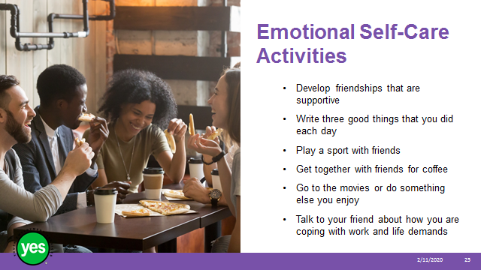 | Timing: 5 minutes.  Interaction Pattern: Whole class.  Materials Needed: None.  Procedures and Notes: Review list.  Highlight 1 or 2 of the examples.
Slide 25 |  | Timing: 5 minutes.  Interaction Pattern: Whole class.  Materials Needed: None.  Procedures and Notes: Share that in an article from the Mayo Clinic the benefits listed for supportive friendships include:  - celebrating the good times  - providing support during bad times  - preventing loneliness  - providing companionship  - increasing your sense of belonging and purpose  - boosting your happiness  - reducing your stress  - improving your self-confidence and self-worth  - helping you cope with traumas  - encouraging you to change or avoid unhealthy lifestyle habits
Slide 26 |  | Timing: 2 minutes.  Interaction Pattern: Whole class.  Materials Needed: Page 6.  Procedures and Notes: Review definition.
Slide 27 | 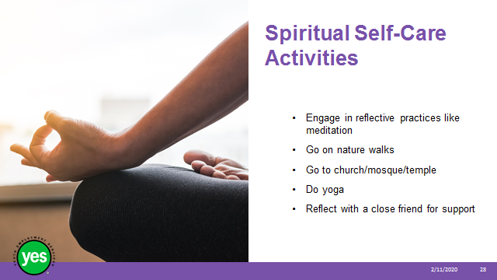 | Timing: 2 minutes.  Interaction Pattern: Whole class.  Materials Needed: None.  Procedures and Notes: Review list.  Highlight 1 or 2 of the examples.
Slide 28 |  | Timing: 5 minutes.  Interaction Pattern: Whole class.  Materials Needed: None.  Procedures and Notes: Share that in the United States there is a national effort called Park Prescription. These programs are designed to strengthen the connection between healthcare, parks, and public lands to improve the physical and mental health of individuals and communities.
Slide 29 |  | Timing: 2 minutes.  Interaction Pattern: Whole class.  Materials Needed: Page 6.  Procedures and Notes: Review definition.
Side 30 | - 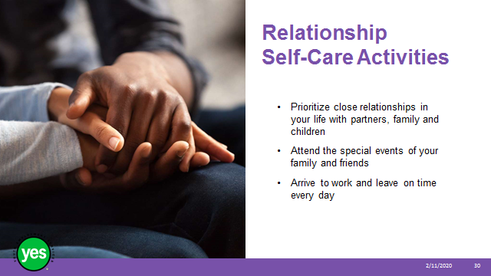 | Timing: 2 minutes.  Interaction Pattern: Whole class.  Materials Needed: None.  Procedures and Notes: Review list.  Highlight 1 or 2 of the examples.  Share a story from your experience related to when you prioritized a close relationship.
Slide 31 | 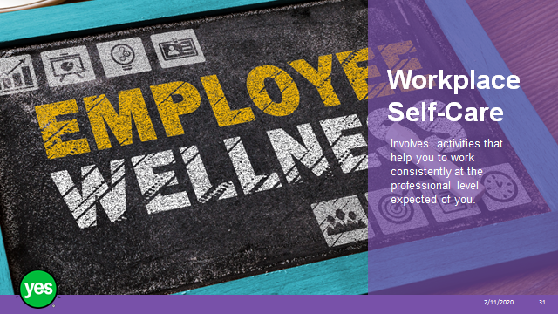 | Timing: 2 minutes.  Interaction Pattern: Whole class.  Materials Needed: Page 6.  Procedures and Notes: Review definition.
Slide 32 |  | Timing: 2 minutes.  Interaction Pattern: Whole class.  Materials Needed: None.  Procedures and Notes: Review list.  Highlight 1 or 2 of the examples.
Slide 33 | 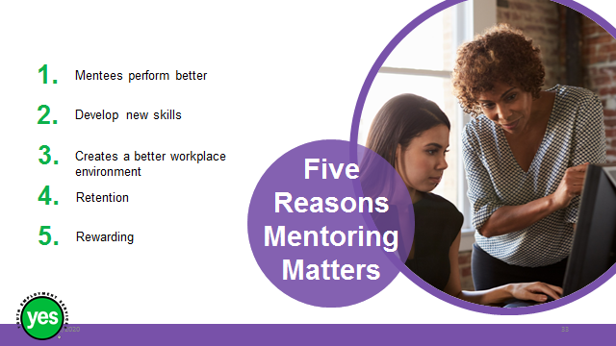 | Timing: 5 minutes.  Interaction Pattern: Whole class.  Materials Needed: None.  Procedures and Notes: Share that in a report supporting the value of mentoring programs at work the Environmental Careers Association of Canada stated that –  - Mentees perform better: Having a dedicated person to go to with questions about your work and help you navigate the workplace is invaluable.  - Develop new skills: Not only can a mentoring partnership help younger and more inexperienced workers gain job-related skills, mentoring helps both parties develop soft skills such as working collaboratively with others.  - Creates a better workplace environment: It fosters a network of both social and professional support within the company and can reduce stress levels for employees.  - Retention: When both employees feel like they are being valued for their contributions, even on a one-to-one basis, then they’re more likely to stay in the game for the long haul.  - Rewarding: Each partner benefits from the relationship.
Slide 34 | 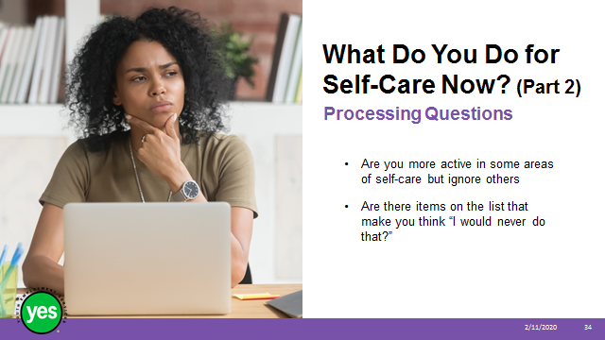 | Timing: 10 minutes  Interaction Pattern: Pair and share.  Materials: Page 5.  Procedures and Notes: Ask participants to take particular note of anything that you would like to include more in your life.  The items in this checklist can give ideas for additional things you may want to do in the future to help prevent stress and burnout and to maintain and enhance your well-being.  Circle the items that you would like to add (or add more of) to your self-care practice.  Try to be sure that each domain of self-care is well represented. If you think of things that are not included in this list, just add them at the end.
Slide 35 | 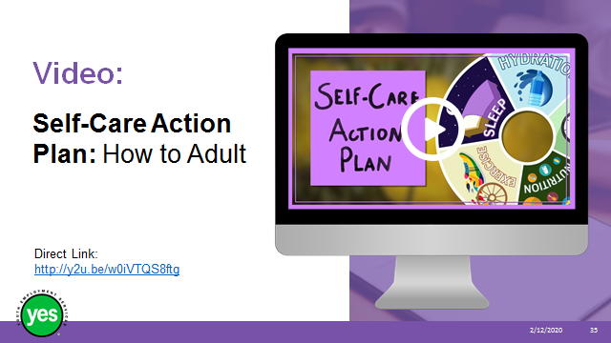 | Timing: 10 minutes.  Interaction Pattern: Whole class.  Materials Needed: YouTube video.  Procedures and Notes: View the video 5:00
Slide 36 |  | Timing: 10 minutes.  Interaction Pattern: Whole class.  Materials Needed: None.  Procedures and Notes: Ask group for feedback on the video. What did they find:  Interesting?  Surprising?  Important?
Slide 37 |  | Timing: 20 minutes.  Interaction Pattern: Individual.  Materials Needed: Page 10 Activity.  Note to Facilitator: The completed Self-Care Plan represents the successful Formative Assessment for this course. As your participants complete this activity, be sure to circulate among the group to check on how well the participants are progressing.  Procedures and Notes: Share with the participants that you might notice areas of overlap between these categories. It is important to develop a self-care plan that is holistic and individual to you  Ask them to fill in your self-care plan with activities that you enjoy and that support your well-being.  Keep this in a place where you can see it every day. Keeping it visible will help you to think about and commit to the strategies in your plan. You can also share it with your supervisor, colleagues, friends and family so they can support you in your actions.  Stick to your plan and practice the activities regularly. Just like an athlete doesn’t become fit by merely “thinking” about fitness, as a worker you can’t expect to perform effectively without putting into practice a holistic plan for your well-being.  Put a reminder on your calendar or in your phone/device to re-assess how you are doing at the end of one month and then three months. Plans can take over a month to become habits, so check-in and be realistic about your own self-care plan. After a while, come back and complete the self-care assessment again to find out how you are doing with your new habits.
Slide 38 | 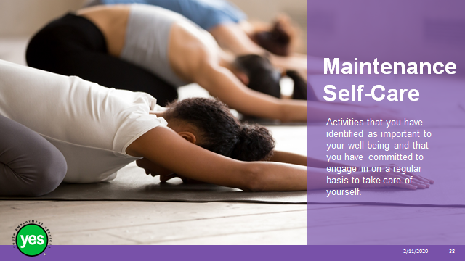 | Timing: 2 minutes.  Interaction Pattern: Whole class.  Materials Needed: None.  Procedures and Notes: Share that a self-care plan asks you to identify what you value and need as part of your day-to-day life (maintenance self-care) and the strategies you can employ when or if you face a crisis along the way (emergency self-care).
Slide 39 | 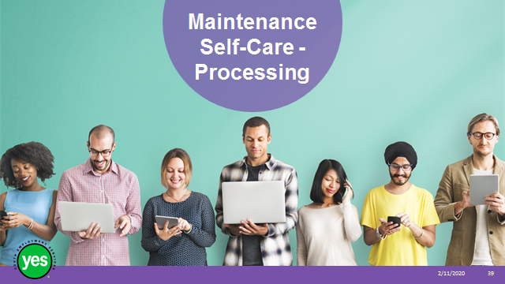 | Timing: 5 minutes.  Interaction Pattern: Individual.  Materials Needed: Page 10 and 11 Activity.  Procedures and Notes: Have participants review their personal self-care plan. The majority of what they have identified will likely be maintenance activities that they would do on a regular basis. Share that this is an opportunity for you to identify the activities you would like to add to your self-care practice in each self-care domain “new practice.” It is also useful to identify possible barriers or obstacles that could get in the way of implementing and/or maintaining these new activities.  Ask participants to -  - Think about what you anticipate these barriers/obstacles to be (try to list at least 3 or 4 in the spaces provided), how you can address them, and how you can remind yourself to follow your plan.  - If you have chosen to limit or eliminate a negative coping strategy that you currently use, note this as well as what you plan to do instead.  - You can revisit this topic and revise your list as the demands of your personal and professional life change.
Slide 40 |  | Timing: 5 minutes.  Interaction Pattern: Whole class.  Materials Needed: None.  Procedures and Notes: Ask the group for examples of obstacles and troubleshoot some potential solutions.
Slide 41 | 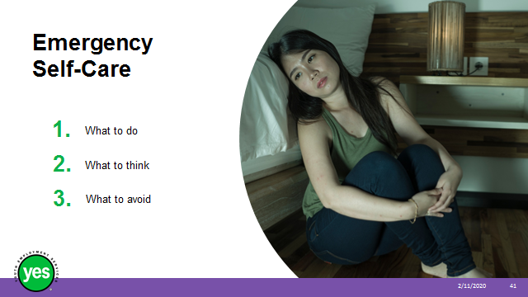 | Timing: 10 minutes.  Interaction Pattern: Individual.  Materials Needed: Blank recipe card (cue card) for each participant.  Procedures and Notes: Have participants complete their card independently.  Share that planning out what you would do under extremely trying circumstances, even though they are rare. Doing this before you are faced with a crisis or feel overwhelmed will help. This is not to say that you will face a crisis, but the idea is to be prepared just in case.  Ask them to think of developing your emergency self-care plan in the way you would think about preparing for other possible emergency situations - it is important to figure out your plan in advance when you have the time, wherewithal, and concentration to do so effectively.
Make up a card to use as an example with the headings. You can either do this ahead of time or you can work along with the group as you give the instructions.
Ask participants to -
- Draw a line down the middle of the front of the card to divide it into two columns.
- Write “Do” at the top of the left column.
- Think about what you can do when you are upset that will be good for you, what helps you relax? What do you like to do when you are in a good mood? Who can you reach out to if you need support?
- Record these ideas in the “Do” column.
- Write “Think” at the top of the right column.
- Think about what positive things you can say to yourself when you are having a hard time?

You can provide some examples for the group – e.g. “I will work on this”, “I will ask for help”, “I can make a difference”, “I belong”, “I can do this”

Ask participants to -
- Write “Avoid” on the back of the card.

Share that -
- Some actions can make a rough time seem even worse. Are there actions you should avoid?
  - Some examples may include – staying in the house all day, staying in bed all day, withdrawing from friends and family, listening to sad music, drinking too much alcohol
- Not everyone is supportive or helpful when you are having a rough time. Are there people who you should steer clear of until you are feeling better?

Encourage participants to keep the card in their purse or wallet or take a photo and keep it in their favourites on their phone. Share that if you check it often and add new ideas it will be there for them when times get rough.

Slide 42 | 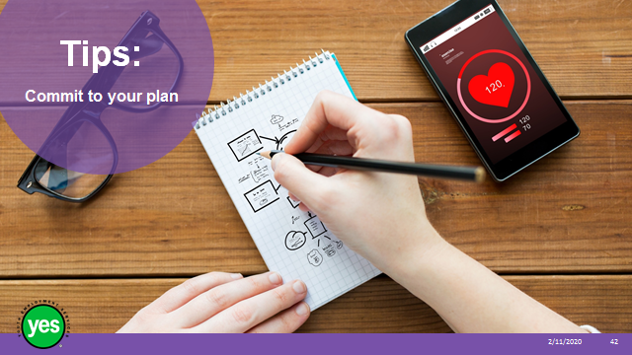 | Timing: 2 minutes.  Interaction Pattern: Whole class.  Materials Needed: None.  Procedures and Notes: Share the example of when a flight attendant asks you to put your own oxygen mask on first before you help out other people. If you don’t take care of yourself, you won’t be able to take care of others.  State that -  If you find making a commitment to be a challenge, then take some time to explore why you might hesitate.  Ask the group if they have a tendency to put the needs of others first? The truth is that your self-care is not only essential to your well-being, but it is also a necessary element for you to be effective and successful in honoring your professional and personal commitments.  Preparing a plan is important - it identifies your goals and the strategies to achieve them. However, your success in implementing your plan is ultimately based on the level of commitment you make to your self-care.
Slide 43 |  | Timing: 2 minutes.  Interaction Pattern: Whole class.  Materials Needed: None.  Procedures and Notes:  Explain that once you have developed your plan and made your commitment; remember that friends, family, peers, and/or colleagues may be good additional resources for exchanging new self-care ideas/strategies and to provide support and encouragement.
Slide 44 | 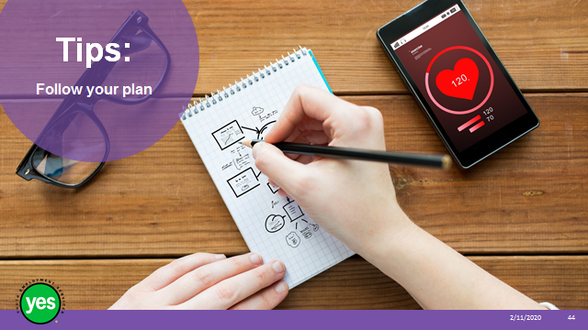 | Timing: 2 minutes.  Interaction Pattern: Whole class.  Materials Needed: None.  Procedures and Notes:  Share that now that you have completed the assessments and worksheets, you have identified the core elements of your personal Self-Care Plan.  State that -  - The final step is to implement your plan and keep track of how you are doing.  - Keeping track of your progress will help you recognize your successes and identify and address any difficulties you may not have anticipated.  - Picking a day each week or month and scheduling it on your calendar will help remind you to keep track.  - There are a number of apps available to help you track your plan online (e.g. Streaks, Habitshare, Tally and others)  - Don’t forget that you can revise your plan as needed.  - Remember, also, to employ your emergency plan should emotionally difficult circumstances arise.  - Remember that self-care is always a work in progress!
Slide 45 |  | Timing: 2 minutes.  Interaction Pattern: Whole class.  Materials Needed: None.  Procedures and Notes: Introduce idea that now that we have our self-care plan in place, we need to consider the aspects that we need to thrive.
Slide 46 |  | Timing: 2 minutes.  Interaction Pattern: Whole class.  Materials Needed: None.  Procedures and Notes: Review definition and clarify concept with participants.  Stress that self-regulation involves using strategies that we develop within ourselves.
Slide 47 |  | Timing: 10 minutes.  Interaction Pattern: Whole class – volunteers.  Materials Needed: Bubble Mixture.  Procedures and Notes: Ask for 5-7 volunteers.  Have the volunteers sit in a circle and you stand in the middle.  Explain that you are going to blow some bubbles in the air and they are welcome to pop as many as they like.  Once all of the bubbles are popped, explain that you are going to blow more bubbles but this time they cannot pop or even touch the bubbles (even if they land on their noses!).  Blow bubbles and be sure to position some of them so that it would be very tempting for your volunteers to pop them.  Ask the volunteers to share how they felt when they were not able to pop the bubbles.  Explain that the feeling of really wanting to do something but holding back is called self-control. Self-control is an important part of self-regulation.  Share that being able to control and adjust your emotions, thoughts and behaviours to reach a personally meaningful goal gets easier to do the more that practice it and that it is valued by employers.  Ask the group for strategies they have used to maintain self-control – take a few responses as time permits.  Share a short story from your own experience related to when you needed to use self-control and/or self-regulation to reach a goal.
Slide 48 |  | Timing: 10 minutes.  Interaction Pattern: Whole class.  Materials Needed: None.  Procedures and Notes: Review the definition.  Stress that being resilient is the ability to effectively cope.
Slide 49 | 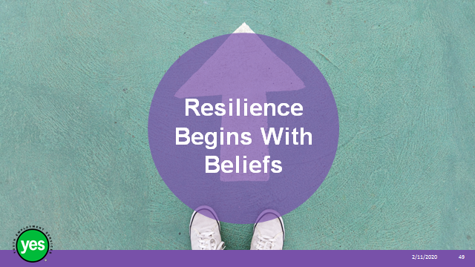 | Timing: 2 minutes.  Interaction Pattern: Whole class.  Materials Needed: None.  Procedures and Notes: Share that if you believe that all people have the capacity to be resilient regardless of age or circumstances.
Slide 50 |  | Timing: 2 minutes.  Interaction Pattern: Whole class.  Materials Needed: None.  Procedures and Notes:  Explain that resilience involves how we interact and negotiate with ourselves, others and our world. How we navigate through the resources that help us thrive. How we move on a positive trajectory of success and health when we encounter trauma, adversity and everyday challenges.
Slide 51 |  | Timing: 10 minutes.  Interaction Pattern: Whole class and pair and share.  Materials Needed: Page 12.  Procedures and Notes: Review the protective factors with the group. Have participants pair up and share examples from their lives of the protective factors from their experience.  After pairs have had 5 minutes to discuss their examples, ask the group for responses to each factor. Note any recurring responses. Suggest potential sources.  Reinforce that resilience is a process and not a trait - what you may have in your life at one point as a caring relationship may not be there at another time, or it may come from a different person, or a different way to participate and contribute. The important take away is that participants should be aware of these factors and be encouraged to seek them out in order to continue to thrive.
Slide 52 |  | Timing: 5 minutes.  Interaction Pattern: Whole class.  Materials Needed: None.  Procedures and Notes: Review the definition.  Stress that Self-Efficacy is the belief in your capacity to achieve. Share that high self-efficacy can look like the following examples, among others.
Slide 53 |  | Timing: 2 minutes.  Interaction Pattern: Whole class.  Materials Needed: None.  Procedures and Notes: Give the example of a student who is not particularly gifted in a certain subject but believes in her own ability to learn it well.
Slide 54 |  | Timing: 2 minutes.  Interaction Pattern: Whole class.  Materials Needed: None.  Procedures and Notes: Give the example of a man who has had bad luck with relationships so far, but retains a positive outlook on his ability to connect with his upcoming date.
Slide 55 |  | Timing: 2 minutes.  Interaction Pattern: Whole class.  Materials Needed: None.  Procedures and Notes: Give the example of an expectant mother who is nervous about caring for a new baby, but believes that she has what it takes to succeed, no matter how difficult or scary it is.
Slide 56 |  | Timing: 2 minutes.  Interaction Pattern: Whole class.  Materials Needed: None.  Procedures and Notes: Give the example of a new graduate who takes a high-profile, high-status job that she has never done before, but that she feels she can succeed in.
Slide 57 |  | Timing: 10 minutes.  Interaction Pattern: Whole class.  Materials Needed: Page 12 Activity.  Procedures and Notes: Ask participants to complete the Evaluating Your Ability to Cope checklist in their workbook. (5 minutes)  Once they have completed the checklist, they can total their score out of a potential 40.  Higher scores indicate more of an ability to cope (higher self-efficacy). Lower scores provide motivation for developing our coping ability more fully (low self-efficacy).  Invite participants to silently reflect on ways that they can increase their self-efficacy in the future
Slide 58 | 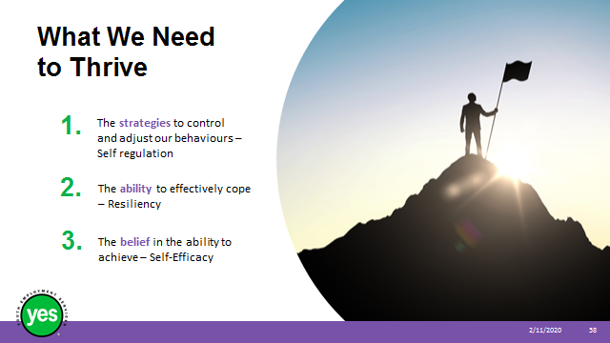 | Timing: 10 minutes.  Interaction Pattern: Whole class.  Materials Needed: Page 12.  Procedures and Notes:  Recap what we need to thrive. Remind participants of the How Do You Cope with Challenging Situations Now Checklist from the beginning of the workshop. Ask the group what new information they might be able to in your self-care actions going forward – take a few responses from the group if time allows.
Slide 59 |  | Timing: 2 minutes.  Interaction Pattern: Whole class.  Materials Needed: Page 13.  Procedures and Notes: Quickly review the topics covered in the module.  Continued on the next slide.
Slide 60 |  | Procedures and Notes:  Remind participants of any examples or moments that really stood out in the workshop with this specific group.
Slide 61 |  | Timing: 5 minutes – more as needed.  Interaction Pattern: Whole group.  Materials Needed: None.  Procedures and Notes:  Ask the group to share any outstanding questions about the workshop content.  Facilitate a discussion to respond to the questions.
Slide 62 |  | Timing: 2 minutes.  Interaction Pattern: Whole class.  Materials Needed: None.  Procedures and Notes: Direct participants to the additional resources at the end of the Participant Manual for further information.
Slide 63

