Youth Employment Services - YES
www.yes.on.ca
Future skills: job search in
THE DIGITAL AGE
Facilitator’s Guide
Job Search in the Digital Age: Workshop at a Glance

Overview and Purpose

This workshop introduces what it means to look for work in an age when so much information and so many opportunities to connect are available online. Tips are provided on how to create and maintain a professional social media presence, including LinkedIn, and on researching a company online. You take part in activities that will increase your understanding of how to keep your personal and professional images separate. You will also be reminded of tried-and-true methods for connecting in person to further your job search efforts.

Time

The workshop is between three and five hours long. All timings provided in the Facilitator’s Guide are approximate. Note that the timings for the slides don’t add up exactly to three or five hours, because some of the activities can be extended or shortened. You can lengthen, shorten or leave out activities based upon the needs of your participants and the amount of time you have for the workshop. You should have short breaks at least every 90 minutes.

Learning Outcomes

At the end of this workshop, participants will:

- Understand online job-search and social networking options.
- Understand the importance of referrals.
- Understand how to research a company online.
- Know how to create a LinkedIn account.
- Have a solid draft of a summary for their LinkedIn personal profile.

Leading Questions

As participants complete this workshop, they will think about and answer the following questions:

- How do I feel about looking for work?
- Do I know what type of job I’m looking for?
- Can I commit to trying something new in my job search?
- How can I get the most out of looking at a company’s website?
- What is the best way for me to build a professional social-media presence?

Workshop Agenda

- Know What You’re Looking For
- Job Search Methods
2.1 “In Person”
2.2 Online
- Researching a Company Online
- Dos and Don’ts of Social Media
- LinkedIn
- Review and Wrap-Up

Materials Needed

- White board/Screen/Internet connectivity
- Each participant should have a workbook and a device, ideally a laptop each with Internet connectivity
- PPT Presentation Job Search in the Digital Age
- Large ball of yarn and a pair of scissors
- Small items such as paper clips – 25 for each person

Formative Assessment

A multiple-choice quiz using an online polling such as Kahoot will make up the formative assessment for this workshop. It will be presented as a handout as well, in case wifi is not available and/or not enough participants have smart phones.

Detailed Workshop Plan

Slide 1 |  | Timing: Display as the participants come in.  Interaction Pattern: Whole class.  Materials Needed: None.  Procedures and Notes: None.
Slide 2 | 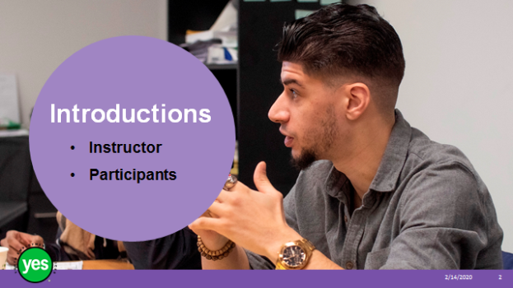 | Timing: 2 minutes.  Interaction Pattern: Whole class.  Materials Needed: None.  Procedures and Notes: Introduce yourself as the instructor. Have each participant briefly state their name. Have each participant put a name card in front of them for your reference.
Slide 3 | 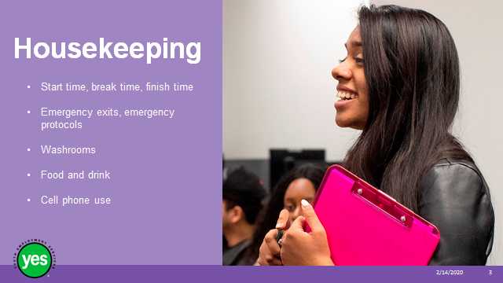 | Timing: 2 minutes.  Interaction Pattern: Whole class.  Materials Needed: None.  Procedures and Notes: Review all of the housekeeping details indicated on the slide and any others you need to add. For cell phone use, indicate that if they are expecting an urgent call, their phone should be on vibrate. Otherwise indicate it should be on silent. They should not respond to texts or emails during the workshop. We may need to use cell phones in an activity.
Slide 4 |  | Timing: 2 minutes.  Interaction Pattern: Whole class.  Materials Needed: One Participant Workbook per participant.  Procedures and Notes: Direct participants to their Participant Workbooks. Have them put their names on them. Indicate that this is their record of the key information in the workshop and ideas they generate during the workshop. It is also a resource they can come back to later as they prepare for real-life situations.
Slide 5 | 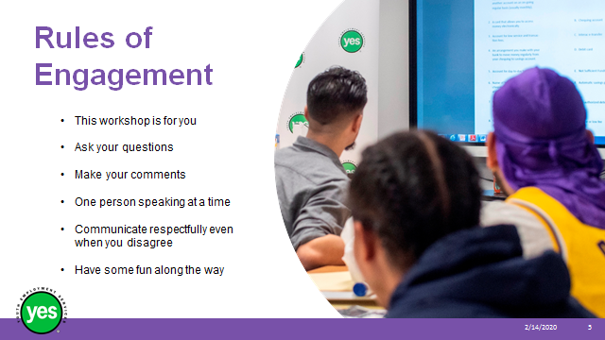 | Timing: 2 minutes.  Interaction Pattern: Whole class.  Materials Needed: None.  Procedures and Notes: Review your expectations for the participants, such as active listening and mutual respect. Indicate that your role is to guide them through the material and facilitate discussion. You may ask the group if they have anything to add to your list.
Slide 6 |  | Timing: 15 to 20 minutes.  Interaction Pattern: Whole class.  Materials Needed: Large ball of yarn.  Procedures and Notes: Ask participants to stand in a large circle or around the outside of the u-shaped table set-up, depending on what is available. Everyone is facing inward.  The first person takes the ball of yarn and wraps some around one finger. Holding onto the strand around the finger, they start talking about themselves. As soon as someone else identifies with what the speaker says, they call “me too.” The speaker then stops talking and, holding firmly onto the yarn, tosses the ball of yarn to the person who said “me too.” The speaker can choose who to toss the ball to if more than one person says “me too” at the same time.  The second person then begins talking about themselves, until someone identifies with what they are saying and calls out “me too.”  This continues until everyone has caught the ball at least once. The yarn should be held tightly and above the ground at all times. Continue until everyone has received the yarn at least once.  Spend a moment admiring the web or network of connections. Ask participants how this activity relates to looking for a job.  Comment on the importance of our social and professional networks and how we now know a bit more about one another. We also have a network we can draw on as we look for work – both in person and online.
Slide 7 | 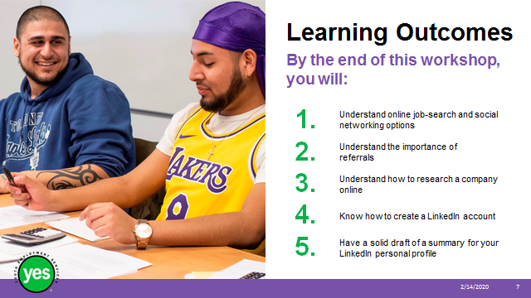 | Timing: 2 minutes.  Interaction Pattern: Whole class.  Materials Needed: Page 1.  Procedures and Notes: Review the learning outcomes of the workshop, stressing that the ways of looking for work are likely to shift as new technology is introduced. This workshop is a combination of information, demonstration and hands-on activities.
Slide 8 | 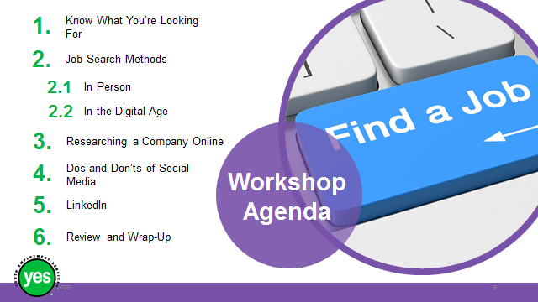 | Timing: 2 minutes.  Interaction Pattern: Whole class.  Materials Needed: None.  Procedures and Notes: Review the agenda for the workshop.
Slide 9 |  | Timing: 10 minutes.  Interaction Pattern: Whole class/ individual.  Materials Needed: Page 2 activity.  Procedures and Notes: This workshop is not a workshop on self-assessment and career direction. It assumes people have at least an idea of the type of job they are looking for. If they don’t, they’ll get a sense of why it is important. Motivation and goal setting are covered in a different workshop.  The goal is for participants to have some parameters so they know how to narrow down their job search. In this age, so much information is available, so much new information is uploaded to the internet every day and the pace of change is accelerating.  Questions for discussion may include:  - Who’s unsure about the type of job they are looking for?  - Who has a good idea of what they are looking for?  - What concerns do you have about figuring out what type of job you are looking for?  - How close are you to knowing what you want over the short term? Longer term?  - What concerns do you have about looking for work?
Slide 10 | 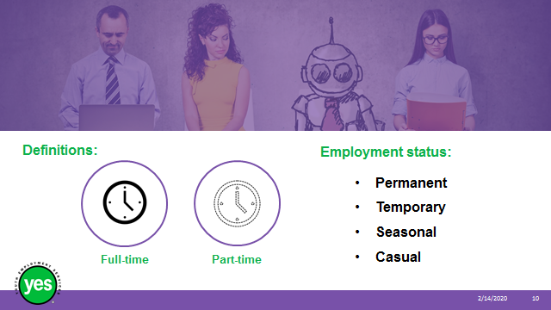 | Timing: 10 minutes.  Interaction Pattern: Whole class.  Materials Needed: Page 3 activity.  Procedures and Notes: It’s important to understand these terms so that we understand what job postings are saying, can describe our work experience accurately and can communicate our needs clearly.  Full-time and part-time employment: Ask the group how many hours you have to work to be considered full-time.  While there is legislation around the maximum number of hours an employee should be asked to work per day (Ontario Employment Standards Act), there is no official definition of full-time hours. It will depend on the company. Some say 30 hours, some 35, some 40. Generally, anything under 30 hours per week is considered part-time.  Employment status: Here are some definitions from the Province of Ontario. Ask for examples from the group and have a few examples on hand.  Adjust these as needed if you are elsewhere.  - “Permanent” status – This generally means that the employment relationship has no fixed end date.  (e.g. Bus driver for city transit company)  - “Temporary” status. This generally means that the employment relationship is not permanent but has a fixed end date or will end upon the completion of a project, task etc.  (e.g. 6-week sales position before the holidays)  - “Seasonal” status – This generally means that the employment relationship is seasonal in nature and will end when the season for which the employee was hired comes to an end.  (e.g. fruit picking, summer camp counsellor)  - “Casual” status – This generally refers to an arrangement where an employee is called to work on an as-needed basis.  (e.g. delivering flyers, supply teacher)  Why does it make a difference? Among many other reasons,  - You should know the terms of your employment before you agree to do the work.  - Extended health benefits are generally only offered to full-time, permanent employees.
Slide 11 |  | Timing: 30 minutes.  Interaction Pattern: Whole class.  Materials Needed: Page 4 activity; small items to place on the grid (such as paper clips) – 25 per person; flip chart paper.  Procedures and Notes: Distribute # small items to each participant.  Part 1: Ask the group to read the grid on page 4 in the workbook and to place a small item on each square that corresponds to how they looked for a paid or volunteer position. Note that there are two “free” squares where they can put in whatever else they choose.  Circulate around the room to get a sense of the range and variety of experience in the room.  Have a flip chart page with the stated options listed.  Take up the exercise:  - Go through each item on the flip chart and ask how many people placed an item on it. Record the number.  - Ask for additional methods and list them. Ask how many other people wrote down these options.  - Ask the group to reflect on the results.  - What stands out?  Part 2: Ask the group to remove the small items from the methods that didn’t work, leaving only those that did. Share results.  - Can any conclusions be drawn about good ways to look for and find work?  - What is the balance of “traditional” and “digital age” approaches used?  - How much depends on the type of job?  - Where are the gaps?  Ask whether participants would be willing to talk to others later about how they found their jobs – an opportunity to practise networking.  Before we look at other job search methods, let’s look at this from the employer’s point of view.
Slide 12 |  | Timing: 20 minutes.  Interaction Pattern: Individual/whole class.  Materials Needed: Page 5 activity; YouTube video cued up and ready to play - https://www.youtube.com/watch?v=pRuWyXQ5t-Q (10:51 minutes)  Procedures and Notes: Ask participants to think about what employers do when they have a job vacancy, are anticipating job vacancies, or are gearing up for growth.  Have participants list ways and share them with the class, taking note of other ways offered by their classmates.  Here’s a list of some approaches used by employers. The list will vary widely, depending on the size and type of company. Add to the list based on your experience, including as many digital-age methods, as possible.  Consider main categories such as advertising and recruiting themselves; using a recruiter; personal connections; being approached by job seekers.  - Advertising on company website  - Engaging a recruiter to find suitable candidates to interview  - Posting on their social media profiles, such as LinkedIn  - Radio announcements  - Articles in local papers  - Sign in shop window  - Asking existing employees for referrals  - Asking friends and colleagues for referrals  - Posting on online job boards  - Participating in career fairs – in person or virtually  - Working with government-funded employment services  Refer participants to page # in the workbook. Screen video. It introduces the concept of the hidden job market and offers ways to access it. You may need to define the word “circumvent” before you press play.  Key parts to stress when debriefing video:  - An active job search means trying to find people to refer you to a job. Referrals are very important.  - People hire people.  - The time lag when positions are posted and how hiring carries on in the meantime  - Never only submit a resume to a job posting board – make a personal connection  - Tell everyone you know you are looking for work.  - Use LinkedIn (more about this later in the workshop)  You may also consider screening parts of another video by the same person. The “only thing” is referrals.  Job Search: The Only Thing You Need to Be Doing 2019 - https://www.youtube.com/watch?v=wp1IWfuoJG8
Slide 13 |  | Timing: 10 minutes.  Interaction Pattern: Whole class.  Materials Needed: Page 6 activity.  Procedures and Notes: Before we focus on using technology to look for work, let’s remember that establishing a face-to-face connection is still a good idea.  Refer back to the previous activities – how many people have found work through referrals and networking in person? Share your own experience.  By this point, several face-to-face options should have been covered. Brainstorm any other in-person networking methods that have not yet come up.  Ask for a volunteer to read out the case studies on page ## in the workbook. Ask for reactions and discuss what it was that led to job search successes – e.g. doing a good job and being recognized for it; interpersonal skills; chance.  Stress that referrals are very important. – Darnell Clarke videos  Looking for work completely online can be isolating. It may be good for people’s spirits to get up and out of the house and meet with people.
Slide 14 |  | Timing: 15 to 30 minutes.  Interaction Pattern: Whole class/individual.  Materials Needed: Page 7 and 8; Internet connection.  Procedures and Notes: Highlight main points from pages 7 and 8 in the workbook. Ask whether the group has anything to add.  Be sure to highlight the applicant tracking system and tips for how to use key words to get a higher score. More information on this is covered in the workshop on resumes and cover letters.  Ask the group to recall some online ways to look for work (from previous activity). Ask whether any other method has come to mind.  Ask for definitions and examples so that everyone is clear as to what they involve.  If you have time, consider going online and searching for virtual career fairs, meet-up groups of interest to participants.  Offer participants a chance to reflect on the range of job search activities they have to choose from, how they feel about these choices, where they’d like to start and what supports they might need. Say how the agency can help.  Refer to the Appendix in the workbook for a listing of recommended online job boards.
Slide 15 |  | Timing: 10 to 15 minutes.  Interaction Pattern: Whole class/individual.  Materials Needed: Page 9 activity.  Procedures and Notes: Take a few moments to have participants reflect on what they have learned so far about how to look for work.  Give them a few minutes to think about the questions on page 9. Take up their answers and clarify any misunderstandings.
Slide 16 |  | Timing: 15 to 45 minutes.  Interaction Pattern: Whole class/individual.  Materials Needed: Page 10; Internet connection; a laptop for each participant or two if available and if free internet connection is available.  Procedures and Notes: Demonstrate how to look up company information. Choose a company yourself or ask the group for suggestions. Walk the group through step-by-step, demonstrating as many steps as possible and referring to the steps on page ## of the workbook.  Company website  - About us  - News  - Investor relations (reports)  - Key people on staff and board  Organization’s social media pages  - Facebook  - LinkedIn  - Twitter  Review websites such as Glass Door  - Take with a grain of salt  Google  - Google news alerts for up-to-date news about the company  If there’s time, and if you have laptops for participants to use, ask participants to research a company or two, using as many steps as they can from the list in their workbook.  Debrief by asking whether there were any surprises, whether there are any questions. Lead a brief discussion on how to keep company information organized for future reference.
Slide 17 |  | Timing: 10 minutes.  Interaction Pattern: Whole class.  Materials Needed: Page 11 activity; Internet connection; video cued up to https://www.youtube.com/watch?v=pwswTJnm1ZI  Procedures and Notes: Before spending the rest of the workshop on LinkedIn, screen this brief video on the dos and don’ts of social media (4:15 minutes)  It includes some tips for using LinkedIn and reinforces other points made during this workshop.  Ask the group to note any surprises from the video and additional tips.
Slide 18 |  | Timing: 20 to 30 minutes for this slide and the next.  Interaction Pattern: Whole class.  Materials Needed: Internet.  Procedures and Notes: Introduce LinkedIn as a form of online resume and a tool for connecting with others online.  Ask how many participants have a LinkedIn account, how many are using its many features.  Screen https://www.youtube.com/watch?v=AcmKZrC89Mo (3:07 minutes)  A brief overview of what LinkedIn has to offer.
Slide 19 | 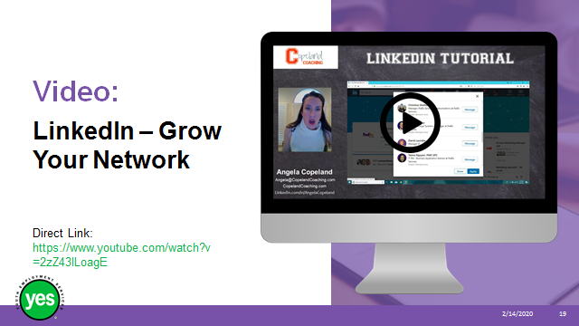 | Timing: 7 to 8 minutes.  Interaction Pattern: Whole class.  Materials Needed: Internet connection.  Procedures and Notes: Screen the following video about how to ask for referrals using LinkedIn. https://www.youtube.com/watch?v=2zZ43ILoagE (6:07)
Slide 20 |  | Timing: 30 to 40 minutes.  Interaction Pattern: Whole class/individual.  Materials Needed: Internet connection; pages 12 to 16 activity.  Procedures and Notes: The goal of this activity is for participants to have a solid draft of a profile summary for their personal LinkedIn account.  See the workbook, pages 12 to 16 for steps.  Circulate and spend time with each participant, making sure they stay on track and offering clarification and feedback on the exercise. If possible, bring in a second or third facilitator or job developer to ensure more 1:1 support with this activity.
Slide 21 |  | Timing: 15 minutes.  Interaction Pattern: Whole class/individual.  Materials Needed: Internet connection, kahoot.it set up and ready to use, free Wi-Fi for participants OR quiz on page 19 of this guide.  Procedures and Notes: Learn how to use Kahoot, a game-based learning platform (visit kahoot.com). Set up the four multiple-choice questions on page 19. Ask participants to use their cell phones, or to work in pairs and enter the password provided and a nickname.  Once everyone is ready (their names will appear on the screen), go through the multiple-choice questions.  Once everyone has answered, you may display the answers on the screen, discuss choices and the correct answers.  Alternatively, hand out the multiple-choice quiz and take up the responses.
Slide  22 |  | Timing: As needed.  Interaction Pattern: Whole class.  Materials Needed: None.  Procedures and Notes: Review the main topics and highlights of the workshop.  Ask participants for a quick take on how this workshop went for them – e.g. thumbs up, thumbs down, thumbs in the middle.  Ask if there are any final questions or comments about the content of the module.

Appendix: Multiple-choice Quiz

Select the most appropriate answer to the following four questions.

- Which of these jobs would be considered seasonal?

- babysitting so parents can go gift shopping
- picking fruit
- greeting patients in the emergency department
- tutoring math to grade 4 students

- What should not be included in your LinkedIn profile?

- your career goals
- your main skills and talents
- your social insurance number
- the past three jobs you’ve had

- Which statement is false?

- 30% of interviewers check out your social media presence before interviews.
- Almost all available jobs are in the hidden job market.
- 74% of interviewers look at your social media presence before interviews.
- Referrals are a very important way to find work.

- How are you feeling about today’s workshop?

- Terrible
- So-so
- Pretty good
- Great!

