Youth Employment Services - YES
www.yes.on.ca
Future Skills: Growth MindSet AND DEALING WITH DISRUPTION
Facilitator’s Guide
Growth Mindset and Dealing with Disruption: Workshop at a Glance

Overview and Purpose

This workshop introduces the key concepts in growth mindset including how your brain works, the definition of fixed mindset and growth mindset, dealing with failure, grit, dealing with disruption and the power of belief. You will take part in activities to define and then explore the concepts. You will also practice strategies to encourage a growth mindset that you have learned.

Time

The workshop is between three and six hours long. All timings provided in the Facilitator’s Guide are approximate. Note that the timings for the slides don’t add up exactly to three or six hours, because some of the activities can be extended or shortened. You can lengthen, shorten or leave out activities based upon the needs of your participants and the amount of time you have for the workshop. You should have short breaks at least every 90 minutes.

Learning Outcomes

At the end of this workshop you will be able to:

- Understand how the brain responds when developing new habits.
- Define growth mindset and fixed mindset.
- Recognize fixed mindset behaviours.
- Reframe fixed mindset behaviours to become growth mindset behaviours.
- Understand that many famous figures have overcome failure and identify some strategies they may have employed.
- Define the concept of grit and why it matters.
- Define disruption and identify strategies to adjust to disruption.
- Analyze how a growth mindset can contribute to your personal success.

Leading Questions

As participants complete this workshop, they will think about and answer the following questions:

- What is a fixed mindset? What is a growth mindset?
- Do you think it is possible to make the switch from a fixed mindset to a growth mindset? Why or why not?
- What needs to be in place to make the switch from a fixed mindset to a growth mindset?
- What does failure really mean? How can we overcome it?
- What does disruption mean?
- How can people react to disruptive situations?
- What can make us think differently about disruption?
- How can having a growth mindset lead to success?

Workshop Agenda

Introductions and Workshop Overview

- How Your Brain Works
- Growth Mindset Explained
- Making the Change
- Famous Failures
- Grit – Traits That Matter
- What Is Disruption?
- Dealing With Disruption
- The Power of Belief – Mindset and Success
- Review and Wrap-Up

Materials Needed

- White board/Screen/Internet connectivity
- Each participant should have a workbook and a device
- PPT Presentation Growth Mindset
- Activity material – flip chart and markers
- Activity material – a small coin
- Activity material – 2 small objects

Formative Assessment

The 3-2-1 exercise at the end of the agenda constitutes the formative assessment for this module. 3-2-1 consists of asking participants to consider the following questions at the session,

- What are 3 things I've learned?
- What are 2 things I want to learn?
- What is 1 question I still have?
Detailed Workshop Plan

Slide 1 |  | Timing: Display as the participants come in.  Interaction Pattern: Whole class.  Materials Needed: None.  Procedures and Notes: None.
Slide 2 | 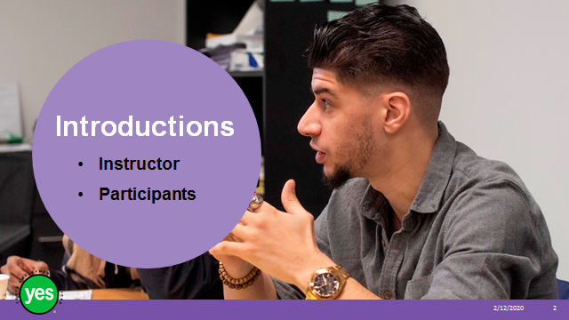 | Timing: 2 minutes.  Interaction Pattern: Whole class.  Materials Needed: None.  Procedures and Notes: Introduce yourself as the instructor. Have each participant briefly state their name. Have each participant put a name card in front of them for your reference.
Slide 3 | 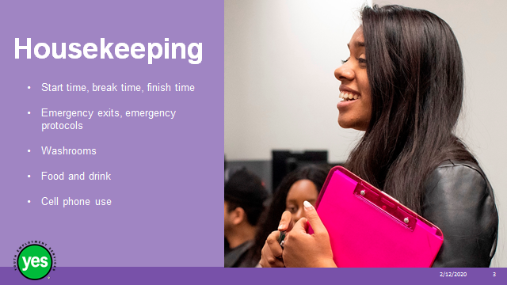 | Timing: 2 minutes.  Interaction Pattern: Whole class.  Materials Needed: None.  Procedures and Notes: Review all of the housekeeping details indicated on the slide. For cell phone use, indicate that if they are expecting an urgent call, their phone should be on vibrate. Otherwise indicate it should be on silent. They should not respond to texts or emails during the workshop.
Slide 4 | 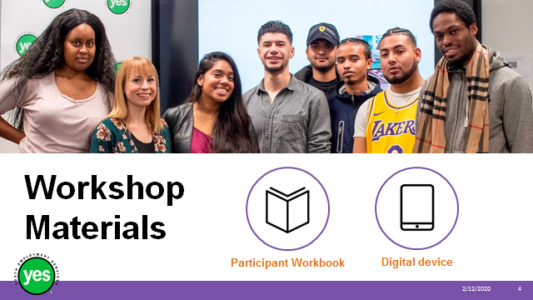 | Timing: 2 minutes.  Interaction Pattern: Whole class.  Materials Needed: One Participant Workbook per participant.  Procedures and Notes: Direct participants to their Participant Workbooks. Have them put their names on them. Indicate that this is their record of the key information in the workshop and ideas they generate during the workshop. Indicate that there are several activities in which they may choose to use their cell phone/device.
Slide 5 | 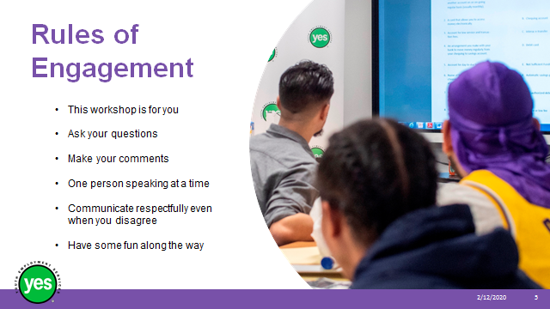 | Timing: 2 minutes.  Interaction Pattern: Whole class.  Materials Needed: None.  Procedures and Notes: Review your expectations for the participants. Indicate that your role is to guide them through the material and facilitate discussion.
Slide 6 | 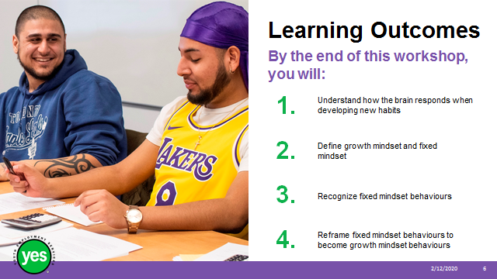 | Timing: 2 minutes.  Interaction Pattern: Whole class.  Materials Needed: Page 1.  Procedures and Notes: Review the learning outcomes of the workshop, stressing the practical knowledge and abilities that participants will walk away with.
Slide 7 | 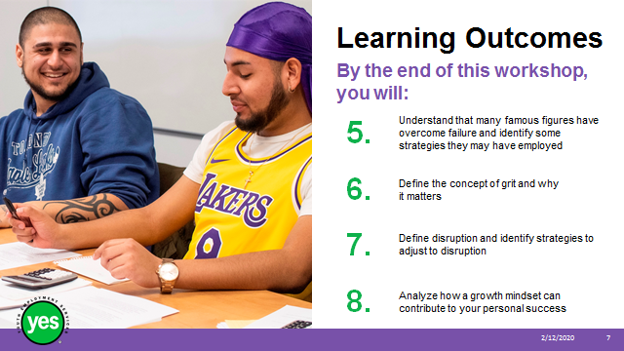 | Continued from previous slide.
Slide 8 | 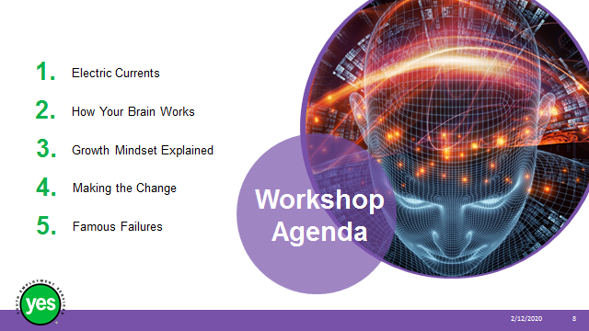 | Timing: 2 minutes.  Interaction Pattern: Whole class.  Materials Needed: Page 2.  Procedures and Notes: Review the agenda for the course.
Slide 9 | 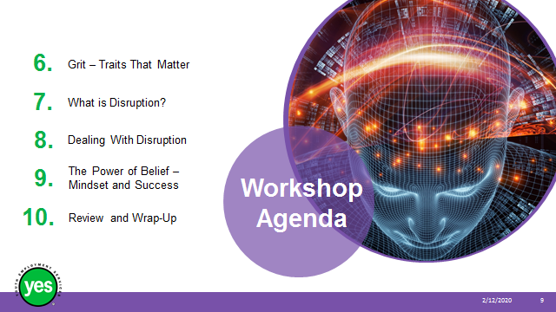 | Continued from previous slide.
Slide 10 |  | Timing: 10 minutes.  Interaction Pattern: Whole class.  Materials Needed: a small coin (like a quarter)  two small objects (such as a paper cup or foam ball) that can be grabbed  If you use the variation, you will need a large item like a stuffed animal or zipped up backpack.  Procedures and Notes: Ask participants to pair up and decide who will be a “1” and who will be a “2.”  Ask all of the “1s” to form a line.  Ask all of the “2s” to form a second line.  Have everyone hold hands as a chain, with everyone facing forward in the same direction.  Place each object at the end of both lines.  Ask all players to close their eyes. This game is to be played silently.  At the start of each round of gameplay, the facilitator does a coin toss.  Whenever “heads” is showing, the facilitator simultaneously lightly taps the shoulder of both team leaders and the “electric current” begins.  The two people at the front of each team squeezes the hand of the next person in the chain as fast as they can.  The next player who received the hand squeeze then also squeezes the next person in the chain, rapidly continuing to “pass the electricity” down the team.  The first team who grabs the object (the paper cup or foam ball) at the end of the chain is the winner.  As facilitator, it is important to flip the coin slowly and wait several sections between flips.  If someone grabs the object but there was no “heads” coin toss, that team loses a point.  You may change up the team order after each round if desired.  Play continues for several rounds. The winning team is the one that gets six points first.  Variation –  If you don’t have a coin you can have the two teams line up and then have the first person from each team join hands.  You as the facilitator can put your hand over their joined hands and ask the whole group to close their eyes.  When you squeeze the leader’s hands, they pass the squeeze along to their respective teams until it reaches the last person and both teams are trying to grab the same object at the end – something larger works well like a stuffed animal or zipped up backpack.  If the teams go for the item when you haven’t actually squeezed the first person’s hands yet they lose and the other team gets the point.  At the end of the game point out just like how we passed the signal along to move the “current” down the line of people our brains process information by using pathways that we can change and strengthen by using them more.
Slide 11 |  | Timing: 5 minutes.  Interaction Pattern: Whole class.  Materials Needed: Page 3.  Procedures and Notes: View video
Slide 12 | 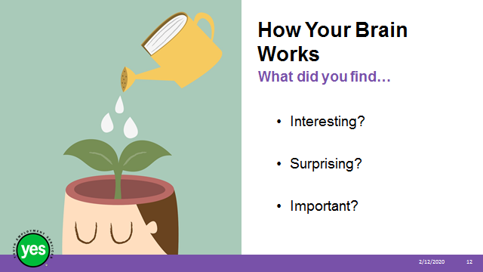 | Timing: 2 to 5 minutes.  Interaction Pattern: Whole class.  Materials Needed: None.  Procedures and Notes: Ask the group to share what did they found in the video to be  - Interesting?  - Surprising?  - Important?
Slide 13 | 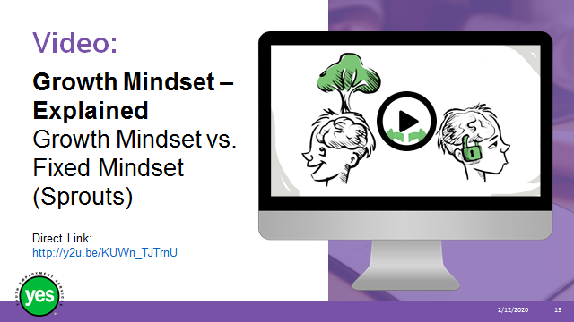 | Timing: 7 minutes.  Interaction Pattern: Whole class.  Materials Needed: Page 3.  Procedures and Notes: View the video  Ask the group – Do you think it is possible to make the switch from a fixed mindset to a growth mindset? Why or why not?  What needs to be in place to make the switch from a fixed mindset to a growth mindset?
Slide 14 |  | Timing: 20 minutes.  Interaction Pattern: Small groups. Whole group. Answers in Appendix.  Materials Needed: Page 4 activity. Flipchart and two colours of markers. Answers in Appendix.  Procedures and Notes: Divide the participants up into groups of 3-4  You can do this by having the participants count off 1,2,3,4,1,2,3,4, and so on as you work around the room.  Facilitator Tip – If you have the participants actually do the counting, rather than doing the counting for them and pointing at them, they are more likely to remember what number they are for this activity.  State that this is our chance to practice making the change from a fixed mindset to a growth mindset.  Direct them to page 4 of their workbook.  There are two examples on the worksheet to get them started.  Challenge the groups to come up with as many examples as possible in 3 minutes.  While the groups are working, take the flipchart and use the marker to divide the page into 2 columns.  At the end of the 3 minutes ask the groups how many ideas they were able to generate.  Start with the small group that generated the most ideas and ask them to share their ideas with the large group.  Record the statements on the left column of the flip chart.  Ask the other groups to add any statements that they generated that were different from what the first group shared.  Add them to the list on the flip chart.  Change the colour of marker you are using to write and ask the group to change each of the fixed mindset statements to a growth mindset statements.  Record the responses on the right column of the flip chart opposite the fixed mindset statement.  Once all of the statements have been converted, review the statements pointing out the transitions from fixed to growth mindset.  Facilitate a final discussion about how these examples can be used by the group in future situations.
Slide 15 |  | Timing: 20 minutes.  Interaction Pattern: Pairs, Whole Group  Materials Needed: Page 5 activity.  Procedures and Notes: View the video.  Ask the participants to find a partner.  Direct the pairs to page 5 in their workbook.  Ask the pairs to review the list of Famous Failures in their workbook and give them 2 minutes to choose 5 “failures” who they want to focus on for this activity.  Once they have identified their choices, ask the pairs to review what happened to each person and brainstorm, recording their ideas for what each of the people might have done to overcome their failure.  Give the pairs 5-7 minutes to complete the task.  After the task is complete, process the assignment by working through the list of names on the worksheet and asking for volunteers to share their responses as to what actions they identified the person may have taken to deal with their failure.  If no group choose a person from the list, you can offer some suggestions or you could brainstorm responses as a whole group.  Process the activity by asking -  - Has anyone heard these stories before?  - How would the world be different if these people listened to the comments?  - Are they are aware of any other examples?  - Are there examples from their own lives they can share?
Slide 16 | 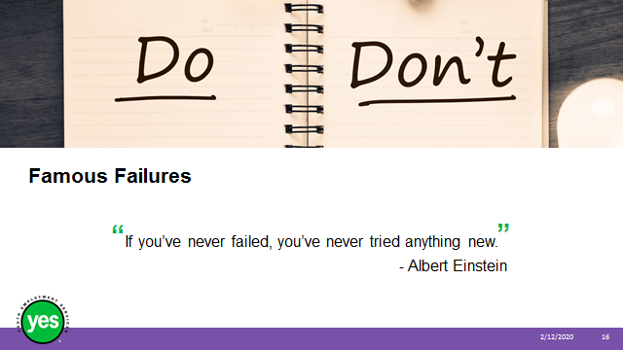 | Timing: 2 minutes.  Interaction Pattern: Whole class.  Materials Needed: Page 5.  Procedures and Notes: Read this statement to the group.  Ask for responses from the participants as to what this statement means to them.  Encourage the participants to follow up after the session. They could search the Internet or pick up a biography at the library or a bookstore of one of the Famous Failures we discussed or of someone else in a field that they are interested in.  Add that learning about the stories behind successful people can help encourage us to pursue our dreams.
Slide 17 |  | Timing: 10 minutes.  Interaction Pattern: Whole class.  Materials Needed: Page 6.  Procedures and Notes: View the video.
Slide 18 |  | Timing: 2 to 5 minutes.  Interaction Pattern: Whole class.  Materials Needed: Page 6.  Procedures and Notes: Ask the group to share what did they found in the video to be  - Interesting?  - Surprising?  - Important?
Slide 19 |  | Timing: 2 to 5 minutes.  Interaction Pattern: Whole class.  Materials Needed: Page 6.  Procedures and Notes: Share that this was the quote used in the last part of the video. Read the statement out loud.  Either relate the statement back to something that was shared in the previous discussion or ask for responses as to whether the participants agree or disagree and ask them to justify why they feel that way.
Slide 20 |  | Timing: 10 minutes.  Interaction Pattern: Whole class.  Materials Needed: Page 7.  Procedures and Notes: Ask the group if they know what this word means and take responses.  Ask additional questions of the participants who volunteer answers if you need the idea they are sharing expanded on.  Try to take at least 3 responses from the group.
Slide 21 |  | Timing: 2 to 5 minutes.  Interaction Pattern: Whole class.  Materials Needed: None.  Procedures and Notes: Share this definition with the group and emphasize that disruptive innovation is something that creates a new opportunity.  State that these new markets have a direct impact on the world of work and the kind of jobs that will be available in the future.  Continued on next slide.
Slide 22 | 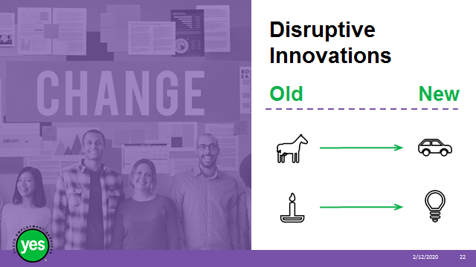 | Timing: 2 to 5 minutes.  Interaction Pattern: Whole class.  Materials Needed: None.  Procedures and Notes: Review the examples and share any personal observations or stories that may help build understanding of the impact of disruptive innovation.
Slide 23 | 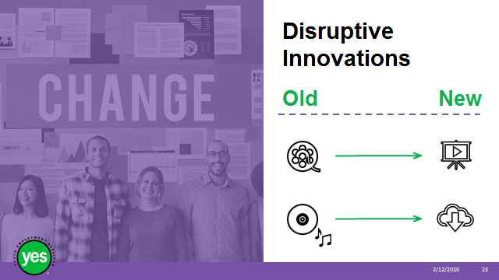 | Timing: 30 minutes.  Interaction Pattern: Small groups and whole class.  Materials Needed: YouTube Video and activity on next slide (page 7 in PW).  Procedures and Notes: Have the group line up in order of their birthday – you can choose as to whether they can talk or if they have to do it silently depending on how much time is available and the culture of the group.  Once everyone is in place, make groups of 3-4 participants by breaking taking the first group of 3-4 participants to make a group, the next 3-4 participants to make the second group, and so on.  Have the participants sit in their groups to view the video.  Before you view the video ask the participants to watch for examples of how the person in the video dealt with disruption.
Slide 24 | 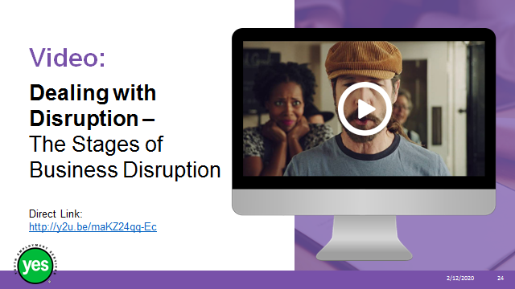 | Timing: 10 to 15 minutes.  Interaction Pattern: Whole class.  Materials Needed: Page 7 activity. Answers in Appendix.  Procedures and Notes: View the video  Direct the groups to page 7 of their workbooks.  Give the groups 10 minutes to work through the questions.  After 10 minutes take up the questions as a group, rotate through the groups to hear the responses and add any additional observations you may have to the responses.  After you have heard all of the responses, share that unexpected things will happen in your life. Your ability to carry on depends on how you react. Try to view the unexpected thing as an opportunity and you will be using a growth mindset.
Slide 25 | 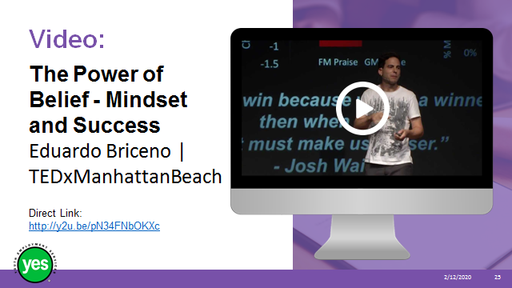 | Timing: 30 minutes.  Interaction Pattern: Pairs. Whole class.  Materials Needed: Page 8 activity.  Procedures and Notes: Prior to showing the video - ask the group to look for three things that stand out to them.  After viewing the video – get them to pair up and share the points they identified that stood out, give time to share responses with their partner.  After the discussions with their partners, ask the group –  - Did you and your partner identify any of the same things? If so what where they?  - Ask for a show of hands from any of the other pairs identified the same things.  - As the participants are sharing, record the ideas on chart paper or white board to reinforce the concepts,  Here are some aspects they might share –  - Chess player story – changing focus  - How losing can help you learn  - We can change our ability to perform and the key to success is a growth mindset.  - Praise effort  - Make feedback process-related versus praising talent.  - “If we win because we are a winner, then when we lose it’s because we are a loser.”  - We can change our mindsets.  - The effect has the biggest impact on minority groups.  - Employees with growth mindsets about skills become better at them.  - Growth mindsets can help us solve social issues.  - The power of ‘Yet’  - (add other points you notice)  Finally, state that keeping these examples in mind will help the participants strengthen their growth mindset practice.
Slide 26 |  | Timing: 10 minutes.  Interaction Pattern: Pairs.  Materials Needed: Page 8.  Procedures and Notes: Share the following:  Start – that is the first critical step  Reflect - Think about all of the skills that you have built throughout your life and how you have advanced them.  Do a Bit of Research – Learning about neuroplasticity will allow you to recognize that your brain’s capacity to grow is much greater than you probably thought. It will help you see that your brain is physically capable of growing and, therefore, your skillset is capable of growing as well.  Seek Out Learning Opportunities - Specifically, seek out a learning opportunity that you think you’re “not cut out” for.  Cultivate Grit - Your grit defines your perseverance to meet your goals. It is the amount of effort you are willing to put forth to accomplish something and your willingness to keep moving–no matter how difficult things get–when the reward is far away. In order to have a growth mindset, you have to cultivate grit.  Keep a Journal for 21 Days - This activity will challenge you to start trying new things every day for 21 days. As long as it challenges you and steers you out of your comfort zone, this growth mindset activity will be effective.  Try New Learning Strategies - Adults need to self-direct their learning, meaning they do it at their own pace and they learn what they want to learn. Adults also have to be able to have a relevant experience to help retain what they’re learning. Finally, adults need to be working toward a goal or have a purpose for learning.  Source – developinggoodhabits.com
Slide 27 | 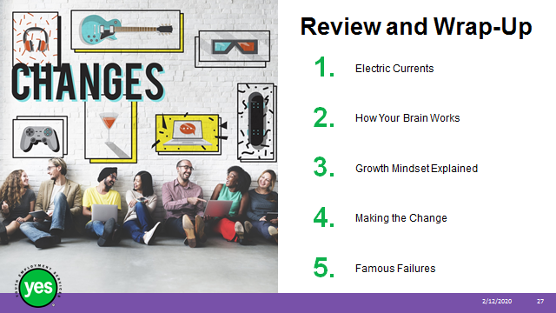 | Timing: 2 minutes.  Interaction Pattern: Whole class.  Materials Needed: Page 9.  Procedures and Notes: Briefly review the topics covered in the module.
Slide 28 |  | Continued from previous slide.
Slide 29 |  | Timing: 5 minutes – more as needed.  Interaction Pattern: Whole group.  Materials Needed: None.  Procedures and Notes: Ask the group to share any outstanding questions about the workshop content.  Facilitate a discussion to respond to the questions.
Slide 30 |  | Timing: 5 minutes.  Interaction Pattern: Individual response.  Materials Needed: Page 9.  Procedures and Notes: The 3-2-1 exercise is the formative assessment activity for this workshop.  3-2-1 consists of asking participants to consider the following questions at the end of the workshop.  Direct participants to page 9 of their workbooks.  Ask the participants to reflect on the workshop and complete the questions independently.  - What are 3 things I’ve learned?  - What are 2 things I want to learn?  - What is 1 question I still have?
Slide 31 |  | Timing: 2 minutes.  Interaction Pattern: Whole class.  Materials Needed: None.  Procedures and Notes: Direct participants to the additional resources at the end of the Participant Manual for further information.

3. Making the Change

Examples for Facilitator - Answer Key

Fixed Mindset | Growth Mindset
Great job! You’re really smart! | Great job! The study plan you made helped a lot. You should make another for the next test.
I’m not good at this subject. | Don’t worry if you don’t understand something right away. Focus on your next steps. What should they be?
This is too easy for me. | How can I make this more challenging so that the experience is worthwhile for me?
I’m afraid that I might make a mistake. | There is no failure; only success or learning.
I won’t try to do this because I know I can’t. | It’s okay if I’m not successful because I can learn from my efforts and try again.
This is too difficult for me. | I will need to work hard and find the right strategy for this.
No one in my family is good at this. | Everyone has their own opportunities and experiences that help them develop.
You tried your hardest, and that’s all you can do. | You really tried hard! Is there another way that you could look at this?
You’ll eventually get these types of questions if you just keep trying. | If you don’t understand these types of questions, try using a different perspective. You may be able to draw or write them out.
I don’t like to be challenged. | Challenges help me to grow.
I stick to what I know. | I like to try new things.
Feedback and criticism are personal. | Feedback is constructive.

The Stages of Business Disruption Answer Key

Stage 1 | Disruption Brings Exponential Change
How did the baker react?
- Sleeplessness
- Longing for the sandwich he can no longer eat
- Closed his business and put it up for sale
- Threw out his inventory

 | Exponential Change Brings Unlimited Possibility
What made the baker start to think differently?
- The cookbook he found by accident in the trash * inspiration can come from the most unusual places!
- He was exposed to new possibilities.

What did the baker do once he began to think differently?
- He reframed what he already loved to do and still dealt with the disruption of needing to be gluten-free.
- He adopted and embraced the new direction and made it his own (e.g. adjustments to the recipe).
- He adjusted his business plan to be a gluten-free bakery.

Stage 3 | Unlimited Possibility Brings Rising Customer Expectations
What happened once he re-branded as a gluten-free bakery?
- People started making very specific special diet requests that they felt were appropriate now that he was gluten-free.

Conclusion | Disruption Brings Opportunity
How did the baker respond?
- Custom-made croissant where he seized on the opportunity and created an app and still kept his bricks and mortar store open with personalized service

