Youth Employment Services - YES
www.yes.on.ca
Future skills: fostering Collaboration and connection
Facilitator’s Guide
Fostering Collaboration and Connection: Workshop at a Glance

Overview and Purpose

This workshop introduces the key concepts related to teamwork, why teamwork skills are important, teamwork skills at work, and the world of virtual teamwork. You will take part in activities to define and explore how to build, improve, demonstrate and reflect on your teamwork skills.

Time

The workshop is between three and six hours long. All timings provided in the Facilitator’s Guide are approximate. Note that the timings for the slides don’t add up exactly to three or six hours, because some of the activities can be extended or shortened. You can lengthen, shorten or leave out activities based upon the needs of your participants and the amount of time you have for the workshop. You should have short breaks at least every 90 minutes.

Learning Outcomes

At the end of this workshop you will be able to:

- Understand the concept of teamwork and why teamwork skills are important.
- Identify the skills needed for positive teamwork to occur.
- Recognize teamwork skills you can build before you start working.
- Understand the stages of group development.
- Identify different work archetypes (capability profile and examples shared with participants).
- Identify ways in which new teams can effectively engage.
- Address conflict and struggle in teams.
- Identify the value of adaptability in teams.
- Understand how to make a good impression about teamwork skills in resumes and interviews.
- Define the concept of virtual teamwork skills and best practices.

Leading Questions

As participants complete this workshop, some of the questions they will think about include:

- What is teamwork?
- Why are teamwork skills important to employers?
- If you do not have a lot of work experience, how can you gain teamwork skills in other ways?
- What type of worker (archetype) do you identify with?
- How could you demonstrate good teamwork skills?

Workshop Agenda

Introductions and Workshop Overview

- What Is Teamwork?
- Why Are Teamwork Skills Important?
- Teamwork Skills You Can Build Before You Start Working
- Teamwork Skills at Work
- Demonstrating Teamwork Skills
- Virtual Teamwork Skills
- Review and Wrap-Up

Materials Needed

- White board/Screen/Internet connectivity
- Each participant should have a workbook and a device
- PPT Presentation Teamwork
- Activity material – pad of sticky notes

Formative Assessment

The Reflection exercise at the end of the agenda constitutes the formative assessment for this module. This activity consists of asking participants to consider the following questions:

- Why are teamwork skills important to an employer?
- How could you develop your teamwork skills? Name at least one example.
- How could you demonstrate good teamwork skills? Name at least one example.

Detailed Workshop Plan

Slide 1 |  | Timing: Display as the participants come in.  Interaction Pattern: Whole class.  Materials Needed: None.  Procedures and Notes: None.
Slide 2 | 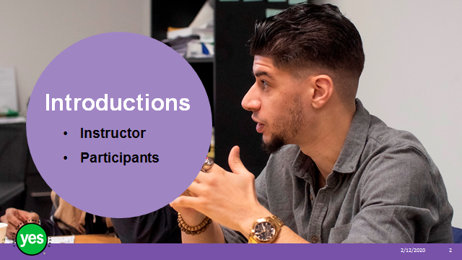 | Timing: 15 minutes.  Interaction Pattern: Pairs and whole class.  Materials Needed: None.  Procedures and Notes: Give the pairs 5 minutes to have a conversation with their partner to find out the answers to these questions:  - What is your name?  - What are you hoping to learn from this workshop?  - What is a fun fact about you that you want to share with the group?  Tell the group that after their conversation they should be prepared to introduce their partner to the group by sharing this information.  If you have an odd number of participants, you (the facilitator) will find a partner yourself and have a conversation to find out the answers for your partner.  If you have an even number of participants, get the group to pair up and then circulate around the room as the pairs are sharing. Identify a particularly strong pair and ask them to lead off the large group sharing. Coach them to follow the prompts on the screen.  At 3 minutes get the attention of the group and comment that they need to make sure that both partners have a chance to share their answers (sometimes one partner will monopolize the conversation).  After 5 minutes get the attention of the group and start the sharing by modeling the introduction format with your partner. After your partner has introduced you, get them to choose which pair goes next.  After the second pair introduces each other, get them to choose who goes next, and so on.  Have some fun with the fun facts shared and if there is a theme that emerges embrace it and try to find commonalities among the group members.  Trainer Tip - By moving around the room randomly instead of going around in order of seating, you are keeping the participants more engaged and introducing some fun in the anticipation of not knowing who goes next.  As a facilitator, take note of what the participants share related to learning goals for the workshop. During the workshop be intentional with your comments related to the various goals shared to point out where the topic area is being covered.  If there is a goal that is shared by a participant that is more related to one of the other workshop topics, you can share that with the group as an additional training opportunity.  After all of the pairs have shared their introductions, ask them to return to their seats and have each participant put a name card in front of them for your reference.  Debrief the activity by sharing that we are already working on our teamwork skills of getting to know each other and creating an environment where people feel comfortable to contribute and share.
Slide 3 | 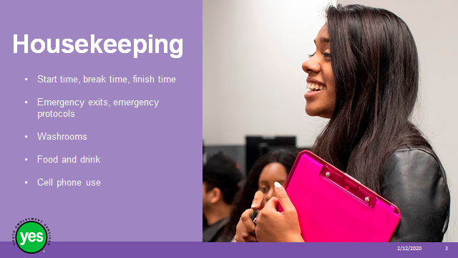 | Timing: 2 minutes.  Interaction Pattern: Whole class.  Materials Needed: None.  Procedures and Notes: Review all of the housekeeping details indicated on the slide. For cell phone use, indicate that if they are expecting an urgent call, their phone should be on vibrate. Otherwise indicate it should be on silent. They should not respond to texts or emails during the workshop.
Slide 4 | 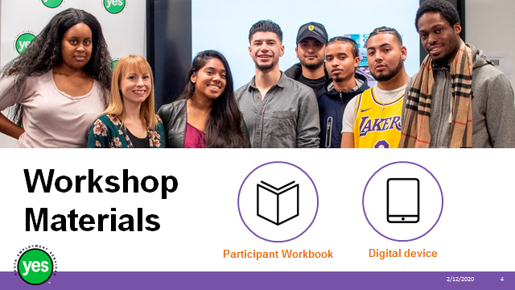 | Timing: 2 minutes.  Interaction Pattern: Whole class.  Materials Needed: One Participant Workbook per participant.  Procedures and Notes: Direct participants to their Participant Workbooks. Have them put their names on them. Indicate that this is their record of the key information in the workshop and ideas they generate during the workshop. Indicate that there may be some activities in which they may choose to use their cell phone/device.
Slide 5 | 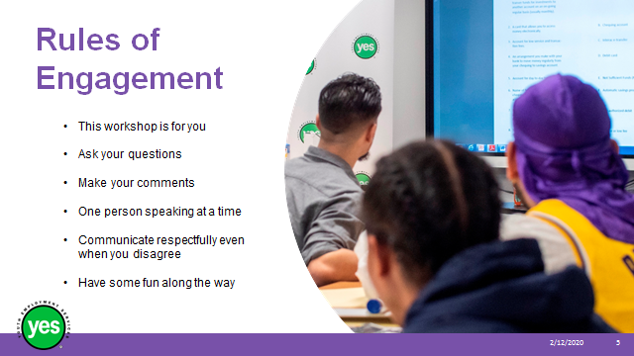 | Timing: 2 minutes.  Interaction Pattern: Whole class.  Materials Needed: None.  Procedures and Notes: Review your expectations for the participants. Indicate that your role is to guide them through the material and facilitate discussion.
Slide 6 | 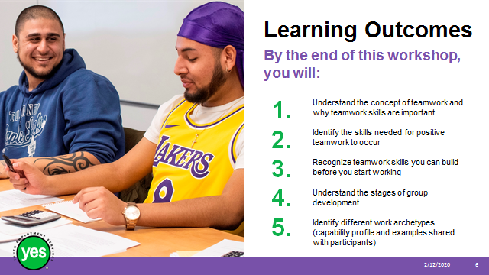 | Timing: 2 minutes.  Interaction Pattern: Whole class.  Materials Needed: Page 1.  Procedures and Notes: Review the learning outcomes of the workshop, stressing the practical knowledge and abilities that participants will walk away with.
Slide 7 | 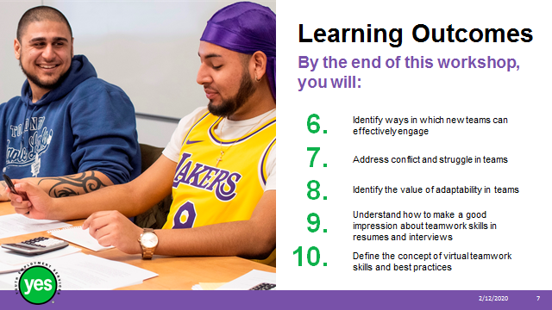 | Continued from previous slide.
Slide 8 | 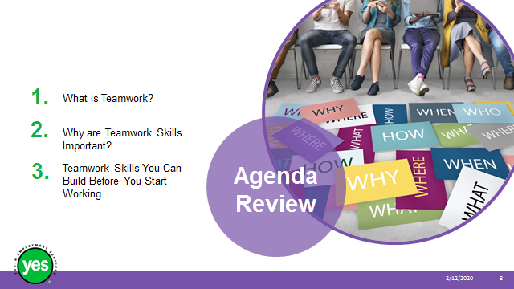 | Timing: 2 minutes.  Interaction Pattern: Whole class.  Materials Needed: Page 2.  Procedures and Notes: Review the agenda for the course.
Slide 9 | 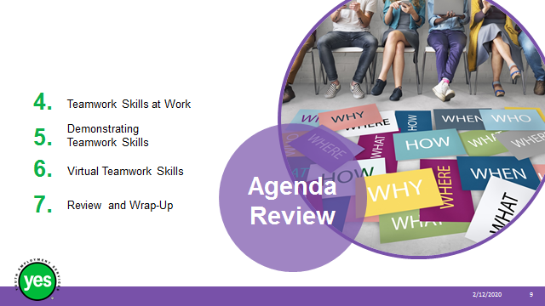 | Continued from previous slide.
Slide 10 | 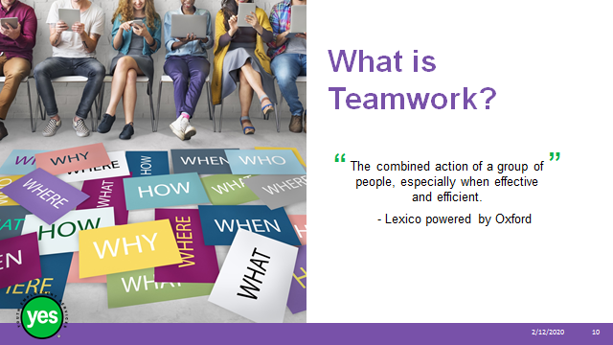 | Timing: 10 minutes.  Interaction Pattern: Whole class.  Materials Needed: Page 3.  Procedures and Notes: Ask the group what Teamwork means to them.  Take a few volunteer responses from the group. Identify any themes that emerge.  Click to share the dictionary definition and share any connections with what the group shared in their responses.
Slide 11 | 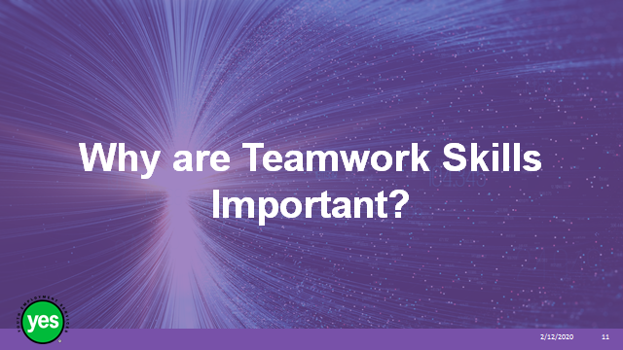 | Timing: 2 minutes.  Interaction Pattern: Whole class.  Materials Needed: Page 3.  Procedures and Notes: State that:  - Teamwork is vital if you want to work well with colleagues and teammates.  - The better you work with others, the more successful your team will be in achieving its goals.
Slide 12 | 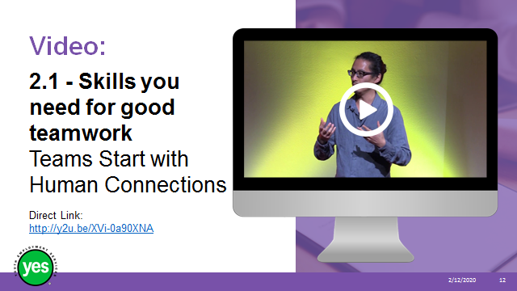 | Timing: 20 minutes.  Interaction Pattern: Small groups.  Materials Needed: None  Procedures and Notes: Ask the participants to form groups of 3 to 4 and sit together.  View video (5:52)
Slide 13 | 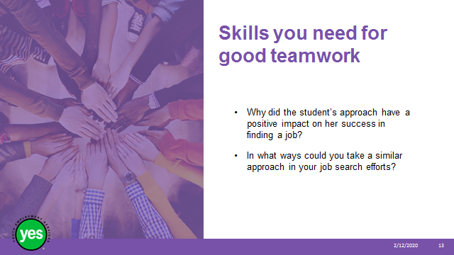 | Materials Needed: None  Procedures and Notes: After viewing the video, ask the participants to think about the first question and have a conversation in their small group about their answers.  After 2 to 3 minutes, ask the participants to think about the second question and share their responses.
Slide 14 | 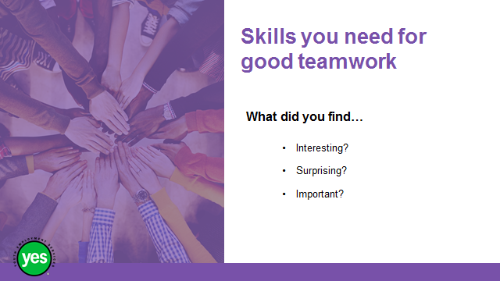 | Procedures and Notes: After 2 to 3 minutes of small group discussion about the second question, get the attention of the whole group.  Ask groups to share a sample of their responses to the questions from the video as well as what they considered to be:  - Interesting?  - Surprising?  - Important?
Slide 15 |  | Timing: 10 minutes.  Interaction Pattern: Whole group.  Materials Needed: Flip chart and marker. Page 3.  Procedures and Notes: State that:  Employers value your ability to work in a team.  If you do not have a lot of work experience how can you gain teamwork skills in other ways?  Ask the group to brainstorm ideas and record them on the flip chart.
Slide 16 | 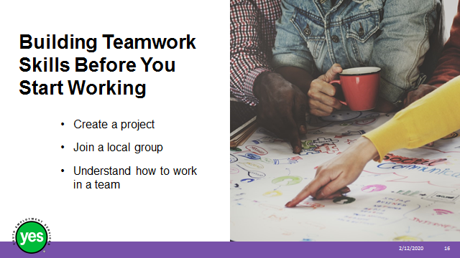 | Procedures and Notes: As you work through the points below one at a time, go back to the flip chart list and connect these responses to any ideas that you have already touched on during brainstorming.  - Create a project - Find opportunities to work in a group. Then make sure you contribute to the group and help others to get involved.  - Join a local group - Lots of groups run in local areas for all kinds of interests including conservation, politics, special interests and team sports. Getting involved in a group is a great way to build your teamwork skills. If you are not sure how to connect with the local groups in your area, visit your government offices or library (either in person or online) and ask or search “groups in my area” on the internet. You can also go to your local grocery store or coffee house and look at the flyers that are posted on the community board for a group that appeal to you.  - Understand how to work in a team - Communication, planning, problem solving and negotiating are some of the skills you will need to develop. Work on these skills and your teamwork skills will improve too!
Slide 17 | 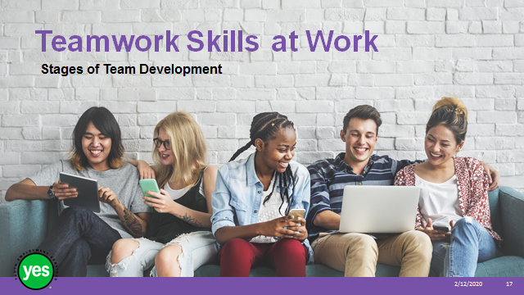 | Timing: 2 minutes.  Interaction Pattern: Whole class.  Materials Needed: Page 4 and 5 activity.  Procedures and Notes: None.
Slide 18 | 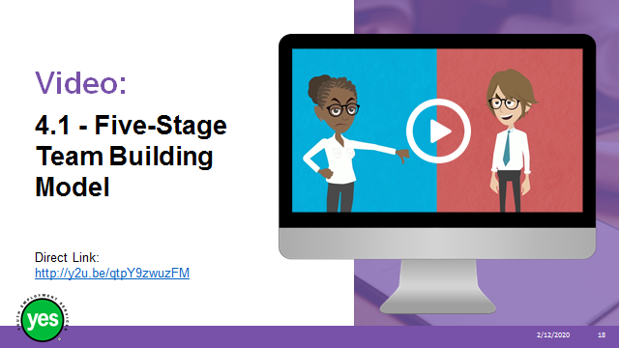 | Timing: 20 minutes.  Interaction Pattern: Pairs. Whole group.  Materials Needed: Page 5.  Procedures and Notes: Find a partner and sit together to view the video (3:04).  Give the pairs 5-7 minutes to review the definitions on the chart and respond to the questions on page 5 together.  After 10 minutes take up the questions with the whole group. Refer to the answer key in Appendix A for responses.  Conclude the discussion by stating that understanding these stages can really help you be an effective team member. Recognizing the stage that your group is at is key in the process of moving toward achieving your goals.
Slide 19 | 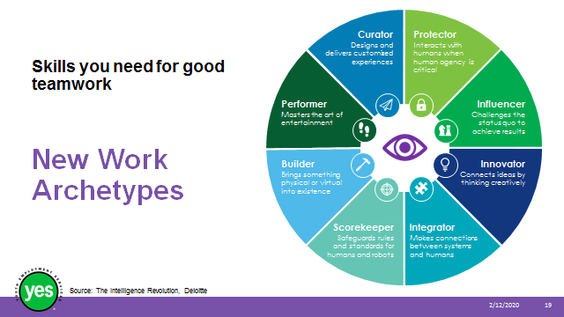 | Timing: 20 minutes.  Interaction Pattern: Small group. Whole class.  Materials Needed: Page 6 and 7.  Procedures and Notes: State:  Research by Deloitte has identified the most critical capabilities workers will need in order to be successful at work in the future. The capabilities have been grouped to form a profile that they have a called an archetype.  By understanding the characteristics that these archetypes possess you will be better prepared to work with these different characteristics in your co-workers.  Ask the group to follow along as you review the different identified archetypes together.  Continued on next slide.
Slide 20 | 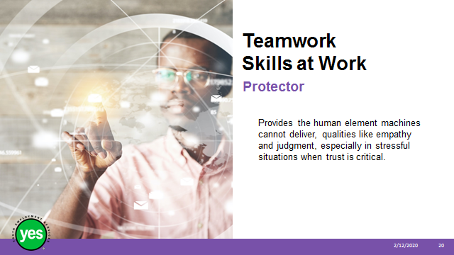 | Procedures and Notes: Read the description out loud.  Point out that the protector builds and sustains relationships between people and is able to detect nuances (unspoken messages we give off, body language, tone of voice, our personality) and social factors (customs, norms, potential conflict).  The protector also takes information obtained through personal interactions to interpret the information to make decisions.  The protector is found in jobs like police officer, family doctor, speech/language pathologist, tele-nurse, end-of-life therapist.  Continued on next slide.
Slide 21 | 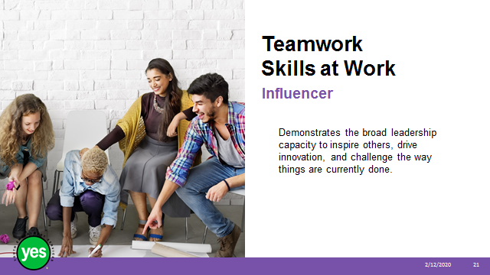 | Procedures and Notes: Read the description out loud.  Point out that the influencer can influence others by building relationships, providing inspirational leadership to motivate and inspire others, and has the competitive edge to drive change, navigate disruption and accelerate new product and idea development.  The influencer can be found in jobs like and online community manager, a relationship manager, coach or politician.  Continued on next slide.
Slide 22 | 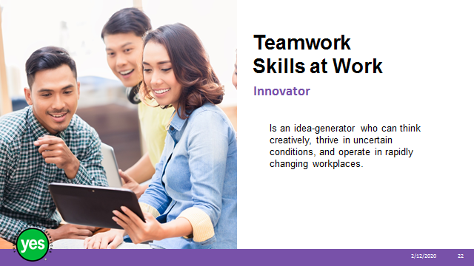 | Procedures and Notes: Read the description out loud.  Point out that the innovator has the ability to create a workplace where there are opportunities to streamline work, minimize waste and drive change. The innovator identifies problems and works to understand the dynamics that cause them while applying effective solutions.  Innovators put plans into action by utilizing resources in new and unique ways to seize new opportunities.  Designers, university professors, game developers, continuous improvement agents and engineers are typically innovators.  Continued on next slide.
Slide 23 |  | Procedures and Notes: Read the description out loud.  Point out that the integrator identifies opportunities to connect people and ideas. The integrator combines the ability to think analytically about complex problems with the capacity to design and communicate solutions. Integrators can uncover relationships between seemingly unrelated things to create new opportunities.  Integrators are often journalists, executive chefs, retail buyers, teachers, networking specialists and company culture ambassadors.  Continued on next slide.
Slide 24 | 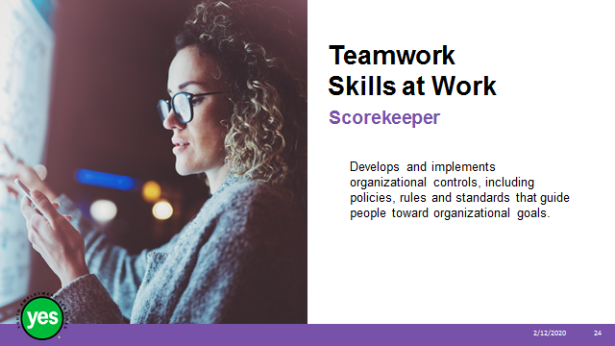 | Procedures and Notes: Read the description out loud.  Point out that the scorekeeper plays a critical role in monitoring and making sure risks are at a minimum. They are trusted advisors and influencers, helping to ensure that the organizations run smoothly, safely and to their fullest potential.  Scorekeepers can build and sustain interpersonal relationships in a way that promotes ethical behaviour and integrity.  Scorekeepers are usually accountants, lawyers, insurance professionals, big data scientists and cybersecurity analysts.  Continued on next slide.
Slide 25 | 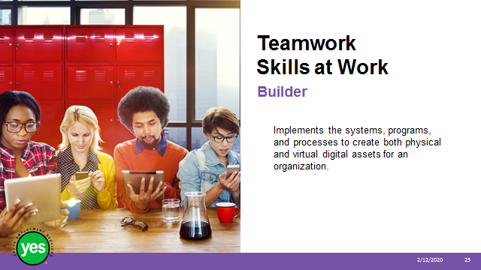 | Procedures and Notes: Read the description out loud.  Point out that the builder works closely with innovators and integrators to bring ideas to life. They build as well as integrate systems like a computer network or production line into a workplace.  Builders gather information about the environment and the needs of the system to make decisions. They leverage key resources and people to resolve complex challenges.  Builders can be car mechanics, financial analysts, farmers, AI developers and robotics programmers.  Continued on next slide.
Slide 26 | 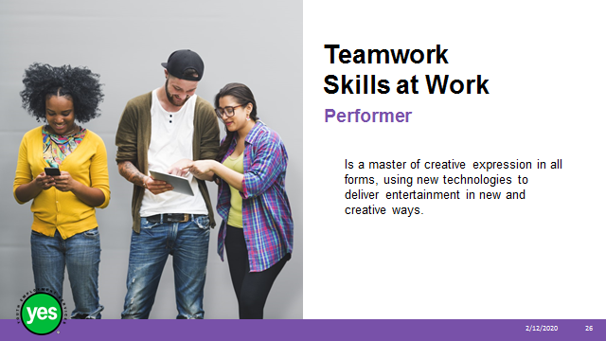 | Procedures and Notes: Read the description out loud.  Point out that the performer will take advantage of technological advances to create visual enhancements that help athletes, use 3D printing to create exciting new works of art. Performers think creatively and connect people with new experiences.  Performers translate the creative vision into reality and they have the ability to read social situations and make adjustments as required.  Performers are musicians, film producers, broadcasters, professional athletes, and vloggers.
Slide 27 | 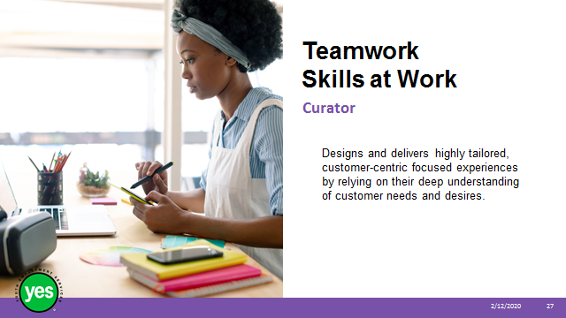 | Procedures and Notes: Read the description out loud.  Point out that the curators evaluate markets, understand customers, and develop products and services people want.  Curators bring a knowledge of social networks and digital platforms to organizations. They possess a deep understanding of what motivates customers, identifying what people want and how to deliver it.  Curators are customer experience strategists, recreation guides, advertising managers, customer service specialists and hairstylists.
Slide 28 | 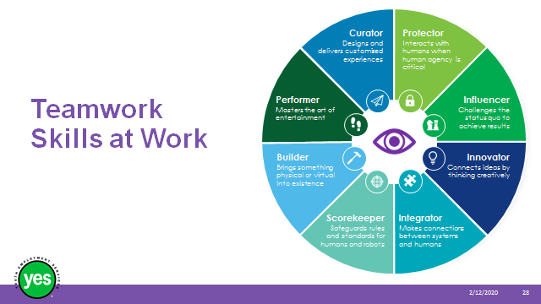 | Procedures and Notes: Ask the participants to review the descriptions of the different types of archetypes on page 7. Give them 3 minutes to choose an archetype that they feel best fits with their interests. Invite the participants to make a note on page 7 of which archetype they’ve chosen and why they chose it.  After 3 minutes work through the list of archetypes and ask for a show of hands as to which archetype they selected. Encourage participants to make note of the others who have chosen the same archetype and to reach out during a break to get to know each other a little better. There may be an opportunity outside of this class for you to provide support to each other to develop your skills in this area further.
Slide 29 | 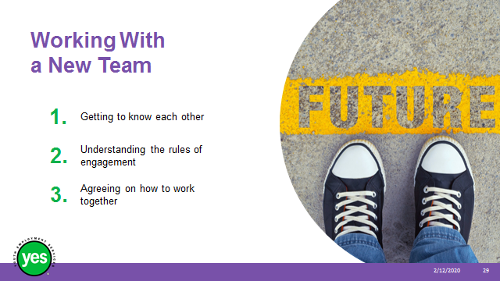 | Timing: 20 minutes.  Interaction Pattern: Small group. Whole class.  Materials Needed: Page 8 activity.  Procedures and Notes: Break participants into small groups by getting them to play “Rock, Paper, Scissors.”  - Review how to play by modeling the symbol for each option – rock (closed fist), paper (a flat open hand), and scissors (hand in a fist except for your pointer and middle fingers that are extended to clap together forming a pair or “scissors”).  - Note that for the purpose of this game we are only using these options (e.g. no single finger extended to symbolize dynamite, etc.)  - Share that winners are determined by the following order – paper covers rock, rock breaks scissors, scissors cut paper.  - Ask for understanding from the group and if any concept is challenging review and/or ask for a volunteer to play a few rounds with you to illustrate.  - Once the group is ready, invite them to play the best 2 out of 3 to determine the winner of each pairing.  - Ask the winners of each pairing to move to one side of the room and sit as a group.  - Ask the other player to move to the opposite side of the room and sit as a group.  Once the two groups are formed, direct them to page 9 and state that here are 3 aspects to think about when you are part of a new team:  1. Getting to know each other  2. Understanding the rules of engagement  * remind participants that we discussed this idea at the beginning of the workshop.  3. Agreeing on how to work together  Ask the groups to identify a team member to be the recorder for this activity and they will keep track of the responses from their group.  Invite the groups to brainstorm ideas of ways that teams could do each of these activities. Encourage participants to think about times when they’ve been on teams at school or in the community. Review the questions under each tip:  - In what ways could a new team get to know each other?  - What are some rules of engagement that are important for new teams?  - What are some of the things to think about when you are working on a project together?  Give the groups 7 minutes to discuss and record their answers.  Take up the questions as a large group and invite responses from both of the groups.  See Appendix A for some possible responses to help you facilitate this discussion.  Wrap up this activity by sharing -  - These aspect of working in a team might sound simple but it is worth taking the time to work them out, conflict often comes when people feel like they are being treated unfairly and it is often too late to set rules after something has gone wrong.  - Getting to know people and setting the expectations of the team early means that you’ll have more time to get on with the task at hand and hopefully enough time left over to have some fun too.
Slide 30 |  | Timing: 15 minutes.  Interaction Pattern: Whole group.  Materials Needed: Page 9 and YouTube video “How to Deal with Conflict and Struggle with Teams.”  Procedures and Notes: Introduce the video by sharing that it is a funny way of showing what bad teamwork and good teamwork can look like.  View the video (3:20)
Slide 31 | 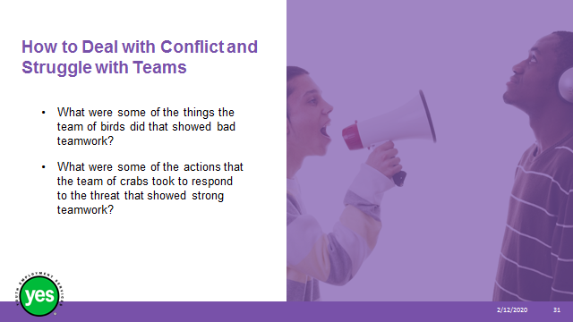 | Procedures and Notes: Ask the group to focus on the bad teamwork example.  Click to reveal the question:  What were some of the things the team of birds did that showed bad teamwork?  - Made fun of the new member  - Moved away from him  - Gossiped about him  - Picked on him  - Physically attacked him  Ask what happened to them in the end?  Now ask the group to focus on the good teamwork example.  Click to reveal the question:  What were some of the actions that the team of craps took to respond to the threat that showed strong teamwork?  - Crab under attack asked for help  - Came together  - Coordinated their efforts  - Acted on their plan  Review the points on page 10 related to how to manage conflict.  Share that there will always be challenges when you work with other people but it’s how you respond to the challenges that makes the difference. Conflict can bring a team together, drive change, share different and creative ways of thinking and develop your skills.
Slide 32 | 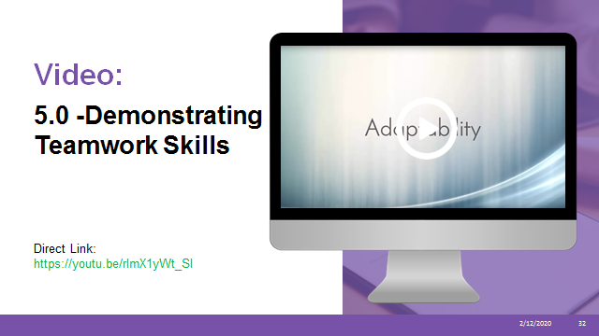 | Timing: 5 minutes.  Interaction Pattern: Whole group.  Materials Needed: YouTube video “Adaptability in the Workplace” and Page 10.  Procedures and Notes: Watch video.  Continued on next slide.
Slide 33 | 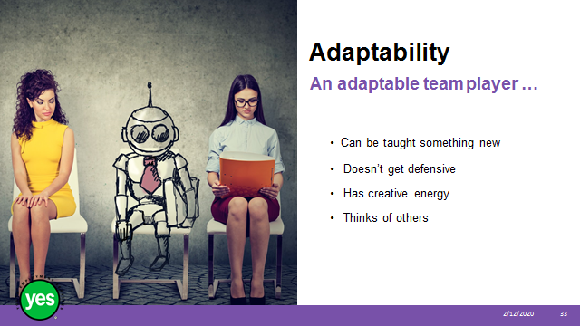 | Materials Needed: Page 10.  Procedures and Notes: Review the following points:  Share that in addition to the points shared at the end of the video, an adaptable team player …  Can be taught something new - e.g. equipment, software, processes. You can use and adapt skills you already have to new situations  Doesn’t get defensive - It’s okay if it takes time to learn something new, so long as you are willing to try. Whatever your reasons, some people get defensive if they have to cope with change or learn something new.  Some examples:  A new manager has been added to the team, your work has been given critical feedback, or there’s a big change at work, like the office becoming open plan instead of having rooms. Just focus on the positives, since the change is happening anyway. Maybe it will mean more new opportunities, a chance to refine your idea, or have new office conversations.  Has creative energy - When you’re faced with the need to do something different, you come up with ideas to work around the changes ahead. It’s good for team spirit and getting things done.  Thinks of others - Thinking of others is an attractive quality in a team player. That’s why volunteering always looks so good on your CV. When you believe the other people in the team are important, it’s easier for you all to achieve great things – especially in times of change.
Slide 34 |  | Timing: 5 minutes.  Interaction Pattern: Whole group.  Materials Needed: None.  Procedures and Notes: Ask the group for a show of hands as to whether or not participants currently list the teams they are involved with from work or personal situations on their resumes.  Share that:  - Your resume is the first place where you can show a future employer your teamwork skills. Record the teams you are involved in from work or personal situations. Summarise how you have contributed to these teams and helped them meet their goals.  - If you are writing a cover letter, think about how you can show team spirit when talking about your achievements and experiences in working as a team.  - You may also share teamwork examples during a job interview.
Slide 35 |  | Timing: 5 minutes.  Interaction Pattern: Whole group.  Materials Needed: None.  Procedures and Notes:  Share that –  - One-on-one you will need to rely on giving examples of your experience to show an employer you’re good at working with others.  - If you have an assessment centre or group interview, that’s a great chance to let your teamwork skills shine.
Slide 36 | 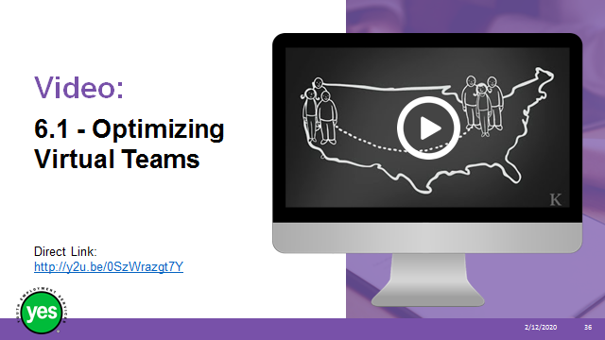 | Timing: 20 minutes.  Interaction Pattern: Whole group and pairs.  Materials Needed: YouTube video and Page 10 and 11.  Procedures and Notes: Ask the group what the definition of virtual is (occurring or existing primarily online).  Ask the group for some examples from the group of something that is virtual (gaming, computer networks, virtual reality goggles, teams at work).  Before you watch the video, share that you may not have a job right away where you are working on a virtual team, but it is definitely a trend for the future.  Ask participants to find a partner and have them review the strategies listed on page 11 together.  Give the pairs 5 minutes to review the list, make their choice and think of their reasons.  Bring the group back together and ask for a volunteer pair to start. After they have shared their answer let them choose the next pair to take a turn, and so on.  Once all of the groups have shared their answers, share any points that were chosen more than once, or themes that emerge.  Close by sharing that regardless of what kind of team you become a part of now, more companies are adopting virtual teams as a method of dealing with rising costs of facilities and the increasing occurrence of teams with representatives in remote locations. Odds are you will be working at some point in a virtual team.
Slide 37 |  | Optional Activity  Timing: 20 minutes.  Interaction Pattern: Whole group and at least one staff member (ideally off-site) who can connect by video conference.  Materials Needed: Access to a video conferencing program like Skype, Google Hangout, Zoom or GoToMeetings; at least one other staff member (ideally at least one would be connecting from a location off-site).  Procedures and Notes: Prior to the workshop - Invite at least one other co-worker to join the workshop for approximately 10 minutes using the video conferencing method of choice for your agency. Ideally one of the people joining the workshop will be located away from the agency location and the participants wouldn’t be familiar with them.  Let your co-worker(s) know that you are orienting a group of participants to the concept of a virtual meeting and that you would like them to share their experiences with virtual meetings with the group. Give the co-worker(s) an approximate time that you will be connecting with them and in the last break before this section send them a quick text message to make sure that they are prepared.  Ask one of the workshop participants to thank the callers at the end of the call on behalf of the group. Encourage them to make note of something specific during the call that they felt was helpful to comment on while giving their remarks.  During the workshop - Tell the group that they are going to be taking part in a virtual meeting.  Ask participants if they have ever taken part in a video call with a group or team before and facilitate a discussion with the group about how this technology is used. This is a good chance to touch on things like the fact that the other person can see you during the whole call and hear what is going on around where you are.  Demonstrate how you are connecting to the caller(s) to the group.  Once the caller(s) are connected, ask them to take turns introducing themselves and sharing a bit about how they use virtual meetings in their work.  Allow time for the participants to ask any questions they may have of the callers.  Ask the workshop participant to share their thanks with the caller(s).  Debrief the experience with the group asking them what they found –  - Interesting?  - Surprising?  - Important?  During the activity.  Direct their attention to page 11 and review the list of best practices for working with virtual teams. Make sure to highlight any of the points that have already come up during the activity.
Slide 38 | 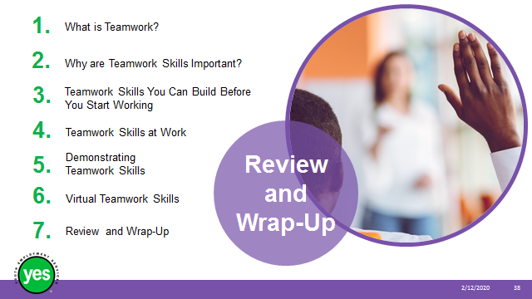 | Timing: 2 minutes.  Interaction Pattern: Whole class.  Materials Needed: Page 12.  Procedures and Notes: Briefly review the topics covered in the module.
Slide 39 |  | Timing: 5 minutes – more as needed.  Interaction Pattern: Whole group.  Materials Needed: None.  Procedures and Notes: Ask the group to share any outstanding questions about the workshop content.  Facilitate a discussion to respond to the questions.
Slide 40 |  | Timing: 15 minutes.  Interaction Pattern: Individual reflection, Pairs. Whole group.  Materials Needed: Page 12. A pad of sticky notes.  Procedures and Notes: Direct participants to the questions on page 12. Give them 5 minutes to reflect on the questions and complete them.  After 5 minutes ask them to find a partner and share their responses. Instruct them to share their answers and look for similarities and differences between their individual responses.  Hand out the pads of sticky notes and instruct each participants to take 3 sheets.  Instruct the participants to write down up to 3 things that “stuck” with them from the workshop.  Ask the participants to stick their responses to a specific wall or door prior to leaving the workshop room.  Note to Facilitator – After the workshop has ended, gather the sticky notes and group them my idea/theme/concept. This is a valuable way to know what workshop content participants find most helpful and it provides you with valuable insight into the messages they are receiving.
Slide 41 |  | Timing: 2 minutes.  Interaction Pattern: Whole class.  Materials Needed: None.  Procedures and Notes: Direct participants to the additional resources at the end of the Participant Workbook for further information.

Appendix A
4.1. 5 Stages of Team Development
- Getting to know each other:
In what ways could a new team get to know each other?
  - Introduce themselves, you’ll need to know who your team members are, what you call them and how you can reach them.
  - Talk about what they enjoy: What do you have in common or is there something new they can teach you?
  - Talk about their strengths and weaknesses: These will become clearer as you work together but understanding early on who likes public speaking, enjoys writing, might be creative or a natural leader will help you understand how the team can take shape – it’ll also show you very soon what skills the team might be missing so you can all work together on filling them.

- Understanding the rules of engagement:
What are some rules of engagement that are important for new teams?

  - Respect for each other
  - Communication – everyone has the right to speak and be heard
  - Time expectations – being on time for meetings

- Agreeing on how to work together:
What are some of the things to think about when you are working on a project together?

- How to deal with other priorities
- When/how you will be meeting
- How to communicate as you work on the project
- What happens when someone can’t attend a meeting
- How the information will be shared

