Youth Employment Services - YES
www.yes.on.ca
Future skills: Cultivating Metacognition and creative thinking
Facilitator’s Guide
Cultivating Metacognition and Creative Thinking: Workshop at a Glance

Overview and Purpose

This workshop introduces the key concepts related to creative thinking, adaptive and innovative thinking, divergent and convergent thinking, original thinkers, critical thinking, reasoning, and metacognition. You will take part in activities to define and explore how to build, improve, demonstrate and reflect on your creative and critical thinking skills.

Time

The workshop is between three and six hours long. All timings provided in the Facilitator’s Guide are approximate. Note that the timings for the slides don’t add up exactly to three or six hours, because some of the activities can be extended or shortened. You can lengthen, shorten or leave out activities based upon the needs of your participants and the amount of time you have for the workshop. You should have short breaks at least every 90 minutes.

Learning Outcomes

At the end of this workshop you will be able to:

- Understand the concept of creative thinking and why it is important in the workplace.
- Identify the concepts of adaptive and innovative thinking.
- Recognize divergent and convergent thinking.
- Understand the pitfalls of creative thinking like groupthink.
- Identify how to think “outside the box.”
- Identify strategies for creative thinking.
- Define the habits of original thinkers.
- Understand the concept of critical thinking.
- Identify the five stages of critical thinking.
- Understand how to use critical thinking in the workplace.
- Define metacognition and its phases.

Leading Questions

As participants complete this workshop, some of the questions they will think about include:

- What is creative thinking?
- Why is creative thinking important to employers?
- How can you think outside the box?
- What are the habits of original thinkers?
- Why is critical thinking important in the workplace?

Workshop Agenda

Introductions and Workshop Overview

- Creative Thinking
- Creative Thinking: How to Connect the Dots
- How to Think Outside the Box
- Strategies for Creative Thinking
- Original Thinkers
- What is Critical Thinking?
- Five Parts of Critical Thinking
- Metacognition
- Review and Wrap-Up

Materials Needed

- White board/Screen/Internet connectivity
- Each participant should have a workbook and a device
- PPT Presentation Fostering Metacognition and Creative Thinking
- Activity material – cue cards

Formative Assessment

The Reflection exercise at the end of the agenda constitutes the formative assessment for this module. This activity consists of asking participants to share what they learned about thinking creatively and critically by providing specific examples to the group.

Detailed Workshop Plan

Slide 1 |  | Timing: Display as the participants come in.  Interaction Pattern: Whole class.  Materials Needed: None.  Procedures and Notes: None.
Slide 2 | 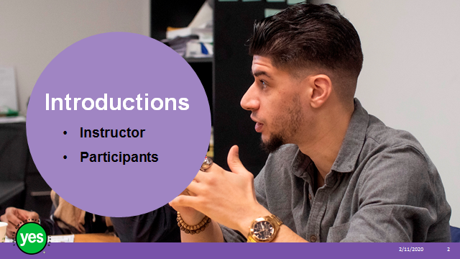 | Timing: 15 minutes.  Interaction Pattern: Pairs. Whole class.  Materials Needed: None.  Procedures and Notes: Introduce yourself as the instructor.  Share that in this workshop we will be talking about thinking creatively. For your introduction we want you get creative and share your name as well as if you were a food, what would you be and why?
Slide 3 | 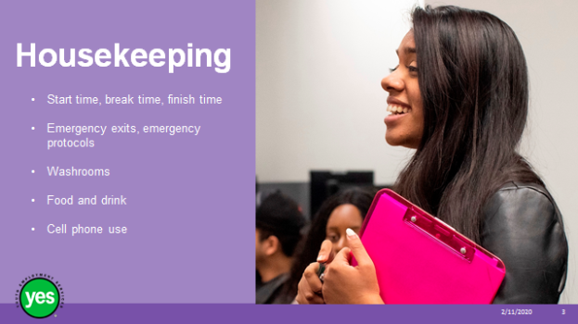 | Timing: 2 minutes.  Interaction Pattern: Whole class.  Materials Needed: None.  Procedures and Notes: Review all of the housekeeping details indicated on the slide. For cell phone use, indicate that if they are expecting an urgent call, their phone should be on vibrate. Otherwise indicate it should be on silent. They should not respond to texts or emails during the workshop.
Slide 4 | 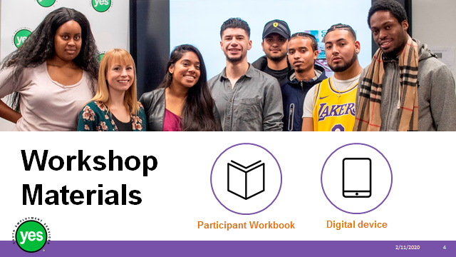 | Timing: 2 minutes.  Interaction Pattern: Whole class.  Materials Needed: One Participant Workbook per participant.  Procedures and Notes: Direct participants to their Participant Workbooks. Have them put their names on them. Indicate that this is their record of the key information in the workshop and ideas they generate during the workshop. Indicate that there may be some activities in which they may choose to use their cell phone/device.
Slide 5 | 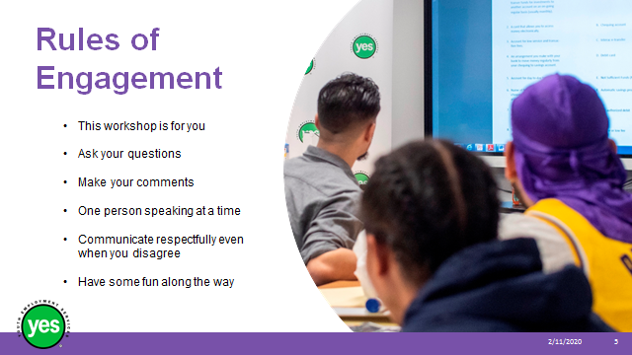 | Timing: 2 minutes.  Interaction Pattern: Whole class.  Materials Needed: None.  Procedures and Notes: Review your expectations for the participants. Indicate that your role is to guide them through the material and facilitate discussion.
Slide 6 | 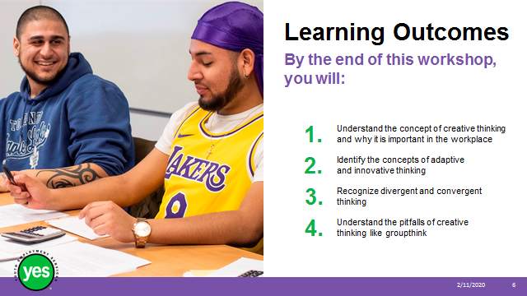 | Timing: 2 minutes.  Interaction Pattern: Whole class.  Materials Needed: Page 1.  Procedures and Notes: Review the learning outcomes of the workshop, stressing the practical knowledge and abilities that participants will walk away with.
Slide 7 | 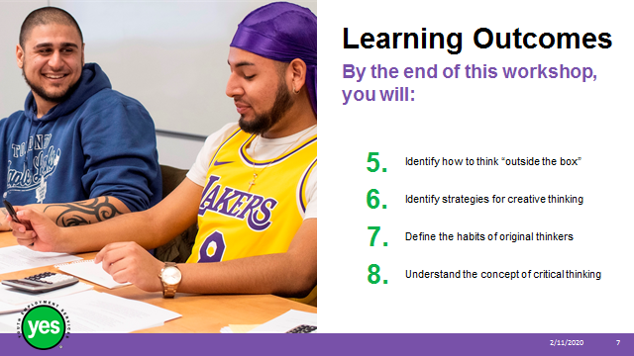 | Continued from previous slide.
Slide 8 | 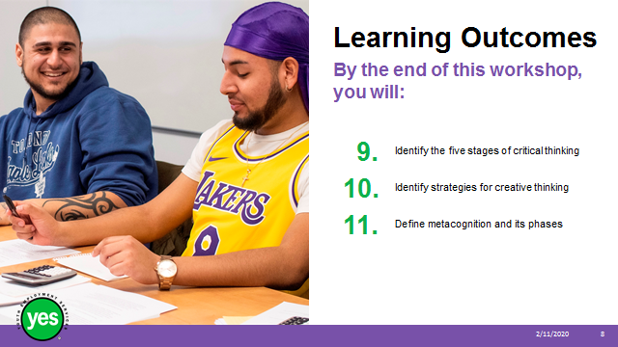 | Continued from previous slide.
Slide 9 | 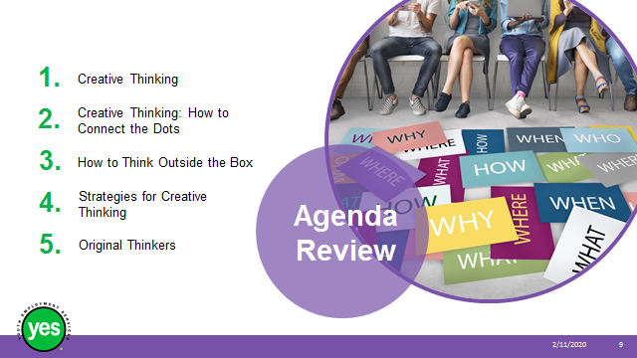 | Timing: 2 minutes.  Interaction Pattern: Whole class.  Materials Needed: Page 2.  Procedures and Notes: Review the agenda for the course.
Slide 10 | 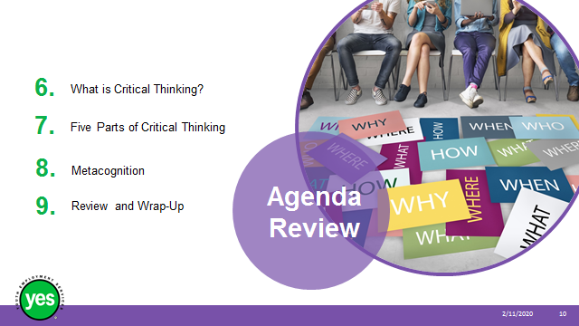 | Continued from previous slide.
Slide 11 | 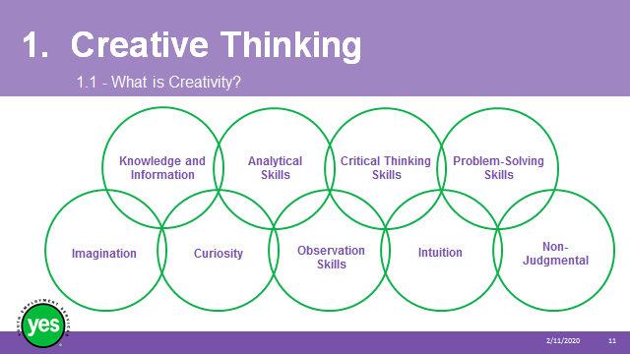 | Timing: 10 minutes.  Interaction Pattern: Whole class.  Materials Needed: Page 3.  Procedures and Notes: Ask the group what Creativity means to them.  Take a few volunteer responses from the group. Identify any themes that emerge.  Refer to the graphic and share any connections with what the group shared in their responses.  Share with the group:  Knowledge and information: Creativity is not based on nothing. It is based on what we already know.  Analytical skills: To be creative, we have to be able to analyze something or a situation and identify what is missing.  Critical thinking skills: To be creative, we have to evaluate everything that we do, making judgements about what is good and what is not.  Problem-solving skills: A lot of creativity is based on finding solutions to problems, often everyday problems.  Imagination: To be creative we have to imagine something that doesn’t exist yet.  Curiosity: Creativity comes from asking questions about everything we see. Why is something the way it is? What would happen if we do something differently?  Observation skills: Creativity comes from noticing everything—what are people doing, how often are they doing something, what tools are they using.  Intuition: Creativity has an intuitive element to it. Our gut tells us something and we listen to it.  Non-judgemental: Creativity comes from not ruling anything out and being open to all ideas, even those that at first seem as though they won’t work.
Slide 12 | 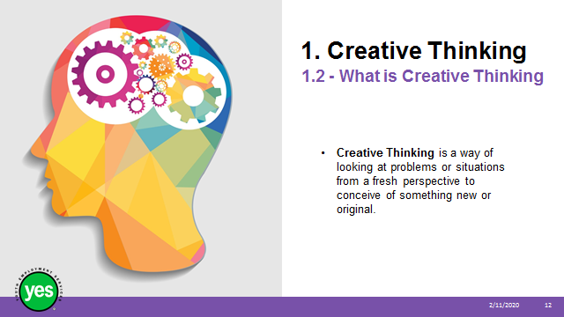 | Timing: 2 minutes.  Interaction Pattern: Whole class.  Materials Needed: Page 3.  Procedures and Notes: Review the definition and share that we will be digging into how creative thinking can be used at work.
Slide 13 |  | Timing: 5 minutes.  Interaction Pattern: Whole class.  Materials Needed: Flip chart and marker  Procedures and Notes: Ask the participants to think about the question and brainstorm ideas. Record the ideas on the flipchart. Some responses may include – helps plan projects, generates innovative ideas, offers potential solutions, saves the company money, and other examples you can add from your own experience.
Slide 14 |  | Timing: 15 minutes.  Interaction Pattern: Whole class.  Materials Needed: Page 4 and YouTube video.  Procedures and Notes: View the video 5:10. After viewing the video share that it included a number of different concepts related to creative thinking and we are going to examine them more closely.
Slide 15 |  | Timing: 2 minutes.  Interaction Pattern: Whole class.  Materials Needed: Page 4.  Procedures and Notes: Review the definition and share that adaptive thinking at work allows you to be flexible and able to adapt to changing work conditions.
Slide 16 |  | Timing: 2 minutes.  Interaction Pattern: Whole class.  Materials Needed: Page 4.  Procedures and Notes: Review the definition and remind the group of the smelly cat litter example from the video. Ask the group if they can remember the solutions the adaptive thinker came up with (better ingredients in making the cat litter, adding a tropical scent). They stayed “inside the box.”  Then ask the group if they can remember the solutions the innovative thinker came up with (cat diapers, toilet training cats, robocats). Their options where “outside the box.
Slide 17 | 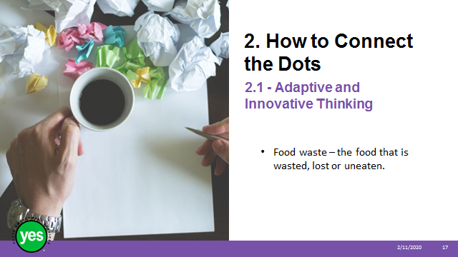 | Timing: 10 minutes.  Interaction Pattern: Small groups.  Materials Needed: Page 4.  Procedures and Notes: Divide the group into two teams by having the participants count off 1,2,1,2,1,2,1,2, and so on as you work around the room.  Facilitator Tip – If you have the participants actually do the counting, rather than doing the counting for them and pointing at them, they are more likely to remember what number they are for this activity.  Ask all of the 1’s to sit together on one side of the room. They will be the adaptive thinkers.  Ask all of the 2’s to do the same on the other side. They will be the innovative thinkers.  Ask each of the groups to raise a pointed finger in the air and on the count of three point to someone else in their group. Count to three and observe. State that the person with the most fingers pointing at them is the recorder for this activity.  Share the challenge (you can use this one or come up with one of your own).  Give the groups 5 minutes to brainstorm as many solutions for their way of thinking as possible.  As the groups are working, circulate around the room and observe the answers being generated. If one of the groups comes up with an idea that should be on the other team’s list point it out to them and ask them to hold on to it but not share it when they report out.  After 5 minutes bring the groups together and have them share their ideas. Once both groups have shared, you can invite the groups to add any responses that were really meant for the other group.  Ask participants what it felt like to be arbitrarily assigned to a group. If they were to identify their own dominant style, which would it be? Were they in the “correct” group for them?  Remind the group that adaptive thinking takes existing conditions and tries to do things better. Innovative thinking stretches outside your comfort zone or does something completely new to address a challenge.
Slide 18 |  | Timing: 15 minutes.  Interaction Pattern: Whole class.  Materials Needed: Page 4.  Procedures and Notes: Review the definition of Divergent Thinking with the group and remind them that divergent thinkers can generate a number of creative solutions.
Slide 19 |  | Timing: 2 minutes.  Interaction Pattern: Whole class.  Materials Needed: None.  Procedures and Notes: Review the definition of Convergent Thinking with the group and remind them of the example where the Divergent Thinker generated a number of ideas on the flip chart and then the Convergent Thinker was able to apply requirements to narrow down the ideas to determine the best option.  Share that the result of Divergent and Convergent Thinkers working together will be better than any one type of thinker working by themselves.
Slide 20 | 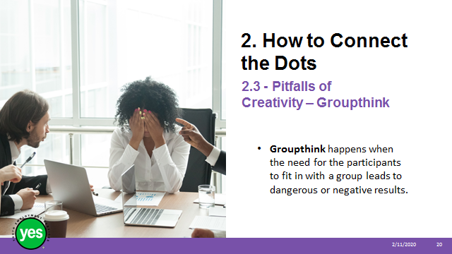 | Timing: 10 minutes.  Interaction Pattern: Whole class.  Materials Needed: Page 5.  Procedures and Notes: Review the definition with the group.
Slide 21 |  | Timing: 10 minutes.  Interaction Pattern: Whole class.  Materials Needed: Page 5 and 6.  Procedures and Notes: Review the definition with the group. View video 2:54  Direct the group to page 5 and review the 8 Symptoms of Groupthink listed. Use the quotes from the video as an example and as you recap the points make sure the participants understand the term.  Ask the group if they have ever knowingly or unknowingly been a part of groupthink. Take at least 3 responses from the group. If they experience difficulty coming up with examples, include a personal story of your own.  Wrap up the discussion by reviewing the suggestions for avoiding Groupthink on page 6.
Slide 22 |  | Timing: 20 minutes.  Interaction Pattern: Whole group.  Materials Needed: Page 6.  Procedures and Notes: Share that: Thinking outside the box means confronting problems in atypical ways, thinking creatively and freely, and encouraging frequent challenges to what currently is.  As you watch this video, think about the examples the speaker shares related to thinking outside the box at work.
Slide 23 | 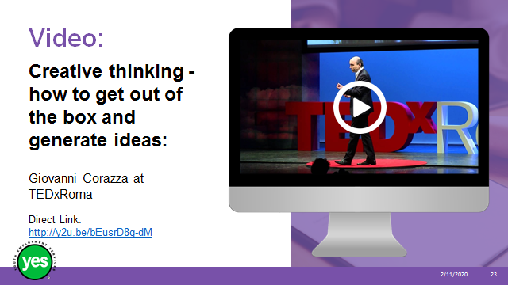 | Timing: 15 minutes.  Interaction Pattern: Whole group.  Materials Needed: None.  Procedures and Notes: Prior to the workshop view the video and choose whether it makes sense to show the whole video or to choose segments that are most suitable to the interests of your group. The key concepts we are trying to deliver are in the speaking points below.  View the video 13:38  Review the headings from the video.  • Why? It’s not a luxury to step out but necessary in order to move forward.  • Which box are we stepping out of? The difference between what we know and what we have not even thought of yet  • How do we get out of the box? Add a new idea not obviously related to the challenge – use divergent thinking.*remind group of concept introduced earlier*  • What are we doing when we step out of the box? We are assessing the value of a new idea and matching it to our original focus.  • When is it a good idea to challenge your environment? Are your workplace and/or boss ready? If your environment punishes mistakes people won’t step out of the box.
Slide 24 |  | Timing: 5 minutes.  Interaction Pattern: Whole group.  Materials Needed: Page 7.  Procedures and Notes: Wrap up the discussion by sharing the “The 3 Silent P’s of Innovation” that people need to step out of the box at work.  Expand on the points:  1. Permission – people need to feel that they have permission to try something new  2. Protection – people should feel that they are protected if something goes sideways  3. Policy – people need assistance in policies that support innovation not slow it down
Slide 25 |  | Timing: 10 minutes.  Interaction Pattern: Individual reflection. Pairs.  Materials Needed: Page 7.  Procedures and Notes: Direct the group to the strategies listed on page 8. Share that this list was generated from a number of sources and it is meant to stimulate ideas for you to follow up with after the workshop. If you are not sure of a concept, look it up.  Ask participants to review the list and choose at least 2 strategies that you plan to learn more about and/or practice.  Give the group 3 minutes to review the list and then ask them to find a partner that they have not yet worked with in this workshop. Invite them to share the strategies they have picked with their partner and discuss. To wrap up the activity you could ask for a show of hands as you read through the list.
Slide 26 |  | Timing: 20 minutes.  Interaction Pattern: Small group. Whole group.  Materials Needed: Page 8.  Procedures and Notes: View the video 15:24  Direct the group to page 8 and review the three traits of Original Thinkers.  Late to the party – After the “first movers” have taken the plunge, original thinkers can think in convergent ways and improve on the idea.  Feel doubt and fear – Self-doubt (you constantly feel like you're not good enough) and idea doubt (you don't know if a specific project or idea is going to work).  Have lots of bad ideas – Original thinkers fail the most because they try the most.
Slide 27 |  | Timing: 10 minutes.  Interaction Pattern: Small group. Whole group.  Materials Needed: Page 8.  Procedures and Notes: Get the participants to make groups of 4-5 people and ask them to think about what they found interesting, surprising or important in the video. Invite them to have a discussion and share their responses.  After 2-3 minutes of small group discussion get the attention of the whole group.  Ask groups to share a sample of their responses to the questions from the video as well as what they considered to be:  - Interesting?  - Surprising?  - Important?
Slide 28 |  | Timing: 2 minutes.  Interaction Pattern: Whole class.  Materials Needed: None.  Procedures and Notes: State that we are now looking at Critical Thinking and that it is made up of many components including logical thinking and reasoning.
Slide 29 |  | Timing: 2 minutes.  Interaction Pattern: Whole class.  Materials Needed: None.  Procedures and Notes: Review the definition of Logical Thinking with the group. Emphasize that in Logical Thinking patterns are made after following a logical process but does not include making an analysis (judgment) of the merits or faults leading to a decision.
Slide 30 | 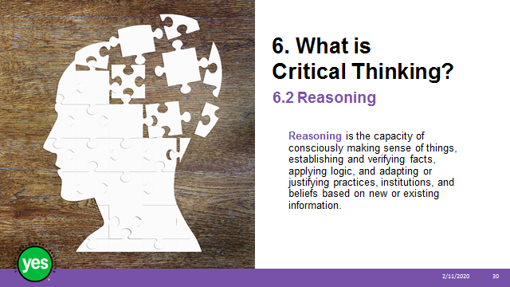 | Timing: 2 minutes.  Interaction Pattern: Whole class.  Materials Needed: None.  Procedures and Notes: Review the definition of Reasoning with the group. Share that there are two types of reasoning.
Slide 31 |  | Timing: 2 minutes.  Interaction Pattern: Whole class.  Materials Needed: None.  Procedures and Notes: Review the definition of Deductive Reasoning with the group. Click to show the graphic for the example and state that:  - Fish are living organisms in the water.  - Goldfish is a fish.  - So the Goldfish lives in the water.
Slide 32 |  | Timing: 2 minutes.  Interaction Pattern: Whole class.  Materials Needed: None.  Procedures and Notes: Review the definition of Inductive Reasoning with the group. Click to show the graphic for the example and state that:  - Playing Clue supports intelligence development of children.  - Playing Chess supports intelligence development of children.  - So all logic games support children's intelligence development.
Slide 33 | 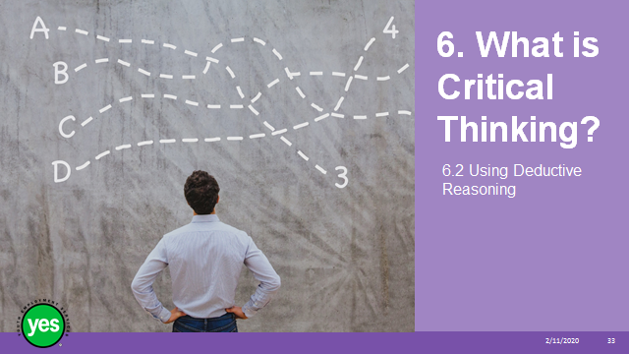 | Timing: 15 minutes.  Interaction Pattern: Pairs.  Materials Needed: Page 9. Grid Puzzle Answer Key in Appendix.  Procedures and Notes: Instruct participants to find a partner by looking for someone who is wearing the same colour that you are. Ask them to sit together and work on the grid puzzle on page 9 of our workbook. Go over the instructions at the bottom of the worksheet.  After 5 minutes check in with the pairs and see how they are progressing. If people are having difficulty, work with the group to figure out where to put the checkmark for the first clue. Let them try to figure it out from there.  After 5 minutes bring the group together and take up the quiz together.  Debrief the activity by asking what was hard about this activity? What was easy about this activity? Do you like this type of puzzle? Let them know that there are grid puzzles available online and in local book stores.
Slide 34 |  | Timing: 5 minutes.  Interaction Pattern: Whole group.  Materials Needed: Page 10.  Procedures and Notes: Today, organizations value critical thinking as a means to greater innovation and improved problem-solving.  The World Economic Forum found that complex problem-solving and critical thinking are the most important skill in the workplace.  Critical thinking is important because it helps individuals and teams more effectively solve problems and identify possible solutions that aren’t entirely obvious at first.  Critical thinking can help resolve conflicts in the workplace.  When workers use critical thinking and consider a range of possible approaches to solving a problem rather than relying on bias or snap judgments, they are more likely to arrive at a better solution.
Slide 35 |  | Timing: 10 minutes.  Interaction Pattern: Whole group.  Materials Needed: Page 10.  Procedures and Notes: Share that:  Using the five step process of critical thinking skills can help us be intentional in our problem solving.  Continued on next slide.
Slide 36 |  | Materials Needed: Page 10.  Procedures and Notes: Share that:  - The first step in critical thinking is to identify the problem.  - Consider what the issue is and break it down so it is specific as possible.  - Ask how big this problem really is.  - Determine why this problem exists and what would the consequences be if no action is taken to solve it.  - Determine who should be involved in the solving process.  - Example – when you take your bike into the shop to be serviced and the technician does a series of tests to determine what the problem that needs to be fixed.  Continued on next slide.
Slide 37 |  | Materials Needed: Page 10.  Procedures and Notes: Share that:  - Learn as much as possible about the problem.  - Look for potential reasons and solutions, but don't just accept facts at face value.  - Research and investigate all possibilities.  - Don't hesitate to seek out other people's opinions and perspectives about the issue.  - Determine both the whether something is true and that you can count of the information you learn  - Example – when you are renting your first apartment you consider how much you have to spend, how much money you make, the size of apartment you need, the reputation of the landlord, the location and services you prefer  Continued on next slide.
Slide 38 | 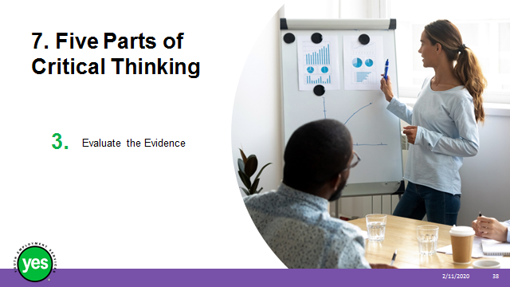 | Materials Needed: Page 10.  Procedures and Notes: Share that:  - Evaluate the evidence or information that has been collected.  - Ensure that the information is accurate.  - Confirm that it has come from more than just one source and that each of the sources are both unbiased and dependable.  - Identify any assumptions or information you may have collected without evidence.  - Ask for clarification of any concept or information you don’t fully understand.  - Determine if the information is based on fact or opinion.  - List all the ways the evidence could be interpreted.  - Example – when you go to the doctor and they take your temperature, look in your eyes/ears/throat, check any test results, and look at your previous records they are using this information to make a judgment about the state of your health  Continued on next slide.
Slide 39 |  | Materials Needed: Page 11.  Procedures and Notes: Share that:  - Plan several ways to approach the case based on the conclusions made from looking at the evidence.  - Figure out the advantage and disadvantages of each of these options.  - Outline what the obstacles might be, as well as any short-term or long-term results the solution has.  - It helps to look back at similar problems from the past and what solutions were used to solve them.  - Example – lawyers consider the solutions to a situation when they are determining what approach to take to a case  Continued on next slide.
Slide 40 |  | Materials Needed: Page 11.  Procedures and Notes: Share that:  - There are three factors to consider when deciding on an option.  - The first is determining the amount of risks involved with the solution.  - The second is whether the solution is practical.  - The third whether there are any priorities that need to be fulfilled.  - Once the solution is selected and put to action, follow-through is needed by monitoring the results of the plan implementation.  - Communicate your decision to anyone who is or will be impacted by the choice.  - Ideally you would also take time to reflect on your choice and its impact.  - Example – when you buy a laptop you look at the features, whether the type of laptop is a practical choice for your needs and whether to buy new or used. After the laptop is purchased you will follow-through and stay on top of the virus protection, service and upkeep and when it comes time to replace it you will take your experience with that laptop into account when you are choosing.
Slide 41 |  | Timing: 20 minutes.  Interaction Pattern: Small groups.  Materials Needed: Page 12.  Procedures and Notes: Divide the group up into small groups by getting them to line up by the first letter of their name. Once the participants are in order count off groups of 4-5 for the small groups.  Review the case study and direct the groups to work through the Five Parts of Critical Thinking to choose a solution to implement.  Give the groups 10 minutes to work through the process. At the 10 minute mark let them know that you are giving them 3 more minutes to finish their work.  Bring the group together and have each group share what they determined for their solution. They do not need to share what they did at each step as it would be too time consuming. Once all of the groups have presented their solutions, ask each group for their thoughts about the activity.  Adaptation – Keeping it Real – Challenge the group to identify and cooperatively solve a real work problem from their experience using the Five Steps of Critical Thinking. You may set parameters including time limit, boundaries, etc.
Slide 42 |  | Timing: 5 minutes.  Interaction Pattern: Whole group.  Materials Needed: Page 14.  Procedures and Notes: Share:  - Try to get your coworkers used to hearing the question, “Why?” for instance, ask things like, “Why is the answer 15?” or “Why did you do it that way?”  - Answering questions like this will help you and others think through the logic used to solve a problem or come to a certain conclusion.  - Be prepared to explain how you arrived at your answers and the process you went through to solve a new problem.  Continued on next slide.
Slide 43 |  | Materials Needed: Page 14.  Procedures and Notes: Share:  - Play card games or board games that encourage strategy and logical thinking. You can learn a lot about your coworkers (and friends!) when you play games with them. It gives you a chance to see how they use critical thinking to plan their strategies. There are many games out there like Apples to Apples, Clue, Mastermind, Chess and Checkers or leave a Rubik’s Cube on your desk and challenge your coworkers to solve it.  Continued on next slide.
Side 44 |  | Materials Needed: Page 14.  Procedures and Notes: Share:  When you are approaching a task at work use the Five Parts of Critical Thinking and share this approach with your coworkers. Tell them what you are doing and how it can make your work more productive.
Slide 45 | 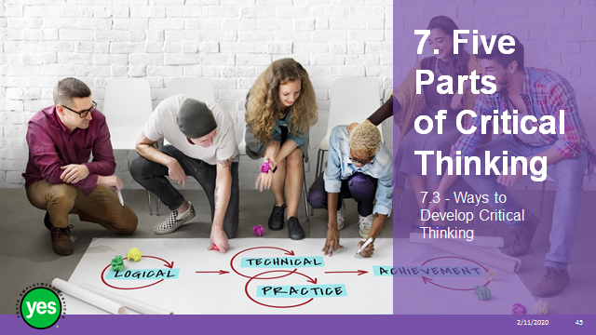 | Timing: 5 minutes.  Interaction Pattern: Whole group.  Materials Needed: Page 14.  Procedures and Notes: Direct the group to page 14 and the checklist.  Give the participants time to review the checklist. Ask for feedback about what is included on the list from the group.
Slide 46 |  | Timing: 15 minutes.  Interaction Pattern: Whole group.  Materials Needed: Page 14.  Procedures and Notes: Share that:  Metacognition refers to awareness of your knowledge—what you do and do not know—and your ability to understand, control, and manipulate your learning.  This video helps explain the concept and was created for students. As you watch the video, I challenge you to think about metacognition and how it applies to what happens in the workplace.
Slide 47 |  | Materials Needed: YouTube Video “What is Metacognition.” Page 14.  Procedures and Notes: View the video 1:38  Debrief the video by brainstorming how it is applied to the workplace with the group.  Share that business is placing a higher value on developing Metacognitive Skills and in an article in the Harvard Business Review it stated that “According to our research, if you can gain awareness of your assumptions, you can build trust and take your team beyond cooperating on a task to true creative collaboration.”
Slide 48 |  | Timing: 25 minutes.  Interaction Pattern: Small groups.  Materials Needed: Page 15. Slips of paper and a paper bag.  Procedures and Notes: Take the total number of participants and divide it by 3. For example if you have 19 participants in group you would have 7 people in one group in 6 in the two other groups. Put the corresponding number of coloured slips of paper in a paper bag, e.g. 7 slips of white paper, 6 slips of pink paper and 6 slips of blue paper. Be sure to mix up the coloured slips before you put them in the bag. Have participants draw a slip to determine what group they are in. Ask the groups to sit together.  Tell the groups that they will have 10 minutes to prepare and at that time they should be able to present what the phase is, questions you can ask yourself during that phase and another idea or example related to the phase.  Ask the first group to review the information about the first phase of Metacognition and be prepared to share the information with the group.  Ask the second group to review the information about the second phase of Metacognition and be prepared to share the information with the group.  After 10 minutes invite the groups to share their information giving them about 2-3 minutes each.  Continued on next slide.
Slide 49 |  | Materials Needed: Page 15. Slips of paper and a paper bag.  Procedures and Notes: The first group presents.  Continued on next slide.
Slide 50 |  | Materials Needed: Page 15. Slips of paper and a paper bag.  Procedures and Notes: The second group presents.  Continued on next slide.
Slide 51 |  | Materials Needed: Page 15. Slips of paper and a paper bag.  Procedures and Notes: The third group presents.  Wrap up the presentations by sharing that:  - Metacognitive skills can be strengthened over time  Employers find awareness of your ability to learn a very attractive skill set
Slide 52 |  | Timing: 2 minutes.  Interaction Pattern: Whole class.  Materials Needed: Page 17.  Procedures and Notes: Briefly review the topics covered in the module.
Slide 53 |  | Timing: 2 minutes.  Interaction Pattern: Whole class.  Materials Needed: Page 17.  Procedures and Notes: Briefly review the topics covered in the module.
Slide 54 |  | Timing: 5 minutes – more as needed.  Interaction Pattern: Whole group.  Materials Needed: None.  Procedures and Notes: Ask the group to share any outstanding questions about the workshop content.  Facilitate a discussion to respond to the questions.
Slide 55 |  | Timing: 15 minutes.  Interaction Pattern: Individual reflection, Whole group.  Materials Needed: One cue card per participant.  Procedures and Notes: Before the workshop count out the number of cue cards you require and then divide them into 3 even piles. On the top of each the cards in the first pile use a marker to write “Creative Thinking.” On the top of each of the cards in the second pile write “Critical Thinking.” On the top of each of the cards in the third pile write “Metacognition.” Shuffle the cue cards so they are in a random order.  Share:  As we wrap up this workshop we want to hear what each of you have learned about Thinking Creatively and Critically.  To help you develop your answer I have some cue cards prepared where you can make some notes. On the top of the cards is a word related to a topic from the workshop that you can use to narrow down your answer if you choose. Feel free to look back through your workbook for ideas. Check-in to make sure that instructions are clear  After 5 minutes ask for a volunteer to start and work through the group to share their responses.  If you have the situation where you start getting repeat answers without a lot of detail use probing questions to develop the response more fully. Probing questions could be –  - Please tell us more about why that stood out for you?  - Please give me an example that you remember from the workshop?  - How do you think that you might use _____ in the future?  Invite the participants to keep their responses as a reminder of the workshop experience or you can collect the cards and group them by idea/theme/concept. This is a valuable way to know what workshop content participants find most helpful and it provides you with valuable insight into the messages they are receiving.
Slide 56 |  | Timing: 2 minutes.  Interaction Pattern: Whole class.  Materials Needed: None.  Procedures and Notes: Direct participants to the additional resources at the end of the Participant Workbook for further information. Be sure that you have reviewed the resources yourself and if you identify one that stands out to you be sure to share it with the group.

Appendix A
  - Reasoning
Grid Logic Puzzle – answer key

To solve the puzzle use deductive reasoning. Use the clues above and put a checkmark in the boxes that you know are true and an X in the boxes you know are or cannot be true.

Sue, Bindi and Kate are wearing different coloured sweaters (brown, blue and white) and also have different coloured hair (grey, black and brown). Can you figure out what each person is wearing?
- Kate thinks white sweaters are not practical, and so does the person with brown hair.
- Bindi thinks her black hair is too long.
- The person with the grey hair is also wearing a blue sweater.

 | Yellow sweater | Blue sweater | White sweater | Grey hair | Black hair | Brown hair
Sue |  |  |  | X | X | √
Bindi |  |  |  | X | √ | X
Kate |  |  |  | √ | X | X
Grey hair | X | √ | X
Black hair | X | X | √
Brown hair | √ | X | X

Sue has _brown_ hair and is wearing a _yellow_ sweater.
Bindi has _black__ hair and is wearing a _white_ sweater.
Kate has __grey__ hair and is wearing a _blue__ sweater.

