Youth Employment Services - YES
www.yes.on.ca
Future Skills: A modern approach to interviews and networking
Facilitator’s Guide
A Modern Approach to Interviews and Networking: Workshop at a Glance

Overview and Purpose

This workshop introduces key details about what to expect in job interviews – before, during and after, including the intent of common interview questions and the importance of following up with a thank-you note. Networking is introduced as a practice you are already doing informally. Tips are provided for how to take networking to the next level. You take part in activities that prepare you for mock interview practice at a later date and for networking in the community.

Time

The workshop is between three and six hours long. All timings provided in the Facilitator’s Guide are approximate. Note that the timings for the slides don’t add up exactly to three or six hours, because some of the activities can be extended or shortened. You can lengthen, shorten or leave out activities based upon the needs of your participants and the amount of time you have for the workshop. You should have short breaks at least every 90 minutes.

Learning Outcomes

At the end of this workshop, participants will:

- Understand what to expect in an interview.
- Know how to prepare for an interview.
- Know how to write a reference list.
- Understand the importance of networking.
- Know how to begin networking effectively.

Leading Questions

As participants complete this workshop, they will think about and answer the following questions:

- How do I feel about interviews?
- What can I expect before, during and after an interview?
- What are employers looking for in an interview?
- Who can I put on my reference list?
- How much networking am I doing already?
- How do I take networking to the next level?
Workshop Agenda

Introductions and Workshop Overview

- The Purpose of an Interview
- Types of Interviews
- Before the Interview
- When You Arrive
- During the Interview
- After the Interview
- Common Interview Questions and How to Answer Them
- Illegal Interview Questions
- Reference List
- What Is Networking?
- Networking Tips
- Review and Wrap-Up

Materials Needed

- White board/Screen/Internet connectivity
- Each participant should have a workbook and a device
- PPT Presentation A Modern Approach to Interviews and Networking

Formative Assessment

Completing the networking activity of listing and grouping current contacts will make up the formative assessment for this workshop.

Detailed Workshop Plan

Slide 1 |  | Timing: Display as the participants come in.  Interaction Pattern: Whole class.  Materials Needed: None.  Procedures and Notes: None.
Slide 2 | 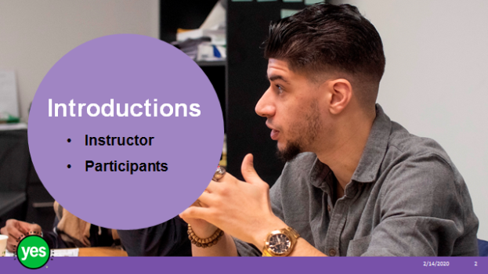 | Timing: 2 minutes.  Interaction Pattern: Whole class.  Materials Needed: None.  Procedures and Notes: Introduce yourself as the instructor. Have each participant briefly state their name. Have each participant put a name card in front of them for your reference.
Slide 3 | 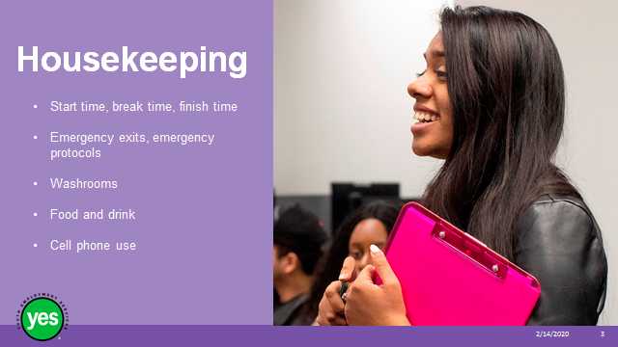 | Timing: 2 minutes  Interaction Pattern: Whole class.  Materials Needed: None.  Procedures and Notes: Review all of the housekeeping details indicated on the slide and any others you need to add. For cell phone use, indicate that if they are expecting an urgent call, their phone should be on vibrate. Otherwise indicate it should be on silent. They should not respond to texts or emails during the workshop.
Slide 4 | 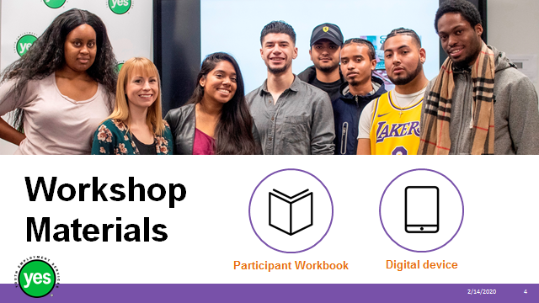 | Timing: 2 minutes.  Interaction Pattern: Whole class.  Materials Needed: One Participant Workbook per participant.  Procedures and Notes: Direct participants to their Participant Workbooks. Have them put their names on them. Indicate that this is their record of the key information in the workshop and ideas they generate during the workshop. It is also a resource they can come back to later as they prepare for real-life situations.
Slide 5 | 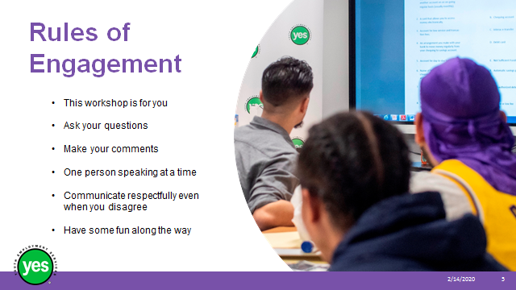 | Timing: 2 minutes.  Interaction Pattern: Whole class.  Materials Needed: None.  Procedures and Notes: Review your expectations for the participants, such as active listening and mutual respect. Indicate that your role is to guide them through the material and facilitate discussion. You may ask the group if they have anything to add to your list.
Slide 6 |  | Timing: As needed.  Interaction Pattern: Whole class.  Materials Needed: Appendix: Warm-up Activity – one per participant.  Procedures and Notes: Review the instructions and monitor the group. Spend a few minutes debriefing answers and connecting the exercise to the workshop themes.
Slide 7 | 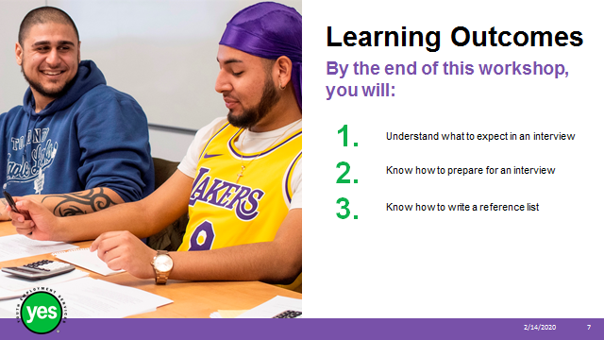 | Timing: 2 minutes.  Interaction Pattern: Whole class.  Materials Needed: Page 2.  Procedures and Notes: Review the learning outcomes of the workshop, stressing the practical knowledge and abilities that participants will walk away with.
Slide 8 | 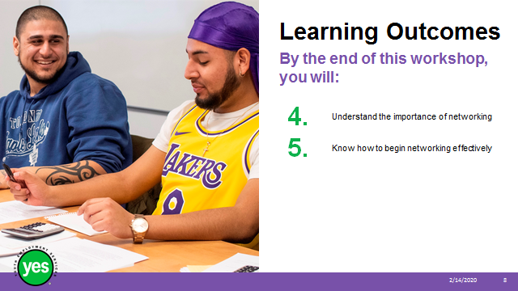 | Continued from previous slide.
Slide 9 | 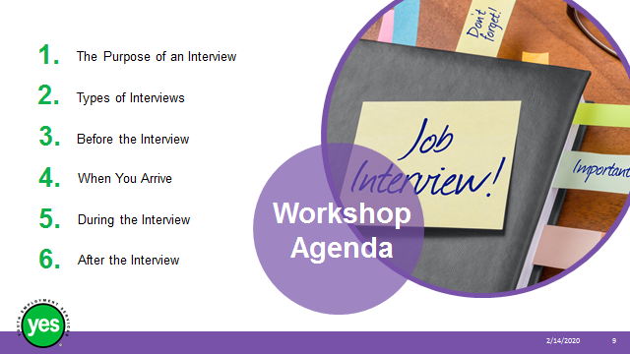 | Timing: 2 minutes.  Interaction Pattern: Whole class.  Materials Needed: None.  Procedures and Notes: Review the agenda for the workshop.
Slide 10 | 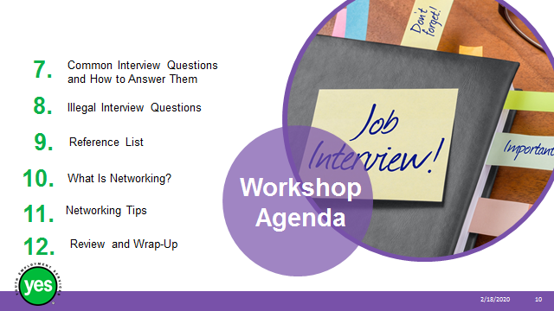 | Continued from previous slide.
Slide 11 |  | Timing: 5 minutes.  Interaction Pattern: Whole class/ individual.  Materials Needed: Page 3 activity.  Procedures and Notes: Stress that while the interview is being arranged on the employer’s terms, it is also an opportunity for candidates to get a sense of whether the company and position are a good fit for them.  Anyone can write your resume. Only you can talk about your skills, abilities and accomplishments.  Ask participants to reflect on their experience with formal interviews, either for paid work or volunteer work, and how they felt about them. Discuss responses to uncover fears or concerns that can be addressed during the workshop or 1:1 with staff.
Slide 12 | 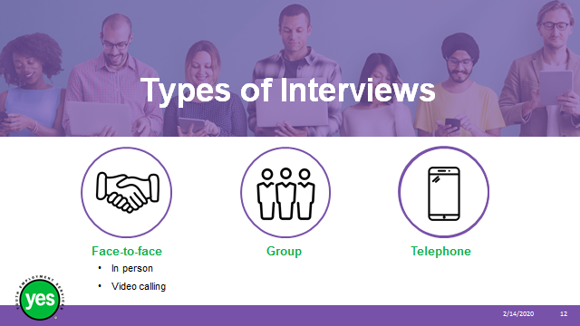 | Timing: 5 minutes.  Interaction Pattern: Whole class.  Materials Needed: Page 4 activity.  Procedures and Notes: While we may traditionally think of a formal interview as being face-to-face, employers have several options. Here are some common ones.  Review the types of interviews and implications for each. Ask participants what employers are looking for in each type and to note responses in their workbook.  For example, in face-to-face interviews, employers may be assessing body language and facial expressions as well as the quality of the answers.  In group interviews, employers will assess the above as well as leadership and interpersonal skills.  In telephone interviews, the employer will rely more on voice and choice of words because visual cues are lacking.
Slide 13 |  | Timing: 2 minutes.  Interaction Pattern: Whole class.  Materials Needed: None.  Procedures and Notes: Briefly review what else an interview candidate may be asked to do when they go to an interview. Ask the group whether they have experienced anything else to add to the list.
Slide 14 |  | Timing: 15 minutes.  Interaction Pattern: Whole class/individual.  Materials Needed: Pages 5 to 7 activity questions.  Procedures and Notes: There is a lot to do to get ready for a job interview, in addition to practising answers to common interview questions.  Review the tips in the workbook.  Pause at the section on professional image. Ask the group for their thoughts on this. How different are their ideas of what a professional image looks and sounds like? What does the program offer to help participants with their professional image, if needed?  Variation on the voicemail exercise on page 6 in the workbook: Ask whether everyone in the group has a cell phone. If so, ask if it is OK if they share their outgoing voicemail message with a partner in the group. If so, divide the group into pairs. Have partner A listen to partner B’s person’s outgoing voicemail message, then offer some feedback on what they liked about the message. Both partners can talk about what might need to change. Switch and repeat.  Ask whether the group has any additional tips to share.
Slide 15 |  | Timing: 10 minutes.  Interaction Pattern: Whole class activity questions.  Materials Needed: Internet connection, https://www.youtube.com/watch?v=u3ciQ9CToE0  Procedures and Notes: Screen the video (3:12 minutes) as an introduction to the next part of the workshop. It is one of many on YouTube.  Indicate that while some of the behaviours may seem too silly to be true, these things really do happen.
Slide 16 |  | Timing: 15 minutes.  Interaction Pattern: Whole class/individual.  Materials Needed: Page 8 activity questions.  Procedures and Notes: Ask for a volunteer to sit just inside the classroom and pretend to be the receptionist.  Ask for two volunteers who are prepared, one at a time, to go outside the classroom, knock on the door and show how they would enter an office and greet the receptionist. Spend a few minutes debriefing and sharing key tips.  Introduce the concept of power poses. Ask everyone to stand up and practise some power poses as illustrated in Amy Cuddy’s TED talk: https://www.youtube.com/watch?v=Ks-_Mh1QhMc. These can also be practised sitting down.
Slide 17 |  | Timing: 15 minutes.  Interaction Pattern: Whole class/individual.  Materials Needed: Page 9 and 10 activity.  Procedures and Notes: When we’re nervous or uncomfortable we can either “clam up” and not answer questions in enough detail or we can go on too long and begin to ramble. If we pay attention, we may notice the listener’s verbal and non-verbal cues that it’s time to stop talking or time to provide more detail.  Take up the matching exercise in the workbook. Ask for additional examples and/or provide them from your experience. Note that conversational cues may vary from one culture to another; for example, in some cultures nodding the head from side to side indicates that the listener agrees and is following the conversation. North Americans may think the listener is disagreeing. The group may be able to provide other examples.
Slide 18 |  | Timing: 10 minutes.  Interaction Pattern: Whole class.  Materials Needed: Page 10 and 11 activity.  Procedures and Notes: Review points in the workbook. Reflecting on our experience is good for our personal and professional growth. Remember to focus on what went well and to be kind to yourself if you feel something didn’t go so well.  Sending a thank-you note shows good manners and helps to put your name at the top of the list. Why not stand out from the crowd?
Slide 19 | 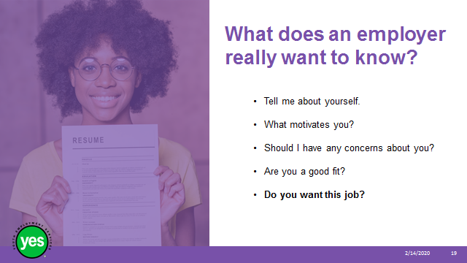 | Timing: 5 minutes.  Interaction Pattern: Whole class.  Materials Needed: Page 12.  Procedures and Notes: Employers have a wide range of interview questions to choose from but what are the main things they really want to know? Review the five points on the slide.  Questions?
Slide 20 | 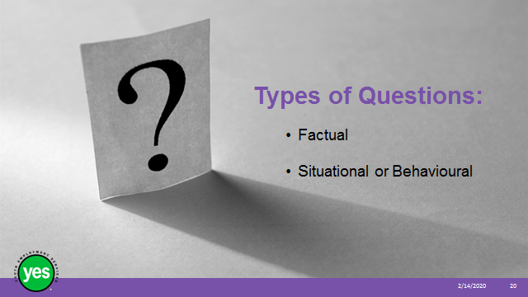 | Timing: 20 minutes.  Interaction Pattern: Whole class.  Materials Needed: Page 12 activity.  Procedures and Notes: Introduce the two types of questions, spending more time on the situational style.  Introduce Situation-Action-Result (SAR), sometimes called Situation-Task-Action-Result (STAR). Use whichever form you prefer.
Slide 21 |  | Timing: 10 minutes.  Interaction Pattern: Whole class.  Materials Needed: Internet connection; page 13.  Procedures and Notes: Screen this video (4:22 minutes) on STAR interview techniques: https://www.youtube.com/watch?v=9C6eBoh0ji4. Beforehand, tell the group that “lorry” means “truck.”  Ask participants how they are feeling about situational questions. What has their experience been? Talk about how the program can support them as they get used to this different style. Offer other examples, as needed.
Slide 22 |  | Timing: 10 to 15 minutes.  Interaction Pattern: Whole class/pairs.  Materials Needed: Page 14.  Procedures and Notes: Review key points about the elevator pitch, or 30-second commercial.  Lead a discussion about how we were brought up – was it OK to say nice things about ourselves or was this discouraged? How can we overcome any obstacles we have when we talk about our good points?
Slide 23 |  | Timing: 10 minutes.  Interaction Pattern: Whole class.  Materials Needed: Internet connection; page 15 activity.  Procedures and Notes: Additional video on elevator pitch: screen https://www.youtube.com/watch?v=wVYyCUwDFhE - Elevator Pitch Example - How To Create A Personal Elevator Pitch (5:11 minutes)  Ask participants to read one sample elevator pitch from the workbook to a partner. The partner will time the speaker. Switch roles with the other sample. It should take around 30 seconds, speaking at a natural pace.  Stress that the elevator pitch may vary according to the position they are interviewing for, just like the resume and cover letter.
Slide 24 | 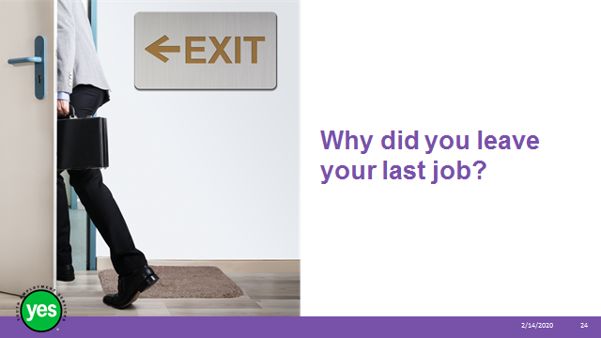 | Timing: 15 minutes.  Interaction Pattern: Whole class.  Materials Needed: Page 16 activity.  Procedures and Notes: Ask the group to identify how this question fits within the five main areas of interest to employers (Should I have any concerns about you? Are you a good fit?).  Ask the group for volunteers who will share why they left their last job. Role play question and answer. Talk about which experiences might best be left off a resume and why.
Slide 25 | 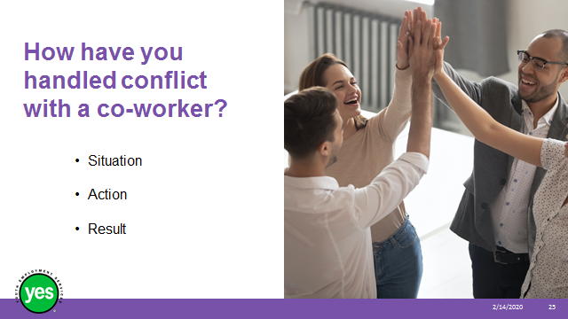 | Timing: 15 to 20 minutes for this slide and the next.  Interaction Pattern: Individual/small group/whole class.  Materials Needed: Page 16 activity.  Procedures and Notes: Ask the group to identify how this question fits within the five main areas of interest to employers.
Slide 26 | 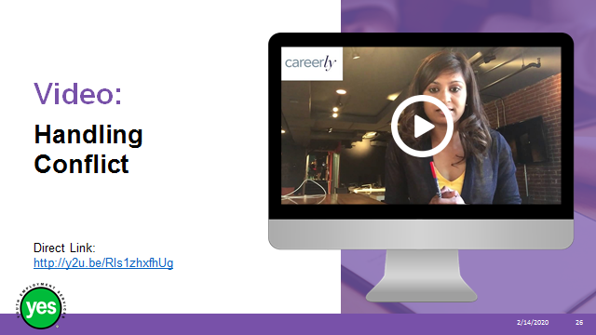 | Timing: 7 minutes.  Interaction Pattern: Whole class.  Materials Needed: Internet connection.  Procedures and Notes: Screen video about how to answer a question about conflict at work (5:08 minutes) https://www.youtube.com/watch?v=RIs1zhxfhUg.  Review the Situation-Action-Result approach and offer additional examples from your experience. Offer participants the chance to think about this question on their own, then practise in a small group. Debrief.
Slide 27 |  | Timing: 10 minutes.  Interaction Pattern: Whole class.  Materials Needed: Page 17 activity.  Procedures and Notes: Ask the group to identify how this question fits within the five main areas of interest to employers.  Highlight key points from the workbook.
Slide 28 |  | Timing: 10 minutes.  Interaction Pattern: Whole class.  Materials Needed: Page 18 and 19 activity.  Procedures and Notes: Review highlights from the workbook and ask for personal experiences from the group. Reinforce that each person will do what they feel is right if this situation comes up.
Slide 29 | 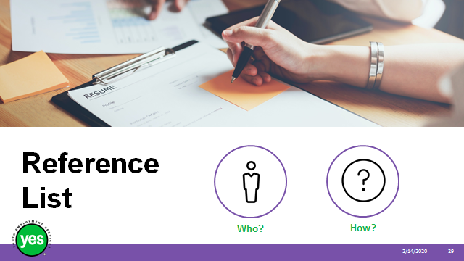 | Timing: 10 minutes.  Interaction Pattern: Whole class.  Materials Needed: Page 20 and 21.  Procedures and Notes: Introduce the concept of references and how they work. Stress that it’s always a good idea to keep references up to date with your job search. Identify who not to ask as references, such as friends or roommates.  Review logistics.  Questions?
Slide 30 |  | Timing: 20 minutes.  Interaction Pattern: Whole class/individual.  Materials Needed: Page 22 activity.  Procedures and Notes: Ask a few leading questions such as these to find out how participants reach out for information and connections.  - When it’s time for a new phone plan, how do you go about deciding which one to get?  - When you want to take someone out for dinner, how do you know which restaurant to go to?  - Your tap needs to be fixed. How would you find a plumber?  - How did you find out about this program?  - Who do you reach out to when you are feeling low? Happy?  Any other examples from the group?  Debrief – Look at how often people reach out to others and how – in person, over the phone, social media. How does personality play a role in networking?  Sum up by saying that even though we might not realize it, most of us have a network already.  Ask participants to spend 10 minutes on the exercise in the workbook. Debrief.  Note that LinkedIn will be covered in a different workshop so there will be only a brief introduction here.
Slide 31 |  | Timing: 5 minutes.  Interaction Pattern: Whole class.  Materials Needed: Page 23 and 24.  Procedures and Notes: There are many, many ways to network. Review the main highlights from the workbook and keep a log of additional ways you know of and additional ways participants share with you.  End with a reminder that networking may feel natural and energizing to some people and like hard work to others.
Slide 32 |  | Timing: 20 to 30 minutes for this slide and the next.  Interaction Pattern: Whole class.  Materials Needed: Internet.  Procedures and Notes: Introduce LinkedIn as a form of online resume and a tool for connecting with others online. We will only introduce the topic now and will cover more “how to” material in another workshop.  Ask how many participants have a LinkedIn account, how many are using its many features.  Screen https://www.youtube.com/watch?v=AcmKZrC89Mo (3:07 minutes)  A brief overview of what LinkedIn has to offer.
Slide 33 |  | Timing: 5 minutes.  Interaction Pattern: Whole class.  Materials Needed: Internet connection.  Procedures and Notes: Grow your network video clip https://www.youtube.com/watch?v=nYoH18JGPQ8 (5:06) Highlight key points such as having a plan about how you want to grow your network – by connecting with everyone or a select group, for example.
Slide  34 |  | Timing: As needed.  Interaction Pattern: Whole class.  Materials Needed: None.  Procedures and Notes: Review the main topics and highlights of the workshop.  Ask participants for a quick take on how this workshop went for them – e.g. thumbs up, thumbs down, thumbs in the middle.  Ask if there are any final questions or comments about the content of the module.  Indicate what is next, especially interview practice.

Appendix: Warm-up Activity

Go around the room and interview one person at a time in order to find out the following. Do not call across the room! Write down your answers.

- How many people in the room have brown eyes?
- Who has the most tattoos?
- How many people are Capricorn?
- Who knows Akon or Jayzee’s full name?
- Who has travelled to the most places?
- Who has the most unusual hobby?
- Find the weirdest thing anyone has eaten.
- Who can name all five band members of One Direction?
- Who has the most siblings?
- How many people have middle names?
- How many people can name the five electoral parties in Canada?
- Who has had the most embarrassing experience?
- Who knows what “hippopotomonstrosesquippedaliophobia” is a fear of?
- How many people have birthdays in February, July or December?
- Who can sing the first verse of Beyoncé’s “if I was a boy” song?
- Who knows how many original members were/are in the band “No Doubt”?
- Who can name three movies featuring Madea?
- Who can say the full meaning of YJC?
- What is the name of the most controversial health plan in the United States of America?
- Who shares the same last name as a famous celebrity in North America?

