Youth Employment Services - YES
www.yes.on.ca
Future Skills: 21ST CENTURY RESUME and COVER LETTERS
Facilitator’s Guide
21st Century Resumes and Cover Letters: Workshop at a Glance

Overview and Purpose

The workshop offers a basic introduction to writing resumes and covers letters – “works in progress” that are tailored to suit each opportunity. Advice is consistent with looking for work in the digital age. You take part in activities that prepare you for drafting these important job search documents at a later time.

Time

The workshop is between three and six hours long. All timings provided in the Facilitator’s Guide are approximate. Note that the timings for the slides don’t add up exactly to three or six hours, because some of the activities can be extended or shortened. You can lengthen, shorten or leave out activities based upon the needs of your participants and the amount of time you have for the workshop. You should have short breaks at least every 90 minutes.

Learning Outcomes

At the end of this workshop participants will be able to:

- Analyze a job posting.
- Understand the importance of key words.
- Identify what goes in each part of a standard resume.
- Differentiate at a glance between a “good” and “bad” resume.
- Identify what goes in each part of a standard cover letter.

Leading Questions

As participants complete this workshop, they will think about and answer the following questions:

- Do I understand how to “read between the lines” to see what employers are looking for?
- How might my experience, skills and qualifications line up against job requirements?
- What is the purpose of resumes and cover letters?
- Do I really have to change my resume and cover letter every time?
- How ready am I to write an effective resume and cover letter?

Workshop Agenda

Introductions and Workshop Overview

- Before We Start
  - How to Analyze a Job Posting
  - Key Words

- Resumes
  - Steps to Writing an Effective Resume
    - Summary of Qualifications
    - Resume Style
    - Relevant Skills
    - Effective One-Liners
    - Experience and Education
  - Online Resumes
  - Dos and Don’ts
  - Emailing

- Cover Letters
3.1 Types
3.2 Parts of a Cover Letter
3.3 Cover Letters Dos and Don’ts

Materials Needed

- White board/Screen/Internet connectivity
- Each participant should have a workbook and a device
- Handouts for activities
- PPT Presentation Resumes and Cover Letters

Formative Assessment

The assessment will be a proofreading and editing exercise based on a sample resume with many mistakes, found in the handout “Resume Examples Good and Bad.”
Detailed Workshop Plan

Slide 1 |  | Timing: Display as the participants come in.  Interaction Pattern: Whole class.  Materials Needed: None.  Procedures and Notes: None.
Slide 2 | 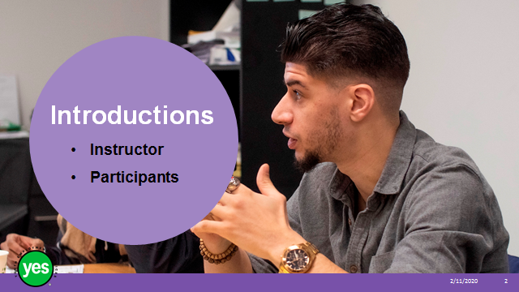 | Timing: 2 minutes.  Interaction Pattern: Whole class.  Materials Needed: None.  Procedures and Notes: Introduce yourself as the instructor. Have each participant briefly state their name. Have each participant put a name card in front of them for your reference.
Slide 3 | 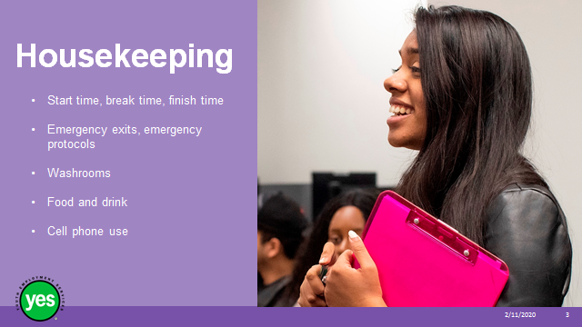 | Timing: 2 minutes.  Interaction Pattern: Whole class.  Materials Needed: None.  Procedures and Notes: Review all of the housekeeping details indicated on the slide and any others you need to add. For cell phone use, indicate that if they are expecting an urgent call, their phone should be on vibrate. Otherwise indicate it should be on silent. They should not respond to texts or emails during the workshop.
Slide 4 | 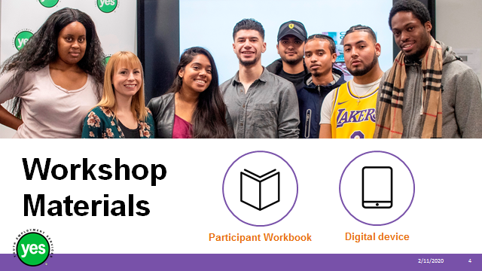 | Timing: 2 minutes.  Interaction Pattern: Whole class.  Materials Needed: One Participant Workbook per participant.  Procedures and Notes: Direct participants to their Participant Workbooks. Have them put their names on them. Indicate that this is their record of the key information in the workshop and ideas they generate during the workshop. It is also a resource they can come back to later as they prepare for real-life situations.
Slide 5 | 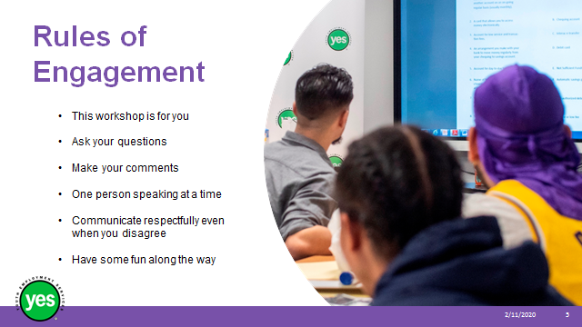 | Timing: 2 minutes.  Interaction Pattern: Whole class.  Materials Needed: None.  Procedures and Notes: Review your expectations for the participants, such as active listening and mutual respect. Indicate that your role is to guide them through the material and facilitate discussion. You may ask the group if they have anything to add to your list.
Slide 6 | 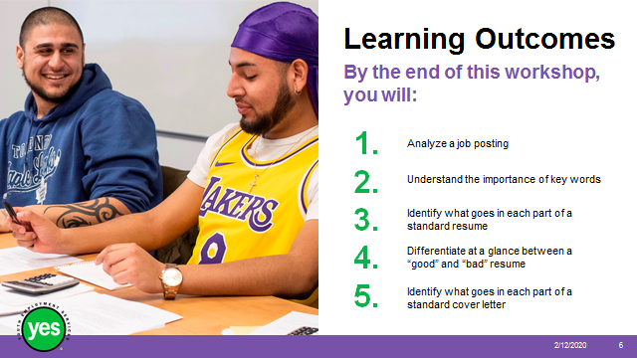 | Timing: 2 minutes.  Interaction Pattern: Whole class.  Materials Needed: Page 2.  Procedures and Notes: Review the learning outcomes of the workshop, stressing the practical knowledge and abilities that participants will walk away with.
Slide 7 | 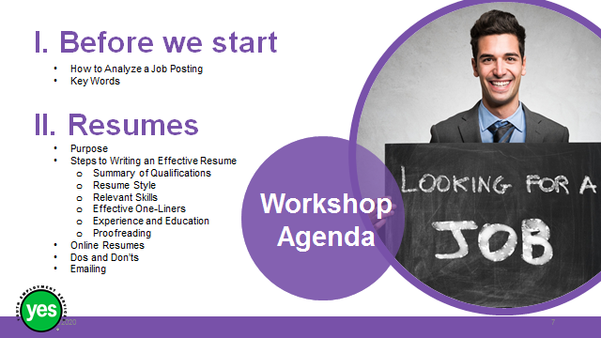 | Timing: 2 minutes.  Interaction Pattern: Whole class.  Materials Needed: Page 2.  Procedures and Notes: Review the agenda for the workshop.
Slide 8 | 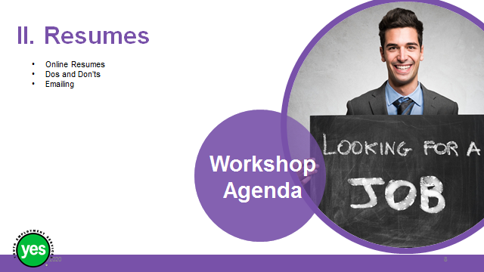 | Continued from previous slide.
Slide 9 | 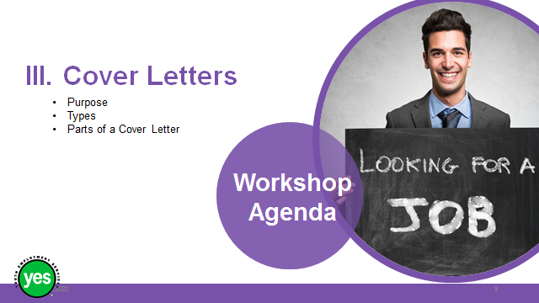 | Timing: 2 minutes.  Interaction Pattern: Whole class.  Materials Needed: Page 2.  Procedures and Notes: Review the agenda for the workshop.
Slide 10 |  | Timing: 5 minutes.  Interaction Pattern: Individuals/whole class.  Materials Needed: None.  Procedures and Notes:  - False – The reference list is a separate piece of paper that you give to the employer during the job interview. We no longer put “references available upon request” on our resumes.  - False – A 2018 eye-tracking study found that employers spend an average of 7.4 seconds per resume. Some people say 6 seconds.  - False – The main purpose is to catch the employer’s attention and be invited to a job interview. The decision about whether or not you get the job will most likely be made at the interview stage. A resume doesn’t usually get you a job but it gets you a big step closer.  Questions?  Introduce the next part of the workshop by acknowledging that as you work through the material, some participants may be embarrassed or upset about the mistakes they have made in previous resumes. Introduce the concept of “no shame, no blame” about past efforts. Stress that it’s about what they do from now on that counts and that staff are there to support them.
Slide 11 |  | Continued from previous slide.
Slide 12 | 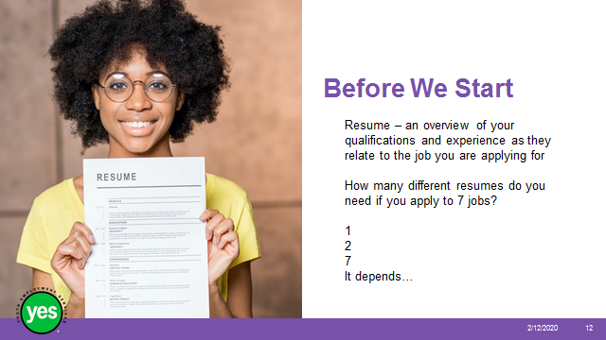 | Timing: 5 minutes.  Interaction Pattern: Individuals/whole class.  Materials Needed: None.  Procedures and Notes: Review definition – what stands out? “as they relate to…”  Ask the group how many resumes they think they’ll need if they apply to seven jobs – show of hands.  Answer – 7. Even if two jobs are very similar, there might be something different about the company that means the resume should be adjusted. Let’s take some time to learn about how to analyze a job posting and about the importance of key words.
Slide 13 |  | Timing: 30 to 40 minutes.  Interaction Pattern: Whole class, individuals, pairs.  Materials Needed: Pages 4 to 11.  Procedures and Notes: Eight steps are presented in this section. It may be tempting to skip some of them, but the results will be better if they are all completed. It is similar to getting ingredients ready before cooking. If you leave out some ingredients, the food won’t taste the same.  Sam Gupta is a made-up character. We will learn a bit about their background and use this information as we look at how to prepare to write a resume.  Refer to workbook. Cover highlights of why it is essential to understand a position and to understand what you bring to the position before you sit down to tailor your resume.  The exercise of listing stated as well as hidden requirements can be used for making decisions about whether or not to apply for a job and as part of preparing to write.
Slide 14 |  | Timing: 4 minutes.  Interaction Pattern: Group of 3 or pairs.  Materials Needed: Pages 3 to 4.  Procedures and Notes: Review steps 1 and 2. Ask them to read about Sam Gupta and read the job posting. Any questions?
Slide  15 |  | Timing: 4 minutes.  Interaction Pattern: Group of 3 or pairs.  Materials Needed: Page 5.  Procedures and Notes: Ask them to read the Retail Sales Associate job posting.
Slide  16 |  | Timing: 4 minutes.  Interaction Pattern: Group of 3 or pairs.  Materials Needed: Page 6 activity.  Procedures and Notes: Ask them to circle 3 areas of the job posting that Sam Gupta is a good fit for.
Slide  17 | 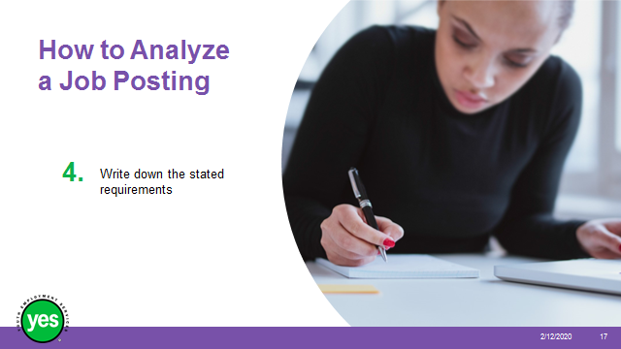 | Timing: 4 minutes.  Interaction Pattern: Group of 3 or pairs.  Materials Needed: Page 6 activity.  Procedures and Notes: Ask them re-read the retail sales associate posting and write down 3 stated requirements.
Slide  18 |  | Timing: 4 minutes.  Interaction Pattern: Group of 3 or pairs.  Materials Needed: Page 7 activity.  Procedures and Notes: Ask them to review the posting and list 2-3 hidden skills and experience that would be important in the position. Then ask them to re-read Sam’s resume and figure out if they have what is required.
Slide  19 |  | Timing: 4 minutes.  Interaction Pattern: Group of 3 or pairs.  Materials Needed: Page 8 activity.  Procedures and Notes: Ask them to write down their own skills and experience beside each of the stated and hidden requirements.
Slide  20 |  | Timing: 4 minutes.  Interaction Pattern: Group of 3 or pairs.  Materials Needed: Pages 8 to 9 activity.  Procedures and Notes: Ask them to compare the skills and experience they have to offer against the job requirements in the posting. How many of the stated requirements do they meet? Which requirements do they not meet? How close are they to meeting them? What do I need to do to get closer to meeting the requirements?
Slide  21 |  | Timing: 4 minutes.  Interaction Pattern: Group of 3 or pairs.  Materials Needed: Page 10.  Procedures and Notes: Remind them that you do not have to apply for every position that looks interesting. Tell them to review step 7 and decide whether or not Sam should apply for the retail sales associate position.
Slide 22 | 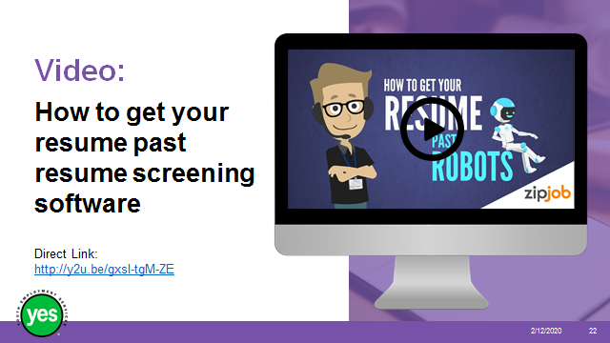 | Timing: 5 to 10 minutes.  Interaction Pattern: Whole class.  Materials Needed: Internet connection.  Procedures and Notes: Screen the video (2:12). This video introduces the concept of an applicant tracking system and offers five tips. We’ll spend some time on key words now and revisit the remaining tips later in the workshop.  - Make sure you have the right key words in your resume.  - Always use a professional resume format.  - Avoid a fancy resume design.  - Use a popular and professional font.  - Always send a resume as a Microsoft Word document.  Questions?
Slide 23 |  | Timing: 10 minutes.  Interaction Pattern: Individuals/whole class.  Materials Needed: Pages 10 to 13; a highlighter for each participant.  Procedures and Notes: Ask participants to read the job posting on page 11 and highlight the key words. Take up the first job posting before assigning the other three.  Take up and debrief, one at a time. Are participants getting used to the concept? It will get easier over time.
Slide 24 | 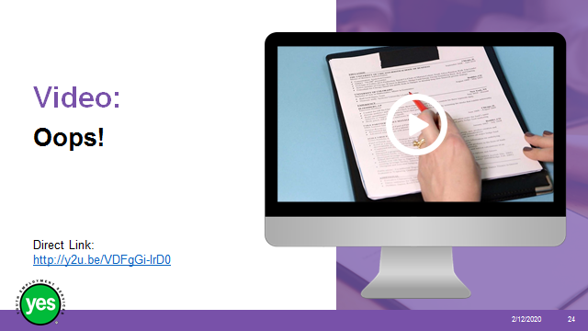 | Timing: 10 minutes.  Interaction Pattern: Whole class.  Materials Needed: YouTube video cued up and ready - We showed real resumes to an expert and the feedback was brutal  https://www.youtube.com/watch?v=VDFgGi-lrD0 (2:47 minutes)  Procedures and Notes: Introduce the video by saying that one way to learn something is to learn what not to do. We’ll take a look at some mistakes before we learn more about the parts of a resume and what’s advisable.  After video – Questions? What did you notice?  Note that this is one person’s opinion and we don’t have to agree with everything – e.g. periods go at the end of a proper sentence, not necessarily at the end of bullet points.  Note how the reader moved her pen across the page as if it were following her eye movements. This gives a sense of how readers scan for information.
Slide 25 | 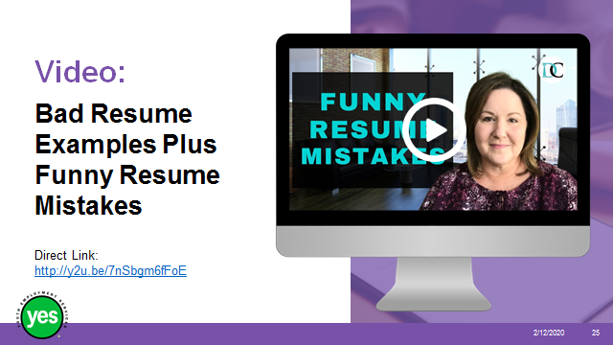 | Timing: 8 minutes.  Interaction Pattern: Whole class.  Materials Needed: YouTube video cued up and ready; Bad Resume Examples Plus Funny Resume Mistakes, https://www.youtube.com/watch?v=7nSbgm6fFoE (7:08 minutes).  Option: Screen this YouTube video which introduces what makes a good resume, followed by some comical spelling and grammar errors from real resumes:  7:08 minutes.  Additional options – cue the above video to the mistakes and ask the group to explain what went wrong. This will reinforce the need for excellent proofreading.
Slide 26 | 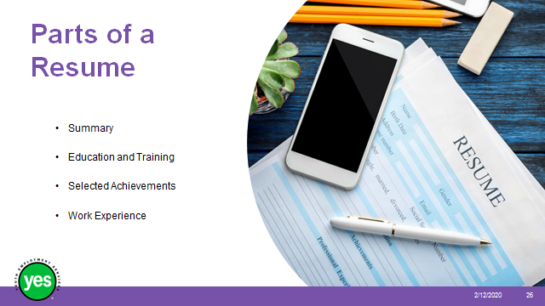 | Timing: 30 minutes.  Interaction Pattern: Whole class.  Materials Needed: YouTube video cued up and ready - How to write a resume with little or no work experience, Heather Austin.  Procedures and Notes: Introduce concept of standard sections for resumes and how these may vary according to current style, the industry and the background of the person who’s applying. As we gain relevant work experience, our education section comes later in the resume, for example. Also, mention that the “objective” section is now considered outdated.
Slide 27 | 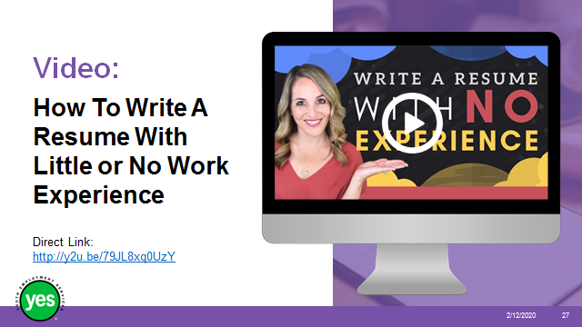 | Timing: 30 minutes.  Interaction Pattern: Whole class.  Materials Needed: YouTube video cued up and ready - How to write a resume with little or no work experience, Heather Austin  https://www.youtube.com/watch?v=79JL8xq0UzY (7:18 minutes).  Procedures and Notes: Screen YouTube video listed above, indicating that this is a guideline and specifically meant for people with little or no work experience. You may choose to stop the video from time to time to stress a point or ask whether the group has any questions.  Offer a few tips from an employer’s, or recruiter’s, perspective; for example, six seconds to look for a few key elements; professional email address; use of key words; using fonts other than Times New Roman and Arial to help stand out.
Slide 28 | 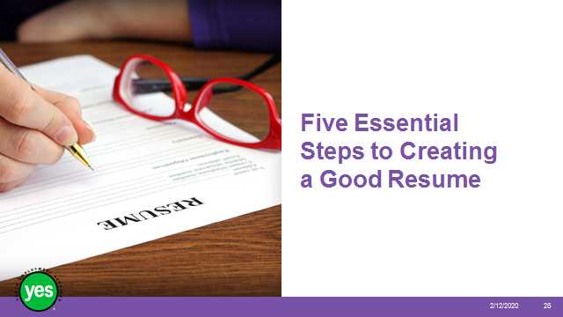 | Timing: 2 minutes.  Interaction Pattern: Whole class.  Materials Needed: Page 14.  Procedures and Notes: Restate the purpose of a resume and how little time is spent on scanning it.  Stress that following five essential steps will result in an effective resume.
Slide 29 |  | Timing: 15 minutes.  Interaction Pattern: Whole class/individual.  Materials Needed: Page 15.  Procedures and Notes: Review this first step, linking it the applicant tracking system and/or resume reviewer.  Allow participants a few minutes to think about their top qualifications, even if they do not yet have a specific job in mind. What are they most proud of? What do they envision using in the workplace?
Slide 30 | 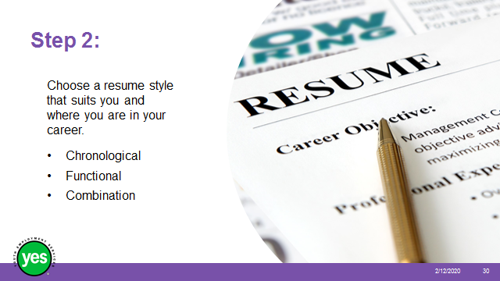 | Timing: 10 to 30 minutes.  Interaction Pattern: Whole class.  Materials Needed: Pages 16 to 19.  Procedures and Notes: Take as little or as long as you need with this section. At the very least, review the resume styles on page 17 and ask the group to reflect on which style suits them best at this stage. It is likely that many people will choose the functional style.  You may choose to have the group compare and contrast the three resume samples (either as a large group or in small groups), keeping in mind the table on page 16 which outlines when to consider using which style.  You may also choose to come back to this section when it is time for the group to start drafting their resumes and spend some 1:1 time helping participants decide what to do.
Slide 31 | 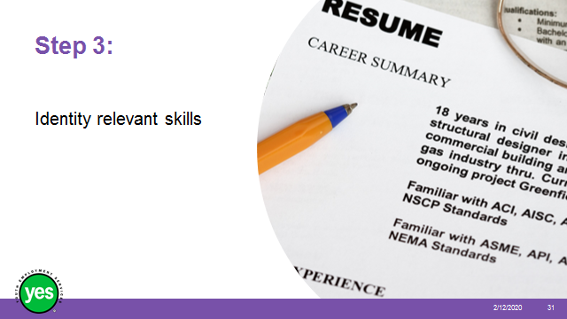 | Timing: 20 to 30 minutes.  Interaction Pattern: Whole class/individual.  Materials Needed: Page 20 activity.  Procedures and Notes: Take this opportunity to stress how important it is to invest time in the stated and hidden job requirements exercise. If done well, applicants should have a wealth of information to draw from for the resume, cover letter and interview.  Allow some time for quiet reflection, using the activity on page 20 – again, without a specific job posting in mind. This activity may help with 1:1 career-exploration activities. Ask for one or two volunteers to share their responses.  Questions?
Slide 32 | 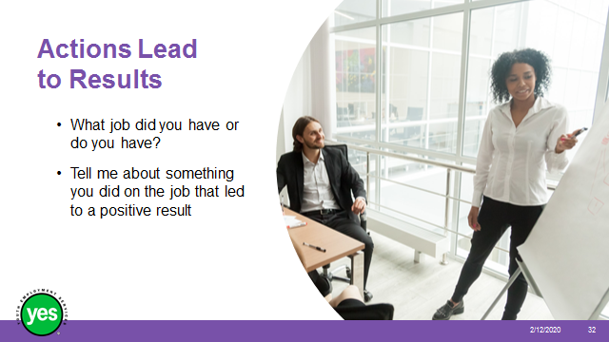 | Timing: 20 minutes.  Interaction Pattern: Pairs/whole class.  Materials Needed: None.  Procedures and Notes: Ask the group to find a partner they haven’t worked with yet.  Give the group a few minutes to think about something they did at work (paid or volunteer) that led to a positive result. What were they praised for?  Have one partner interview the other, using the sample questions on the slide as a guide. Encourage practice. People are welcome to attempt their answers more than once.  Switch roles.  Take up a few examples, modeling how to ensure that the one-liner is at an appropriate level of language – paraphrasing the actions and results.
Slide 33 | 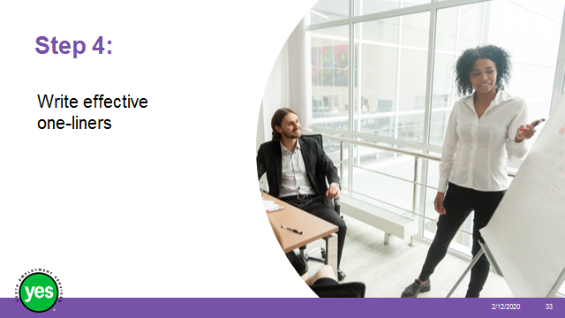 | Timing: 15 minutes.  Interaction Pattern: Whole class/individual.  Materials Needed: Page 21 and 22 activity.  Procedures and Notes: These are also called accomplishment statements.  Go back to the sample resumes and ask the group to point out the one-liners and assess how well they are done. Stress the importance of keeping track of successes at work. It can be difficult to remember the impact we have had.  Review where they should be placed in a resume. Activity: Allow a few minutes for the activity at the top of page 23.
Slide 34 | 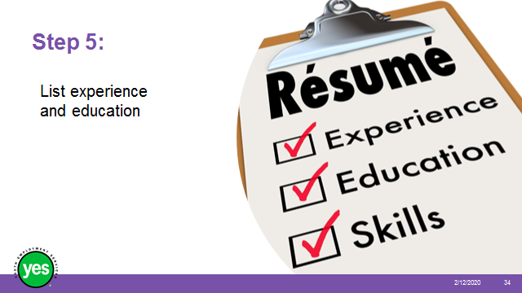 | Timing: 10 minutes.  Interaction Pattern: Whole class.  Materials Needed: Page 22 activity.  Procedures and Notes: Review points in the workbook. Ask whether there are questions about the education section, in particular.
Slide 35 | 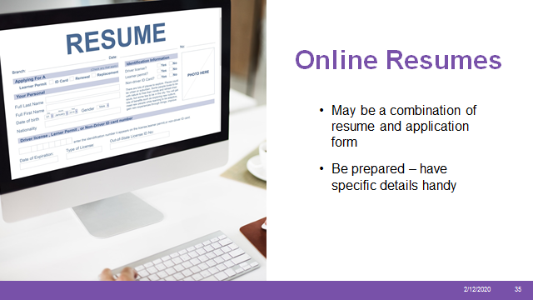 | Timing: 15 minutes.  Interaction Pattern: Whole class.  Materials Needed: Page 23 activity.  Consider looking online ahead of time and bookmarking a current job posting that requires an online resume.  Procedures and Notes: Refer to the section in the workbook on online resumes.  Review key elements and what makes this process different from solely uploading a complete resume. This can be done orally or by demonstrating an actual website. For example, talk about how the software may draw from the uploaded resume to populate sections online and how the applicant can edit the imported parts to make sure they are correct.  Spend a few moments asking participants why they have left previous jobs and brainstorm appropriate ways to list reasons on an application form. Note that this topic will come up again during the workshop on interviews.
Slide 36 | 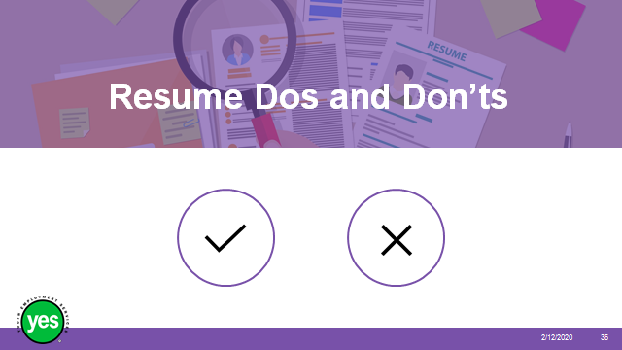 | Timing: 5 minutes.  Interaction Pattern: Whole class.  Materials Needed: Page 24 activity.  Procedures and Notes: Review highlights and answer questions.
Slide 37 |  | Timing: 5 minutes.  Interaction Pattern: Whole class.  Materials Needed: Page 25 and 26.  Procedures and Notes: Review highlights and answer questions.
Slide 38 | 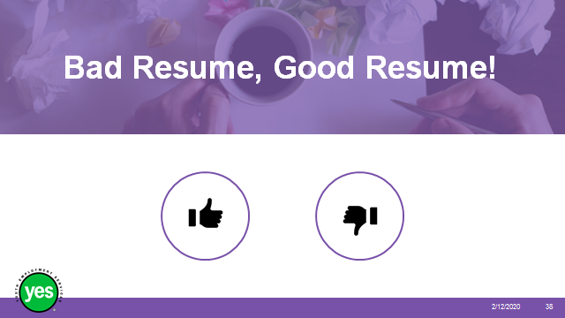 | Timing: 20 minutes.  Interaction Pattern: Individual, pairs and whole class.  Materials Needed: Handout of bad resume, then handout of good resume in Appendix.  Procedures and Notes: Hand out a copy of the bad resume to each person.  Give youth a few minutes on their own to review the “bad” resume and mark the errors they find.  Break the group into pairs or groups of three. Ask them to share what they have found and to see whether they can find additional errors. You may ask people to call out the number of errors they found.  Take up the exercise in the large group, asking each participant to identify an error and explain why it is incorrect. Discuss points, as needed.  Hand out the “good” resume and point out a few high-level features such as correct spelling, consistent dates, and so on.
Slide 39 |  | Timing: 15 minutes.  Interaction Pattern: Individuals/whole class.  Materials Needed: Appendix 3 Cover Letter exercise (letter from Sindy Nathan) cut up into slips as indicated – one set for each person, put in the wrong order.  Procedures and Notes: Distribute a complete set of slips of paper to each participant. Ask them to clear the space in front of them and arrange the pieces of paper to create a cover letter.  Take up the exercise together. Ask participants to explain their choices.  Was this exercise easy or difficult?  Why?  Describe the purpose of each paragraph and how they fit together, referring to page 29 of the workbook.  Discuss the overall impression of this applicant.
Slide 40 |  | Timing: 3 minutes.  Interaction Pattern: Whole class.  Materials Needed: YouTube video cued up (next slide).  Procedures and Notes: None.
Slide41 | 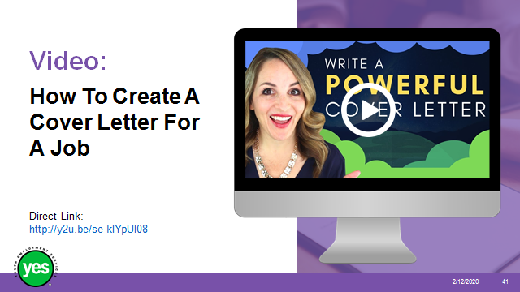 | Timing: 15 minutes.  Interaction Pattern: Whole class.  Materials Needed: YouTube video cued up and ready – How to create a cover letter for a job in 2019 – GOOD cover letter example by Heather Austin  https://www.youtube.com/watch?v=se-klYpUI08 (4:57 minutes)  Procedures and Notes: Screen video. Discuss reactions, questions.
Slide 42 | 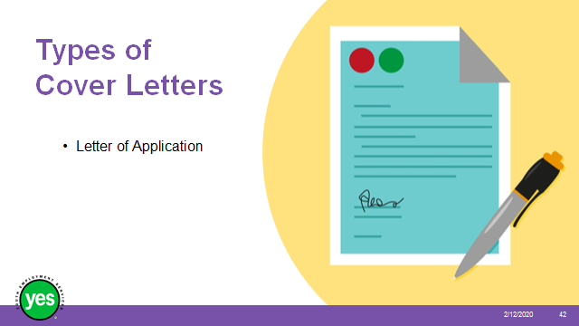 | Timing: 5 minutes.  Interaction Pattern: Whole class.  Materials Needed: Pages 27 to 29.  Procedures and Notes:  - used when applying for a specific job opening or responding to a job advertisement  - used when you know of an open position at the company  Offer and ask for examples to illustrate the points. Refer to example on page 31 in the workbook.
Slide 43 | 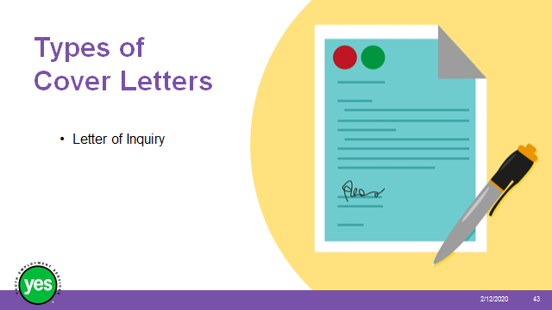 | Timing: 5 minutes.  Interaction Pattern: Whole class.  Materials Needed: Page 31.  Procedures and Notes:  - used when you are inquiring about possible openings within a company  - used to network with companies to show your interest in working with them when a position becomes available  Offer and ask for examples to illustrate the points. Have participants tried this before? What was the result?
Slide  44 | 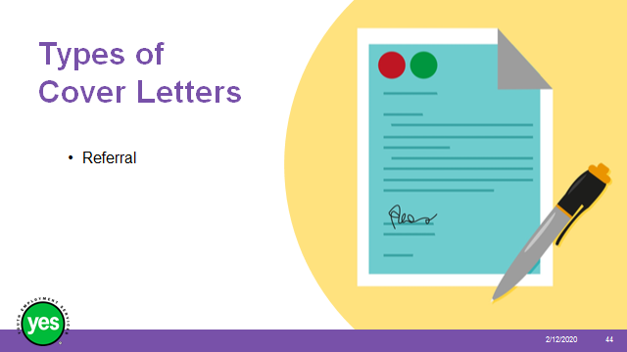 | Timing: 5 minutes.  Interaction Pattern: Whole class.  Materials Needed: Page 32.  Procedures and Notes:  - used when you found out about a job opening in a company from someone who works there  - used when you know someone who works for the company already  - only use this format if the referral is someone who will help you (if they were fired recently, it might not be a good referral)  Offer and ask for examples to illustrate the points. Refer to pages 32 and 33 in workbook.
Slide 45 |  | Timing: 10 minutes.  Interaction Pattern: Pairs/whole class.  Materials Needed: Page 29.  Procedures and Notes: Refer participants back to the sales associate posting and background on Sam Gupta. Ask them to use the table in the cover letter workbook and complete it as best they can with what they know about Sam Gupta. Full sentences are preferable rather than a description of what they’d include.  Take up together by asking for responses from the group. Discuss paragraphs that may be more difficult than others. Share tips and advice.
Slide 46 | 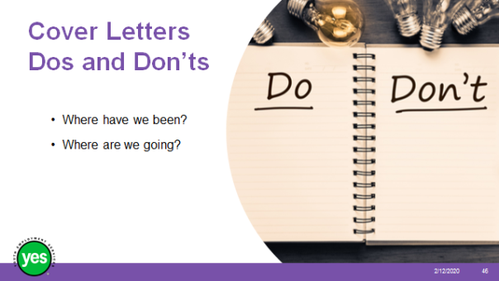 | Timing: 10 minutes.  Interaction Pattern: Whole class.  Materials Needed: Page 33.  Procedures and Notes: Review highlights from page 33.  Questions?
Slide 47 |  | Time: As needed.  Interaction Pattern: Whole class.  Materials Needed: None.  Procedures and Notes: Sum up the workshop in a few sentences. Refer back to the learning objectives. Talk about next steps for resume writing.  If there’s time, ask for a few comments from the group about what really stood out for them during this workshop, actions they may take now because of what they’ve learned.  Encourage participants to note down what their next steps will be.

Appendix 1: Bad Resume

MICHAEL FISHER

HunkyRockStar@gmail.com
SUMMRY OF QUALIFICATIONS
- 7 years experience working as a waiter
- Work in fast-paced environment
- Leader
- Good with computers
RELEVANT EXPEREINCE
All Star Wings January 2016– Oct ‘19
Server
- Greeted custmers
- Trained new staff
- Dealt with difficult customers
- Brought food out quickly
- Used computer/cash register
Smokey Poutine Shack Sept 2012 – December ‘15
Server
- Helped customers
- Recommended specails
- Trained new staff
- Used computer/cash register
OHTER EXPERIENCE
Allman and Sons Landscaping March 12– Oct. 2012
Landscaper

EDUCATON
Ontario Secondary School Diploma
Richmond Secondary School, Toronto, ON (dropped out in 2012)
HOBBIES
- Guitar
- Drawing
References
Jacob Wilder, Bestest Friend: 647-555-5555
Felicia Fisher, Mother: 416-282-2828

Appendix 2: Good Resume

MICHAEL FISHER

M.Fisher@gmail.com 123 Fake Street
416.555.4545 Toronto, On, M1N 2P3
SUMMARY OF QUALIFICATIONS
- Energetic food server with over 5 years’ experience in a range of customer-service roles
- Strong ability to problem solve and multitask in fast-paced environments
- Strong leadership skills obtained by training new groups of staff
- Quick learner with strong computer skills as evidenced by the ability to learn new systems at various restaurants
- Exceptional knowledge of beverage and food service standards

RELEVANT EXPERIENCE

Server January 2016 – October
2019
All Star Wings, Toronto, ON
- Greeted and served all customers courteously and efficiently as shown by positive customer feedback
- Trained new servers on all necessary tasks, resulting in a strong service team
- Handled loud or difficult customers discreetly and smoothly, resulting in a positive dining atmosphere
- Ensured timely delivery of bar foods and beverages, resulting in repeat business as evidenced by regular customers
- Learned new computer system quickly, leading to kitchen staff receiving food orders in a timely manner

Server September 2012 – December 2015
Smokey Poutine Shack, Toronto, ON
- Attended to all customer needs and requests promptly and courteously
- Followed all establishment hygiene practices, resulting in safe food handling
- Recommended special drinks and menu items to customers to increase restaurant profit
- Oversaw and provided on-the-job training to new servers, resulting in fewer service errors
- Learned computer system quickly, resulting in prompt communications with kitchen staff

OTHER EXPERIENCE
Landscaper March 2012 – October 2012
Allman and Sons Landscaping, Toronto, ON

EDUCATION
Ontario Secondary School Diploma 2008 - 2012
Richmond Secondary School, Toronto, ON

Appendix 3: Cover Letter Activity

Sindy Nathan
383 Main Street North
Toronto, ON M4J 3X7

_________________________________________
January 7, 2020

_________________________________________________________

Abdul Nazim
The Right Montessori
775 Princess Avenue
Toronto, ON M3Z 2K1

_____________________________________________________________

Dear Mr. Nazim,

Subject: Daycare Assistant Position

__________________________________________________________________

Mr. Bill Smith, the Executive Director of Youth for Kids, suggested that I write to you about the possibility of working as a daycare assistant this summer. He told me how impressed he is by your school and thought I would be a good fit.

_________________________________________________________________
I feel confident that I could contribute to making The Right Montessori a positive experience for the children who go there. For the past six years, I’ve babysat regularly for a number of families with children between two and ten years old. Repeat business and word-of-mouth referrals show me I’ve done a good job at keeping the children safe and engaged.

____________________________________________________________________
The Right Montessori has had positive coverage on social media recently. I appreciate your willingness to contribute to the community by donating holiday hampers to local families. My high school volunteer work included arranging for the collection of new toys and their delivery to the fire station for distribution to young children.

_________________________________________________________________

Thank you for taking the time to consider my application. I have attached a copy of my resume and will follow up within the next week. I look forward to speaking with you then.

_____________________________________________________________________

Sincerely,

Sindy Nathan

Sindy Nathan
Encl. Resume

