Youth Employment Services - YES
www.yes.on.ca
Future Skills:
motivation AND goal setting for today AND tomorrow
Facilitator’s Guide
Motivation and Goal Setting for Today and Tomorrow: Workshop at a Glance

Overview and Purpose

This workshop introduces the concept of human agency and how it relates to goal setting and motivation. Tips are provided on how to set SMART goals and how to stay motivated while working towards them. Deciding on a word of the year will help to set the stage for the next 12 months.

Time

The workshop is between three and five hours long. All timings provided in the Facilitator’s Guide are approximate. Note that the timings for the slides don’t add up exactly to three or five hours, because some of the activities can be extended or shortened. You can lengthen, shorten or leave out activities based upon the needs of your participants and the amount of time you have for the workshop. You should have short breaks at least every 90 minutes.

Learning Outcomes

At the end of this workshop, participants will:

- Understand the concept of human agency.
- Know how to set SMART goals.
- Identify a few personal and career goals.
- Understand the difference between extrinsic and intrinsic motivators.
- Know how to choose a word of the year.

Leading Questions

As participants complete this workshop, they will think about and answer the following questions:

- What does human agency mean and how does this help me understand myself?
- How do I set SMART goals?
- What are some of my personal and career goals?
- What motivates me?
- How can I keep motivated as I pursue my goals?
- What do I want for myself for the next 12 months?

Workshop Agenda

- Human Agency
- Goal Setting
- Motivation
- Word of the Year
- Review and Wrap-Up

See the Appendix for an optional vision board activity.

Materials Needed

- White board/Screen/Internet connectivity
- Each participant should have a workbook and a device
- PPT Presentation Motivation and Goal Setting
- Activity Material – flip chart
- Handout of quotes

Formative Assessment

The completion of two to three SMART goals constitutes the formative assessment for this workshop.

Detailed Workshop Plan

Slide 1 |  | Timing: Display as the participants come in.  Interaction Pattern: Whole class.  Materials Needed: None.  Procedures and Notes: None.
Slide 2 | 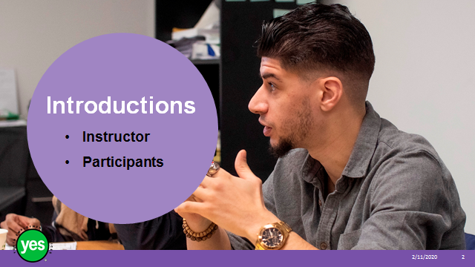 | Timing: 2 minutes.  Interaction Pattern: Whole class.  Materials Needed: None.  Procedures and Notes: Introduce yourself as the instructor. Have each participant briefly state their name. Have each participant put a name card in front of them for your reference.
Slide 3 | 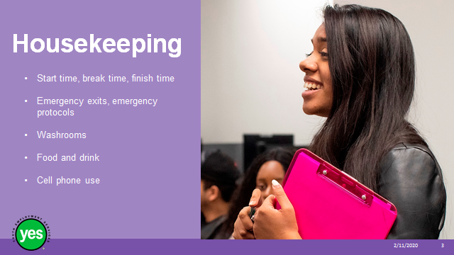 | Timing: 2 minutes.  Interaction Pattern: Whole class.  Materials Needed: None.  Procedures and Notes: Review all of the housekeeping details indicated on the slide and any others you need to add. For cell phone use, indicate that if they are expecting an urgent call, their phone should be on vibrate. Otherwise indicate it should be on silent. They should not respond to texts or emails during the workshop. We may need to use cell phones in an activity.
Slide 4 | 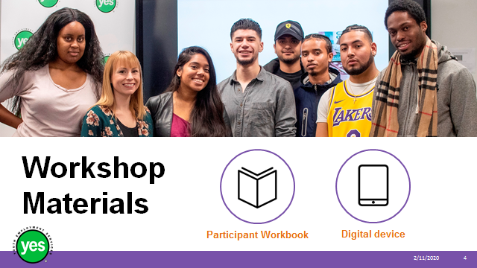 | Timing: 2 minutes.  Interaction Pattern: Whole class.  Materials Needed: One Participant Workbook per participant.  Procedures and Notes: Direct participants to their Participant Workbooks. Have them put their names on them. Indicate that this is their record of the key information in the workshop and ideas they generate during the workshop. It is also a resource they can come back to later as they prepare for real-life situations.
Slide 5 | 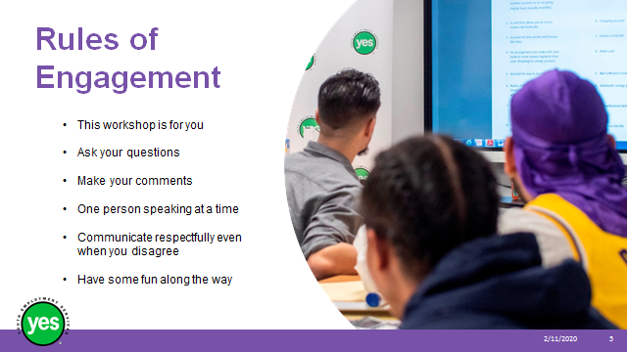 | Timing: 2 minutes.  Interaction Pattern: Whole class.  Materials Needed: None.  Procedures and Notes: Review your expectations for the participants, such as active listening and mutual respect. Indicate that your role is to guide them through the material and facilitate discussion. You may ask the group if they have anything to add to your list.
Slide 6 | 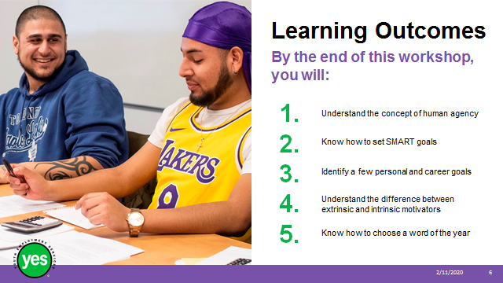 | Timing: 2 minutes.  Interaction Pattern: Whole class.  Materials Needed: Page 1.  Procedures and Notes: Review the learning outcomes of the workshop, stressing that the ways of looking for work are likely to shift as new technology is introduced. This workshop is a combination of information, demonstration and hands-on activities.
Slide 7 | 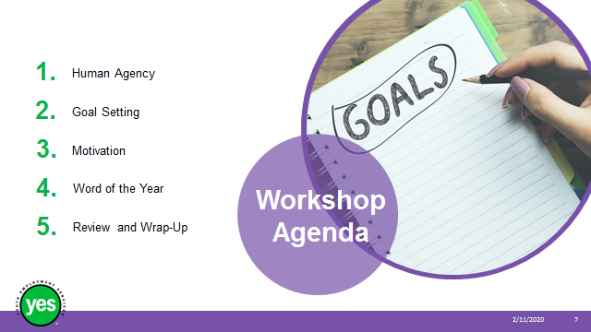 | Timing: 2 minutes.  Interaction Pattern: Whole class.  Materials Needed:  Procedures and Notes: Review the agenda for the workshop.
Slide 8 | 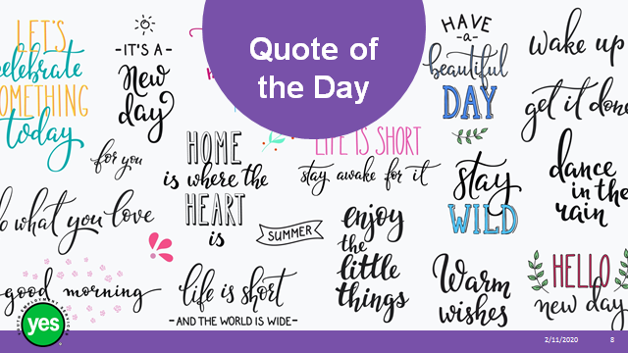 | Timing: 15 to 20 minutes.  Interaction Pattern: Whole class / small group.  Materials Needed: Pieces of flip chart paper with quotes posted.  Procedures and Notes: Beforehand, write out 3 to 5 quotes, 1 per page and post them around the room. Flip chart paper and large lettering will work best.  Ask participants to read the quotes and then stand by the one that captures their attention. They don’t have to agree with the quote.  Once the small groups are formed, ask them to spend a few minutes talking about why they’ve chosen this quote.  Debrief by asking for conversation highlights or conclusions and saying that we will see how this relates to today’s learning outcomes and agenda.  Quotes for consideration:  Setting goals is the first step in turning the invisible into the visible. (Anthony Robbins)  The future belongs to those who believe in the beauty of their dreams. (Eleanor Roosevelt)  Dreams don’t work unless you do. (John C. Maxwell)  There’s only one thing that makes a dream impossible to achieve: the fear of failure. (Paulo Coelho)  You fail at 100% of the goals you don’t set. (Mark Victor Hansen)  People with goals succeed because they know where they are going. It’s as simple as that. (Earl Nightingale)
Slide 9 |  | Timing: 20 to 25 minutes.  Interaction Pattern: Whole class.  Materials Needed: Page 2.  Procedures and Notes: Before delivering the workshop, acquaint yourself with the concept of human agency. This video is helpful: Human Agency by Albert Bandura: https://www.youtube.com/watch?v=YMOA1XGHQhQ (5:37 minutes)  The beginning of the video may be suitable for your group.  “Your ability to take action, be effective, influence your own life, and assume responsibility for your behaviour is important. This sense of agency is essential for you to feel in control of your life: to believe in your capacity to influence your own thoughts and behaviour, and have faith in your ability to handle a wide range of tasks or situations.”  https://www.psychologytoday.com/ca/blog/the-white-knight-syndrome/201009/your-sense-agency-are-you-in-control-your-life  We are learning a bit about human agency because it relates to setting goals and being motivated. (Refer back to the quotes in the warm-up exercise.)  Review the terms and explanations on page 3 in the workbook.  Intentionality – possible discussion questions  - What does it mean to have intentions?  - When you think about intending to do something, do you think about how you’ll do it and when? Why or why not?  Forethought – possible discussion questions  - What are prospective actions? (anticipated or likely)  - What’s the difference between goals and outcomes?  - Outcomes are measurable results. Can you share some goals and outcomes? (e.g. My goal is to pass this course. Outcome: I got a B+; My goal is to have a part-time job within two months. Outcome: I got a job that is 15 hours a week six weeks after I started looking.)  - What do you think of when you hear the term “visualization?” What field does it make you think of? (sports – we hear about athletes visualizing their success, seeing themselves through the race, dive, etc.)  - Have you ever tried to visualize something you wanted to do? What was your experience?  Self-reactiveness – possible discussion questions  - What does it mean to be contributors to our own life? (to take action, influence our life and take responsibility)  - What is it like to feel in charge of your life?  - Can we control our circumstances? (yes and no; talk about resilience and coping with what is beyond our control)  Self-reflectiveness – possible discussion questions  - What does it mean to have free will? (the power of acting without the constraint of necessity or fate; the ability to act at one's own discretion)  - What is the opposite of free will? (determinism - is the philosophical belief that all events are determined completely by previously existing causes…so, we have no control over what happens to us)  - What are some of the benefits of self-reflection? Downsides?
Slide 10 | 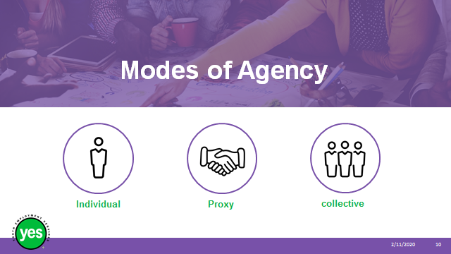 | Timing: 10 minutes.  Interaction Pattern: Whole class.  Materials Needed: Page 3.  Procedures and Notes: Review three ways in which agency takes place, relating them to looking for work and to work itself.  Individual - influencing self and own functioning (e.g. looking for a job, taking initiative on the job)  Proxy – influencing others to achieve what they truly desire (e.g. coaching, supporting others)  Collective – working together through independent effort to finish a task (e.g. group projects at school and work)  The work world of the future will likely be structured, or organized, in a different way from today. You will not be able to count on getting one job and staying in this job, or even company, for your whole career. You will need to know what skills and experience you have to offer, as well as how to turn your skills and experience into paid employment. You may find that you do project or contingency work, moving from company to company until the work is completed. You’ll need to take responsibility for your career.  You, the facilitator, may choose to use this model to describe how your organization supports its clients as they look for work, for example:  Individual – youth choose to attend the program  Proxy – staff support youth as youth identify their strengths and weaknesses, narrow down job goals, etc.  Collective – individual youth draft their resumes; staff review and provide feedback, etc.
Slide 11 | 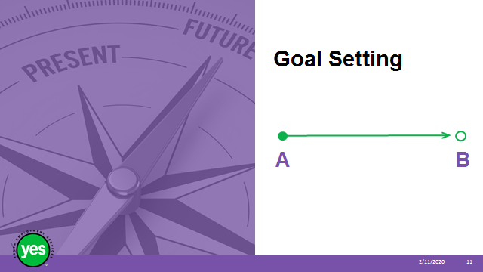 | Timing: 5 minutes.  Interaction Pattern: Whole class.  Materials Needed: Page 4.  Procedures and Notes: Begin with a definition of the word “goal” – e.g. something that you hope to achieve  Ask the group why we set goals. The process of setting goals helps you choose where you want to go in life.  Talk about how in theory it may seem that there is a direct line between today and achieving our goals, that every action will bring us a step closer. It is seldom that way in reality.
Slide 12 | 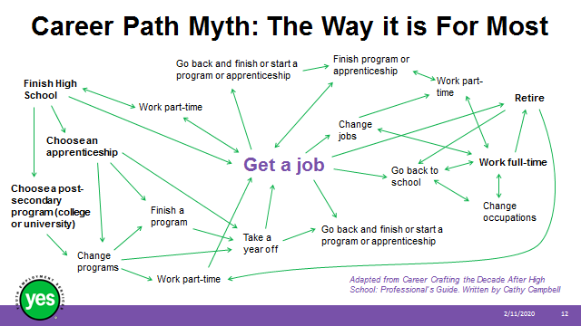 | Timing: 5 minutes.  Interaction Pattern: Whole class.  Materials Needed: None.  Procedures and Notes: This photo gives us an idea of how achieving our career goals looks in reality. The type will be too small to see.  Give a sense of the routes depicted on the slide – get a job is in the centre.  One possible route: go back to school, work full-time, go back to school because want to change occupations  Another possible route: finish high school, choose an apprenticeship, take a year off, finish apprenticeship  Another possible route: finish high school, choose a college or university program, change programs, work part-time, get a job  Ask for a few volunteers to share the route they have taken so far.
Slide 13 |  | Timing: 10 minutes.  Interaction Pattern: Whole class.  Materials Needed: Page 5.  Procedures and Notes: We can set personal goals as well as career goals, and it is beneficial to have both. Regardless of the type of goal, it is useful to have a method for setting goals. This helps you  - Decide what is important for you to achieve in your life.  - Separate what is important from what is irrelevant.  - Motivate yourself.  - Build your self-confidence as you achieve your goals.  One popular way of doing this is to set SMART goals. Unclear goals are difficult to implement, while focused goals are more effective.  Review slide and refer to the workbook.  Some people may have a slightly different set of words for A (attainable) and R (relevant).  Offer an example. Goal – to sail around the world vs. to have completed my trip around the world by December 31, 2021.
Slide 14 | 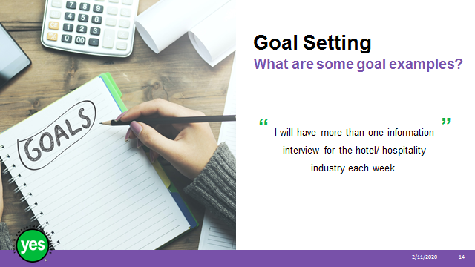 | Timing: 30 minutes.  Interaction Pattern: Pairs / whole class.  Materials Needed: Page 6 activity.  Procedures and Notes: Divide the group into pairs or groups of three.  Refer to the exercise on page 6 in the workbook. Ask the pairs to do one sentence at a time – is it a SMART goal? If so, why? If not, why not? What could you say instead?  Do one job search goal at a time so that participants have a chance to catch on faster, rather than make the same mistake more than once.  Come up with your own answers. Discuss and move on to the next.  You may insert your own examples if they would be better for the group.  Continued on next slide.
Slide 15 | 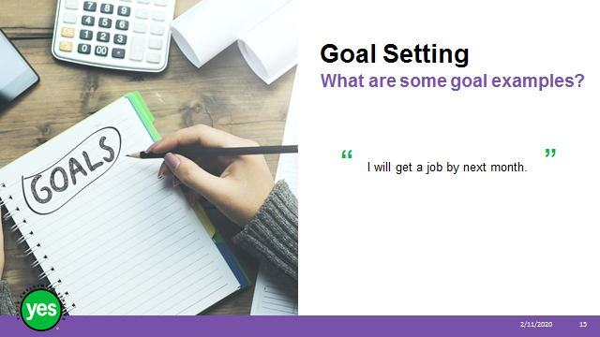 | Procedures and Notes:  Continued on next slide.
Slide 16 | 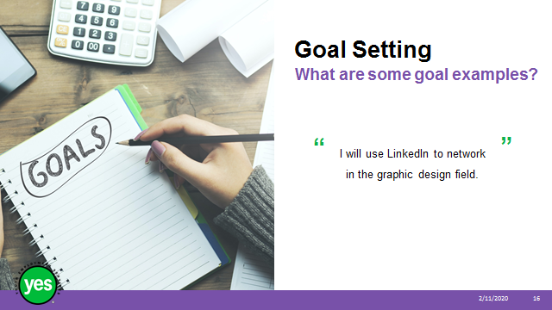 | Procedures and Notes:  Continued on next slide.
Slide 17 | 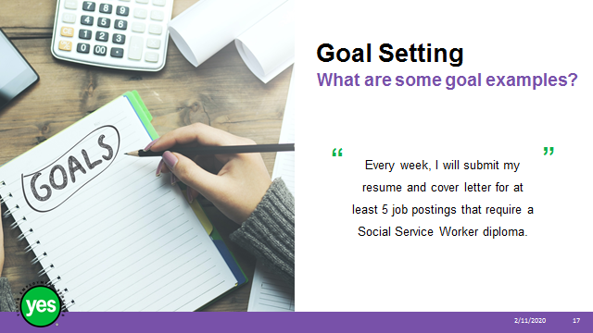 | Procedures and Notes:  Continued on next slide.
Slide 18 | 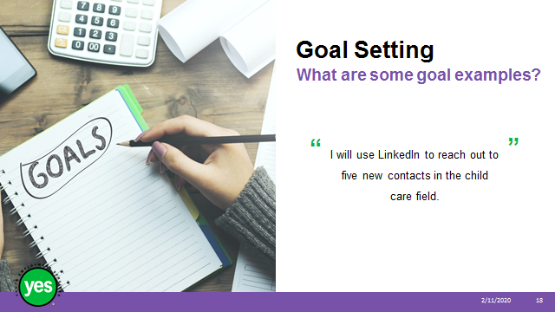 | Procedures and Notes:
Slide 19 | 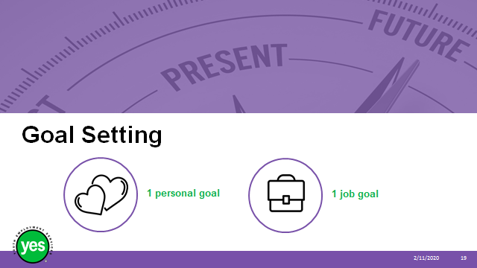 | Timing: 15 minutes.  Interaction Pattern: Individuals.  Materials Needed: Page 7 and 8; additional facilitator(s) or job developers  Procedures and Notes: Ask participants to sit quietly and write down the first personal goal and career goal that comes to mind, then rewrite it to fit the SMART structure.  Circulate around the room, asking probing questions to help narrow down the goal.  It may be helpful to have an additional facilitator or small team of job developers come for this activity so that more participants can get some 1:1 attention.  Introduce next section of the workshop by saying setting goals is one thing, how do you become motivated to take the first step and stick with it?
Slide 20 | 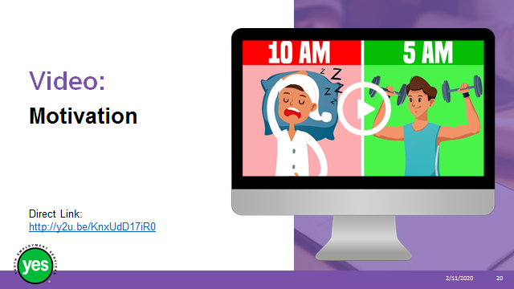 | Timing: 45 minutes.  Interaction Pattern: Whole class/individual.  Materials Needed: Page 9 activity and YouTube video cued up - 4 simple tricks to stay motivated every day, (10:27 minutes)  https://www.youtube.com/watch?v=KnxUdD17iR0\  Procedures and Notes: Screen the video, either in its entirety or in parts. You may also choose to show the whole thing, then go back to certain parts.  The timing is listed below, along with the four tricks to staying motivated and some possible discussion points. Allow participants time to reflect and make some notes in their workbooks.  What are the four simple tricks to staying motivated?  #1. Own your goals. 1:52  - Are they your goals or did someone choose them for you?  - Your motivation has to come from you – your skills, passions…  - “You won’t have the perseverance to achieve your goals if they aren’t yours.”  2. Envision the details. 4:13  - Visualize your goals. Picture them down to the smallest detail.  - Motivation is where you start. Still have to do the work and deal with setbacks.  - Be specific. You can turn vague ideas into real, achievable goals.  3. The power of expectations. 6:28  - “If no one knows what you’re doing, you can get away with not doing it.”  - Create an expectation.  - Talk to people about your goals and the steps you are taking. – tell only person you care about, not everyone who will listen. -- where you’re going and why, steps taking to turn dream into reality  4. Resurrecting motivation. 8:54  Figure out ahead of time how to resurrect your motivation – how to get through darkest, laziest moments. Find a way to accept your failures. Whatever happened, happened and you can’t change that. You can learn from your mistakes and try again.  What does it mean to “wipe the slate clean?”
Slide 21 |  | Timing: 2 minutes  Interaction Pattern: Whole class  Materials Needed: None.  Procedures and Notes: Highlight the comment from the video that motivation is the starting point.  Let’s look at what motivates us and how to make the most of it.
Slide 22 |  | Timing: 15 minutes.  Interaction Pattern: Whole class/individual.  Materials Needed: Page 10 activity. Finish by reviewing page 11.  Procedures and Notes: Review the definitions of extrinsic and intrinsic motivation.  Intrinsic – we are born motivated to achieve. You do an activity because it’s internally rewarding. You find it fun, enjoyable and satisfying. The goal comes from within and there is no reward or deadline.  Extrinsic – motivation can be enhanced and rekindled. You do an activity in order to get an external reward in return. The goal is focused on an outcome.  Ask for examples from the group.  Ask the group to think about which term applies to them most of the time or which term applies to them when. Share your response.  Knowing what motivates you and what motivates others can be useful in relationships at work and socially.  Relate the types of motivation to looking for work and keeping a job.  Review the characteristics of motivated people on page 11 and refer to the additional strategies for staying motivated.  We will talk a bit more about rewards.
Slide 23 |  | Timing: 10 minutes.  Interaction Pattern: Whole class.  Materials Needed: Page 12.  Procedures and Notes: Rewards can be motivating but they can also inhibit motivation.  Review the table on page 12 of the workbook.  Ask for volunteers to share how they reward themselves and how this helps them stay motivated. You may link this to self-care.
Slide 24 |  | Timing: 20 minutes or as needed.  Interaction Pattern: Individual.  Materials Needed: Page 13 and 14. Support materials (example words) for participants on page 15.  Procedures and Notes: Introduce the word of the year as an alternative to a new years’ resolution. It’s not about succeeding, failing, or putting pressure on yourself. It’s about a little reminder that you can consult or think about when there’s a choice to be made or a task to be undertaken.  Review the instructions in the workbook. Allow 5 to 7 minutes or #1; 3 minutes for #2 and about 10 minutes for reflecting on the words to see which stand out.  You may choose to break the group into pairs and discuss their word. You may also choose to share your word of the year.
Slide 23 |  | Timing: As needed.  Interaction Pattern: Whole class.  Materials Needed: None.  Procedures and Notes: Review the main topics and highlights of the workshop.  Ask participants for a quick take on how this workshop went for them – e.g. both arms up, one arm up, no arms up.  Ask if there are any final questions or comments about the content of the module.

Appendix: Optional Vision Board Activity

Timing: 45 minutes or as needed

Interaction Pattern: Whole class/individual

Materials Needed: A piece of 11 x 17 paper for each participant; sources of photos and words, such as magazines and newspapers; coloured paper, coloured markers, scissors, glue sticks, stickers; workbook, page #

Procedures and Notes: Refer to the instructions on page # in the workbook and go through them, step by step.

Ask whether there are any questions.

Distribute materials around the tables within easy reach.

Step 1: Decide – ask participants to think about whether they’d like to do a vision board for all areas of their life, or only one. Make sure everyone has made a decision after 5 minutes.

Steps 2 and 3: Give the group about 30 minutes to collect material and play around with how they’d like it to appear on the page.

About 10 minutes before you’d like this activity to be over, tell participants they should be gluing their material to the page.

Optional: Depending on the time and on the nature of the group, you may invite 2 or 3 participants to present their vision board.

Conclude the exercise by saying that this is a very personal, individual exercise. There is no right or wrong. Each person’s vision board will look different from everyone else’s. The hope is that participants will use the boards to help them visualize their dreams and goals. Review tips from the workbook on how to use the vision board.

Vision Board Handout

Follow these steps to create a vision board – a representation of your future!

Step 1: Decide

- Decide whether you’d like to make one vision board for all areas of your life, or one for each area you choose (such as career, personal).

Step 2: Select material to place on your vision board.

- Collect images, symbols and words that represent the experiences, the feelings and the possessions you want to attract into your life. These may include
  - Photos, magazines, pictures from internet, stickers – whatever inspires you
  - Anything else, such as meaningful symbols and/or a picture of yourself (taken in a happy moment)
  - Affirmations, quotations and thoughts
  - Words that bring up positive emotions

Step 3: Get creative!

- Place the material you’ve collected onto a large piece of paper or bristol board, following these tips:
  - Play around with how you’d like to present the material until it feels right.
  - Get a sense of the big picture before you glue anything.
  - Keep it simple, not too crowded or chaotic.

Step 4: Use your vision board.

- Spend time each morning and evening visualizing, especially before bed.
- Take time to acknowledge what is working.
- Don’t remove the goals you’ve achieved. Keep them there as a reminder of how far you’ve come.
- Create a new vision board each year and consider keeping the old ones.

